Reactions
Chapter 11

Chapter 11: Reactions
- Chemical Equations
- Balancing Reactions
- The Mole
- Formula Weight
- Reaction Diagrams
- Kinetics
- Chemical Equilibrium

Chemical Equations
Chemical change involves a reorganization of the atoms in one or more substances.

The Hindenburg Reaction
- Reactants are on left, products to the right.
- Arrow indicates the change

A chemical equation

2 H₂ + O₂ à 2 H₂O
- Notice that the formula for the molecules is unchanged.
- To indicate that more than one molecule is required, use coefficients (shown in green).
- The equation is balanced.

The Rules
- Change only the coefficients to balance the chemical equation.
- Balance one element at a time.
- Continue to balance the other elements in the same manner.
- Adjust coefficients to the lowest whole number common multiple.
- Check your answers.
Example
FeI₂ + Cl₂ à FeCl₃ + I₂
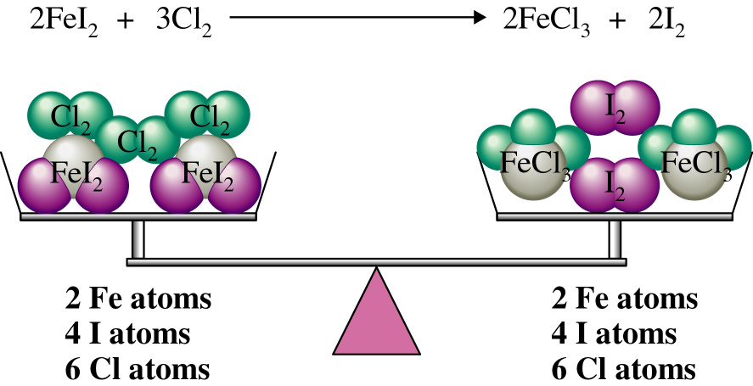

Balancing Combustion Reactions
(fuel + oxygen gives carbon dioxide and water)
- Balance carbon first
- Hydrogen second
- Oxygen last
- Multiply by 2 if you need to.

___ C₃H₈ + ___ O₂ Ú ___ CO₂ + ___ H₂O

More Balancing and Things to Avoid
___ C₄H₁₀ + ___ O₂ Ú ___ CO₂ + ___ H₂O

1 C₄H₁₀ + 13/2 O₂ Ú 4 CO₂ + 5 H₂O

2 C₄H₁₀ + 13 O₂ Ú 8 CO₂ + 10 H₂O

- Coefficients should always have the lowest whole number ratio.
- Never Change the subscripts. 8 CO₂ is not the same as C₈O₁₆.

Quantifying Chemical Reactions
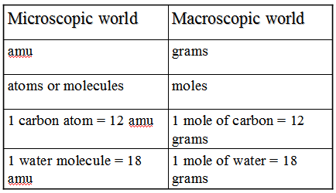
The mole (6.02 x 10²³)
- A macroscopic version of the molecule defined so we can use the periodic table for the macroscopic and microscopic world.
- Defined as the number of atoms in exactly 12.0 g of carbon-12 isotope.
- This is number is called Avogadro’s number after the Italian physicist Amedeo Avogadro (1776-1856).
Formula Weight
- The sum of the atomic weights of all the atoms in the molecular formula, whether ionic or molecular.
- Expressed in amu/molecule or grams/mole.
- Also called molecular weight, molar mass
Formula Weight
H₂O (2 x 1.0) + (1 x 16.0) = 18.0 g/mole
Ca(OH)₂ (1 x 40.1) + (2 x 1.0) + (2 x 16.0) = 74.1 g/mole
C₃H₈ (3 x 12.0) + (8 x 1.0) = 44.0 g/mole
A Chemical Reaction
What is happening in a reaction?
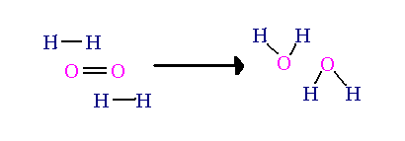

Three things are required for a reaction to occur:
- Molecules must collide.
- They must collide with enough energy to break old bonds so new ones can form.
- They must collide in the correct orientation.

Energy Diagram for exothermic reaction
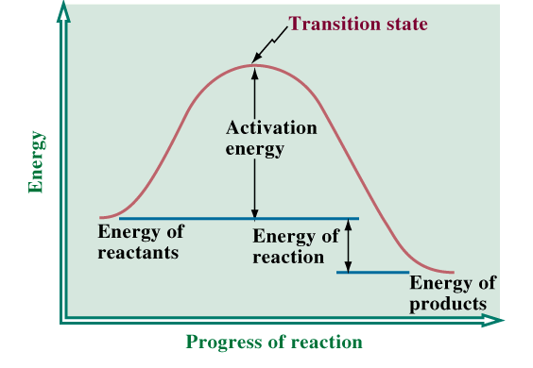

Energy Diagram for endothermic reaction
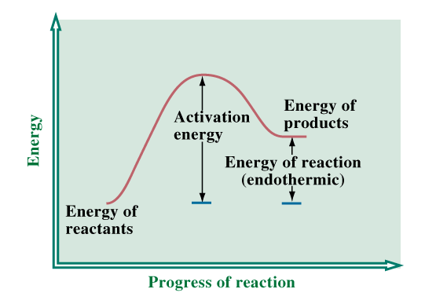

Kinetics (rate of reaction)

Three ways to increase the rate of a reaction
- Increase Concentration
  - Increases number of collisions
- Increase Temperature
  - Increases collisions & collisions that have enough energy to break old bonds
- Use a catalyst.
  - Lowers energy barrier (Activation energy)
A Catalyst
- A compound that increases the rate of a reaction without itself undergoing a permanent change at the end of the process.
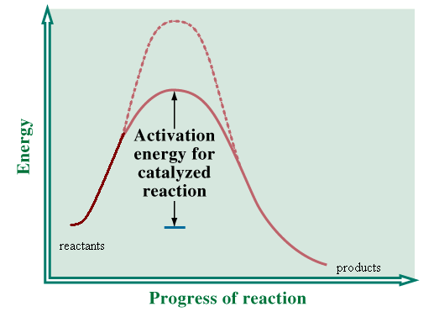

Chemical Equilibrium

- Most reactions are reversible, some are not.
- Reversible reactions are shown with a double arrow.
- An equilibrium condition exists when the rate of the forward reaction equals the rate of the reverse reaction.
- Equilibrium: The exact balancing of two processes that are opposite each other.
- Chemical equilibrium: A dynamic state where the concentrations of all reactants remain constant.

Concentrations as a solution reaches equilibrium
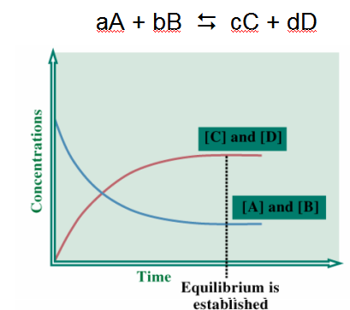

Homework
- Balance the following equation:__ C₅H₁₂ + __ O₂ -> __ CO₂ + __ H₂O
- Balance the following equation:__ C₆H₁₄ + __ O₂ -> __ CO₂ + __ H₂O
- __ FeCl₃ + ___ NaOH -> __ NaCl + __Fe(OH)₃
- The combustion of a hydrocarbon fuel does not produce
  - H₂
  - H₂O
  - CO₂

Answers 1) 1,8,5,6 2) 2, 19, 12, 14 3) 1, 3, 3, 1 4) A

