PSC1341 Chapter 5
Electricity and Magnetism

Chapter 5: Electricity and Magnetism

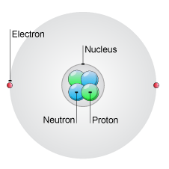
- The Atom
- Electricity
- Static Electricity
- A circuit
- Current and Voltage
- Resistance
- Ohm’s Law
- Power
- Magnetism
- Electromagnets
- AC/DC

The Atom
- Atoms are made of subatomic particles
- Protons, + charge, mass of 1 amu.
- Neutrons, neutral charge, mass of 1 amu
- Electron, - charge, very small mass (1/1896 amu)
- Protons and neutrons reside in the nucleus, electrons orbit outside the nucleus.

Electricity
- Ben Franklin identified to types of charges, positive and negative.
- Unlike charges attract
- Like charges repel
- $F_{E}=K\frac{q_{1}q_{2}}{D^{2}}$
  - q1 , q2 = charge (plus or minus)(In coulombs C)
  - K = 9.0 x 10⁹ Nm²/C²
  - D = distance between charges (In meters)

- ‘Charge’ arises because of a transfer of electrons
  - all charged objects will have charge equal to an integral number of the basic charge on an electron.
- Charge is measured in Coulombs (C).
- Charge on one electron = 1.6 x 10-19 C.
- The symbol of charge is Q.

Static Electricity
Some compounds have a greater affinity for electrons than others. When two objects, made of different compounds, rub against each other electrons transfer and build up on one object. Later, this charge difference can be neutralized by a static discharge.
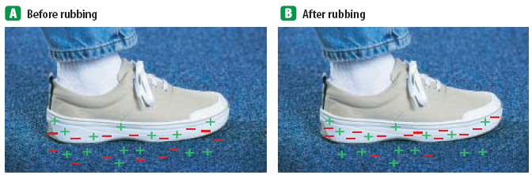

- Triboelectric Series: Materials ranked in order of their ability to hold or give up electrons.
glass
Hair
nylon
wool
paper
Cotton
Hard rubber
polyester
PVC
- Under ideal conditions, if two materials are rubbed together, the one higher on the list should give up electrons and become positively charged.
- As electrons collect on an object, it becomes negatively charged. As electrons leave an object it attains a positive charge. Charges interact with each other:
- Often when you remove clothes from the clothes dryer, they seem to stick together. This is because some of the clothes have gained electrons by rubbing against other clothes. The clothes losing electrons become positive. The negative clothes are attracted to the positive clothes.

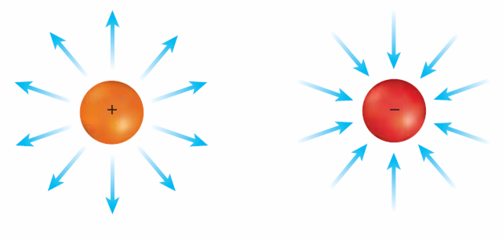
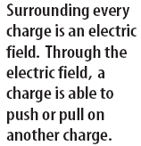
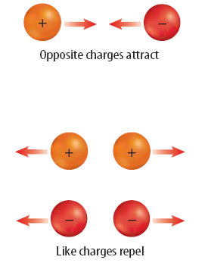

A Circuit
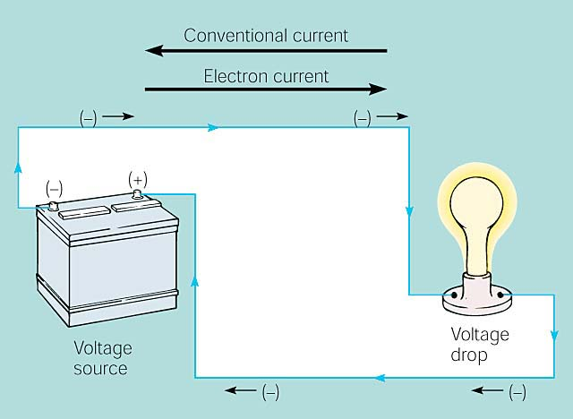

Circuit Analogy
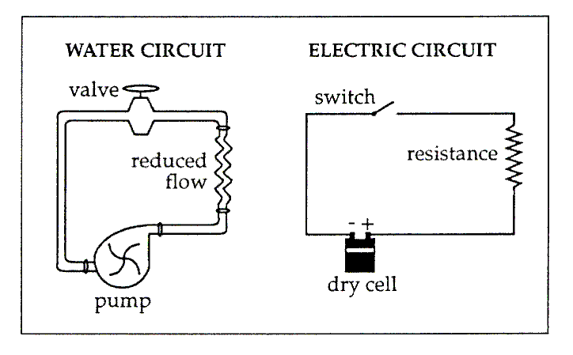
Term | Definition | Unit | Plumbing Analog
Voltage | Electrical Pressure | Volt | Water Pressure
Resistance | Resistance to electron flow | Ohm | Pipe diameter
Current | Flow rate of electrons | Amp | Flow rate
Power | Current times voltage | Watt | Rate of work done by moving water

Current and Voltage
- The flow of electrons is called current and is measured in amperes (A). An ampere is equal to a flow of 1 coulomb/second.
- This push, from the battery in the preceding circuit, is called the electrical potential or voltage and is the electric potential energy per amount of charge. It is measured in voltage (V). 1 volt = J/C
Conductors vs. Insulators
- Conductors – material through which electric current flows easily.
- Insulators – materials through which electric current cannot move.
Examples
- Conductors:
  - Metal
  - Water
- Insulators:
  - Styrofoam
  - Rubber
  - Plastic
  - Paper

What is Resistance?
- The opposition to the flow of an electric current, producing heat.
- The greater the resistance, the less current gets through.
- Good conductors have low resistance.
- Measured in ohms. (W)

What Influences Resistance?
- Material of wire – aluminium and copper have low resistance
- Thickness – the thicker the wire the lower the resistance
- Length – shorter wire has lower resistance
- Temperature – lower temperature has lower resistance

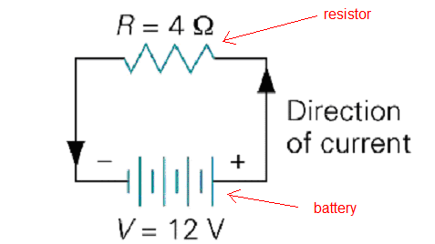
A circuit
A battery produces electricity by transforming chemical energy into electrical energy

Sample Problem
If we have a circuit with a 4 Ohm resistor and a 12 volt battery, what is the current?

Voltage(V) = current(I) times resistance(R)
$I=\frac{V}{R}\text{ or V}=I⋅R$
Current = I = V/R
= (12 Volts)/4.0 W
=3.0 Amps

Power
- Power: Rate at which work is done.
- Electric Power: The rate at which charge carriers convert electrical potential energy into non-mechanical energy. As electric current flows in a circuit, it can transfer energy to do mechanical or thermodynamic work.

Your electric bill
- P=W/t so W= P*t power is in J/s and time is in seconds so what comes out will be Joules
- This meter measures the amount of electric work done in the circuits, usually over a time period of a month. The work is measured in kWhr instead of Joules.
Sample Problems:
What is the resistance of circuit with a voltage of 6.0 volts and a current of 2.0 amps?

$R=\frac{V}{I}=\frac{6\text{.}\text{0 volts}}{2\text{.}\text{0 amps}}=3\text{.}\text{0 ohms or 3}\text{.}\text{0 }Ω$

When you turn on the ignition of your automobile, your 15-volt car battery must turn a 400-amp starter motor. How much power is required to start your car?

$P=\text{IV}=(\text{400}\text{.}\text{ amps})⋅(\text{15}\text{.}\text{0 volts})=\text{ 6000 Watts or 6}\text{.}\text{00 kW}$

A CD system is 250 watts. Assuming that your system is plugged into a 115-volt outlet, how much current will flow through the stereo at full power?

$I=\frac{P}{V}=\frac{\text{250 watts}}{\text{115 volts}}=2\text{.}\text{17 amps}$

Magnetism
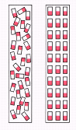
- Some atoms, depending on their electronic structure, act like magnets and have a north and south pole. In most matter, there is no alignment of the poles of the atoms. In a bar magnet, the atoms will line up.

Magnets have two ends or poles, called north and south poles. At the poles of a magnet, the magnetic field lines are closer together.
Unlike poles of magnets attract each other and like poles of magnets repel.
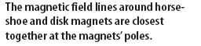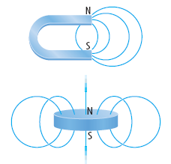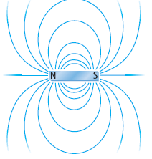

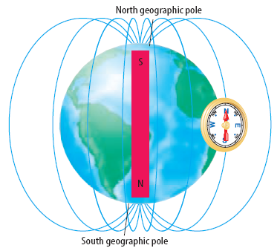
The earth is like a giant magnet
The nickel iron core of the earth gives the earth a magnetic field much like a bar magnet.

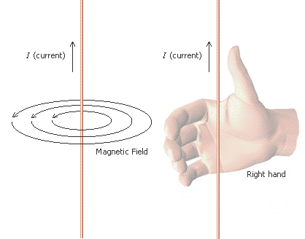
Right hand rule
- Hans Christian Oersted discovered that a moving charge , a current, creates a magnetic field.
- This is governed by the right hand rule:

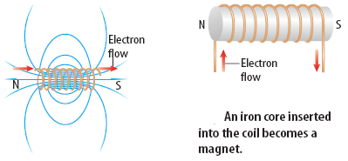
Electromagnets
When an electric current is passed through a coil of wire wrapped around a metal core, a very strong magnetic field is produced. This is called an electromagnet.

AC vs. DC
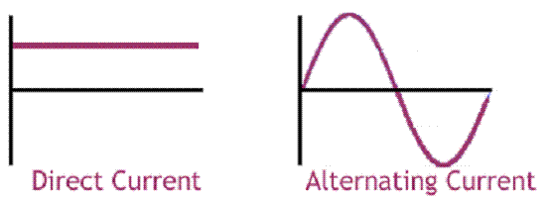
- There are two types of current. Alternating current (AC) and direct current (DC).
- Direct passes in the same direction constantly. A battery produces a direct current
- Alternating current on the other hand, is always changing direction. This is the form that domestic electricity supply takes

Motors and Generators
- Electric motor - a device which changes electrical energy into mechanical energy.
- Uses an alternating current to create a magnetic field which can repel each end of a magnet successively, turning a wheel or other device.
- Generator – a machine that changes mechanical energy to electrical energy
- Usually use moving magnets to create currents in coils of wire.

Homework

1. positive electric charge
- attracts other positive charges
- repels other positive charges
- does not interact with other positive charges but only with negative ones
- consists of an excess of electrons

2. The particle easiest to remove from an atom is the
- electron
- proton
- neutron
- nucleus

3. Which of the following statements is not true?
- Protons are positively charged.
- The proton mass is greater than the electron mass.
- The proton mass is about the same as the neutron mass.
- The proton in an atom circulates around its nucleus.

4. The voltage needed to produce a current of 12 A in a resistance of 20. ohms is
- 0.60 V
- 1.67 V
- 8.0 V
- 240 V

5. The power rating of an electric motor that draws a current of 3 A when operated at 120 V is
- 40W
- 360 W
- 540 W
- 1080 W

6. The current in a 24-W, 12-V light bulb is
- 0.5 A
- 2 A
- 12 A
- 288 A

7. What is the resistance in a 24-W, 12-V light bulb?
(Hint: You may need your answer from the previous question.)
- 0.5 ohms
- 2 ohms
- 6 ohms
- 24 ohms

8. What is the current of a circuit that has 12.0 V and 0.79 ohm of resistance?

Answer 1) B, 2) A 3) D 4) D 5)B 6)B 7) B 8) Amps

V=IR so I=V/R which is 12.0 Volts/0.79 Ohms

