PSC1341 Chapter 4
Waves
Chapter 4: Wave Motion
A.. The Behavior of Light
B. The E-M spectrum
C. Equations
D. Reflection, Refraction, Lenses and Diffraction
E. Constructive Interference, Destructive Interference & Dispersion
F. Sound Waves & the Doppler Effect
Waves
- A wave is a repeating disturbance or movement that transfers energy through matter or space
- Waves can be mechanical and electromagnetic
- Waves can be Transverse and Longitudinal
- A wave is characterized by its wavelength, frequency, and amplitude

Mechanical vs. Electromagnetic
- Mechanical
  - Examples -- sound waves, water waves, etc.
  - Require medium for transfer; cannot be transferred through a vacuum
  - The speed of the wave depends upon the mechanical properties of the medium.
  - Some waves are periodic (particles undergo back and forth displacement as in a sound wave.)
  - Some waves are sinusoidal (particles undergo up and down displacement as in a wave on a string.)
- Electromagnetic
  - Examples -- light waves, radio waves, microwaves, X-rays, etc.
  - Do not require a medium for transfer; can be transferred through a vacuum
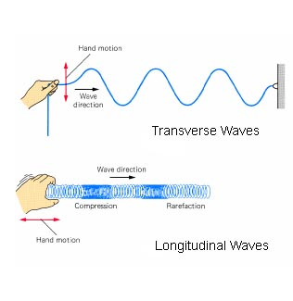
Transverse vs. Longitudinal
- Transverse waves cause the medium to move perpendicular to the direction of the wave.
- Longitudinal waves cause the medium to move parallel to the direction of the wave

Behavior of Light
- Visible light is part of the electromagnetic spectrum.
- Light does not require a medium to travel through. (It can travel through space.)
- The speed of light and all parts of the EM spectra is 3.0 x 10⁸ m/s (in a vacuum).
- Is a transverse wave.

The Electromagnetic Spectrum
- Speed = 3.00 x 10⁸ m/s
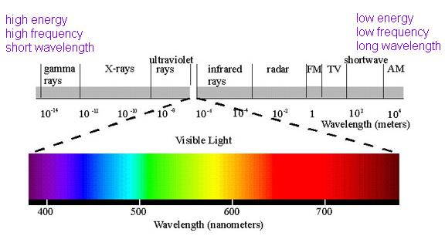

Wave Parameters
- Wavelength (l) length or size of one oscillation
- Amplitude (A) strength of disturbance (intensity)
- Frequency (f) repetition / how often they occur per second
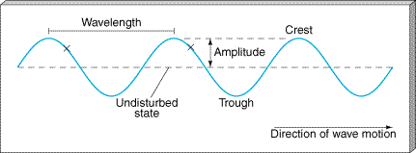

Equations
- Frequency (n) is measured in cycles per second or Hz.
- Wavelength (l) is measured in meters or sometimes nm (n is nano which is 10⁻⁹)
- $\text{νλ}=c$The speed of light (c) is 3.00 x 10⁸ m/s
- Frequency times wavelength equal the speed of light.

Energy in Joules
- $E=hν=h\frac{c}{λ}$c is the speed of light (3 x 10⁸ m/s in a vacuum)
- λ is the wavelength in meters
- n is the frequency in Hertz
- h is Planck’s constant (6.63 x 10⁻³⁴ J⋅s)
- E is the energy of a photon in Joules

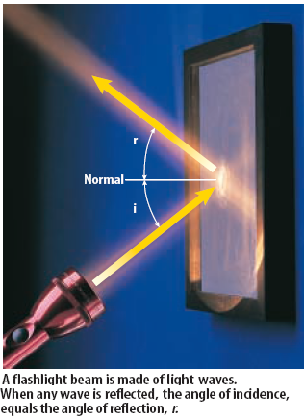
Reflection
- reflection : When a wave bounces off an object and changes direction.
- The angle of incidence equals the angle of reflection (or it can be stated θ_{i} = θ_{r})

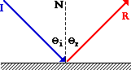


Refraction
- Refraction is the bending of a wave as it passes from one medium to another.
- Refraction at the water surface gives the "broken pencil" effect shown above. Submerged objects always appear to be shallower than they are because the light from them changes angle at the surface, bending downward toward the water

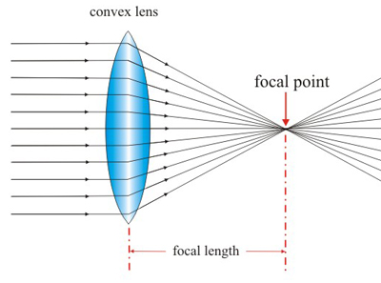
Lenses
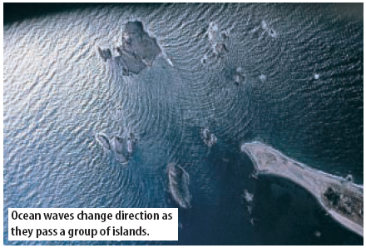
- A lens is a transparent material, such a glass, that has either one curved surface or one flat surface or two curved surfaces. Lenses are either convex or concave. Convex lenses are thicker in the middle then the edges and concave are thicker at the edges then the middle. When light travels through lenses, refraction occurs. The light bends either outward or inward, depending on the lens.

Diffraction
- Diffraction occurs when an object causes a wave to change direction and bend around it.

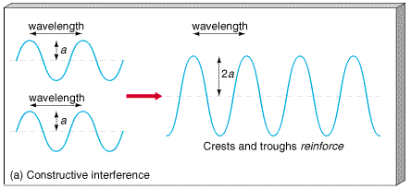
Constructive Interference
- Waves combine without any phase difference
- When they oscillate together (“in phase”)

Destructive Interference
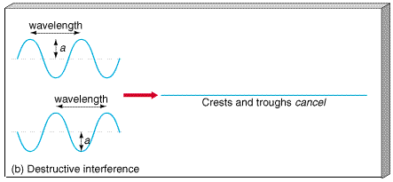
- Waves combine differing by multiples of 1/2 wavelength
- They oscillate “out-of-phase”

Dispersion
- The separation of visible light into its different colors is known as dispersion.
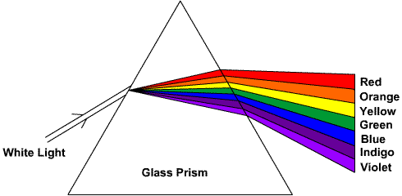

Sound
- Sound is a series of compression waves that moves through air or other materials.
- Sound waves are a longitudinal wave.
- The speed of sound is about 343 m/s which is much slower than the speed of light.
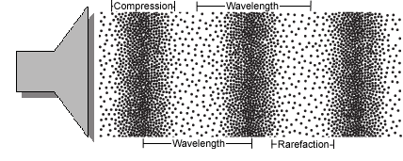
Doppler Effect
The Doppler Effect is the apparent change in frequency detected when the sound is moving relative to the hearer.
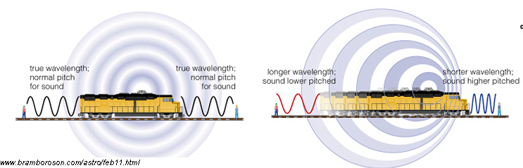
Homework
1. An example of a purely longitudinal wave is a
(A) sound wave (B) light wave (C) water wave (D) wave in a stretched string
2. The property of a sound wave that governs its loudness is its
(A) frequency (B) wavelength (C) speed (D) amplitude
3. The bending of waves around the edge of an obstacle in their path is an example of
(A) refraction (B) reflection (C) diffraction (D) the Doppler effect
4. Of the following kinds of waves, the only ones that cannot travel through a vacuum are
(A) X-rays (B) radio waves (C) light waves (D) sound waves
5. In an electromagnetic wave, the electric field is
(A) parallel to both the magnetic field and the wave direction
(B) perpendicular to both the magnetic field and the wave direction
(C) parallel to the magnetic field and perpendicular to the wave direction
(D) perpendicular to the magnetic field and parallel to the wave direction
6. Light of which of the following colors has the highest frequency?
(A) red (B) blue (C) yellow (D) green
7. Light of which of the following colors has the longest wavelength?
(A) red (B) blue (C) yellow (D) green
8. Which of the following are electromagnetic waves?
(A) radio waves (B) optical light (C) X-rays (D) all of these
9. Which of the following is true about the frequency and velocity of electromagnetic waves?
(A) as frequency increases, wavelength decreases
(B) as frequency increases, wavelength increases
(C) frequency is constant for all wavelengths
(D) frequency and wavelength are independent of each other
10. The property of light waves that leads to the phenomenon of color is
(A) speed (B) amplitude (C) acceleration (D) wavelength
11. What is the wavelength of a radio wave with a frequency of 99.1 MHz?
Answers:
1) A 2) D. 3) C 4) D 5) B 6) B 7) A 8) D 9) A 10) D 11) 3.03 m

