Chapter 9
Periodic Law
The structure of molecules and describing reactions

Homework from the book:
Exercises: 1-6, 8-10, 14-1618-20, 22, 23, 25, 27, 31-37
Questions: none
Problems: 3-5, 8
In the study guide: All the Multiple choice.

In this chapter we will begin by looking at types of matter and then look at how atoms combine to form compounds and then look at how compounds change during chemical reactions.

http://www.community.pima.edu/classes/chm080/class1.htm

Please begin by looking at the above web site and from this site write the definitions of the following terms:

Matter:

Substance:

Element:

Compound:

Mixture:
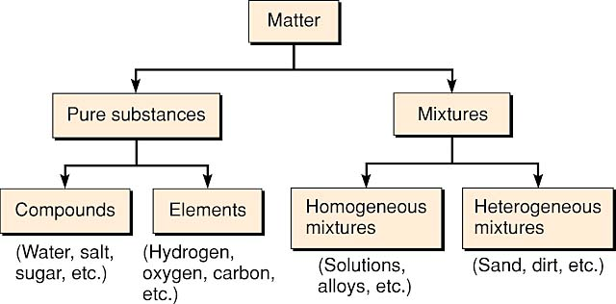
A homogeneous mixture is uniform (all the same) and a heterogeneous mixture is not.

Elements
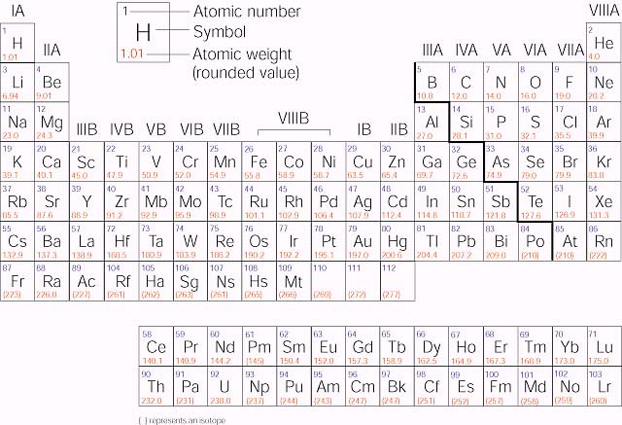
Elements are arranged by reactivity in the periodic table. Elements with similar reactivity are put into the same column or group. Some of these groups have special names. The elements in group IA are called the alkali metals. The elements in group IIA are called the alkaline earth metals. The elements in group VIIA are called the halogens and the elements in group VIIIA are called the noble gases or the inert gases. The metals in group IB (copper, silver and gold) are sometimes called the coinage metals. The columns with B (IB through VIIIB) are called the transition elements. The columns with A (IA through VIIIA) are called the main group elements.

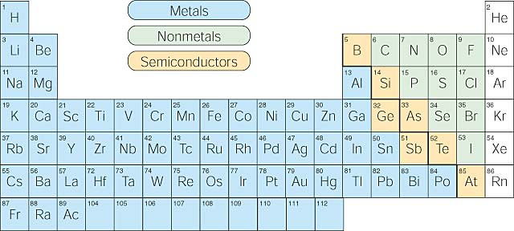

The elements can also be divided into two main groups, the metals and the non-metals. Metals are typically have a metallic sheen (shiny) are malleable (bendable) and conduct electricity. Nonmetals typically do not show these properties. There are some elements that show some, but not all, of the metallic properties. These elements are called metalloids and are labeled here are semi-conductors.

Electrons are the “glue” that hold atoms together in compounds. It is the outer shell electrons that form these bonds between atoms. The first two quantum numbers n (the shell) and l (the subshell) are both important in understanding bonding. In this class we focus on the shell. The shells correspond to the orbits of the Bohr model. (See lecture 10.3)

The first shell is the smallest so it can only hold a maximum of 2 electrons. The second shell can only hold a maximum of 8 electrons. The third shell can only hold a maximum of 18 electrons but is particularly stable at 8 electrons.

Because it is the outer shells that react, we are most interested in the outer shell electrons. We can represent the number of electrons in the outer shell with dots. The outer shell are given the name valence electrons. Officially, the valence electrons are the electrons in the outer shell of the uncharged atom. Chlorine has 7 electrons in its outer shell and so can represent it as a “Cl” with seven dots around it.
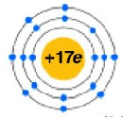 becomes . Notice how 2 electrons in the first shell and the 8 electrons in the second are inner shell electrons and are not written with dots. Here is a chart of the main group elements and their Lewis dot symbols.
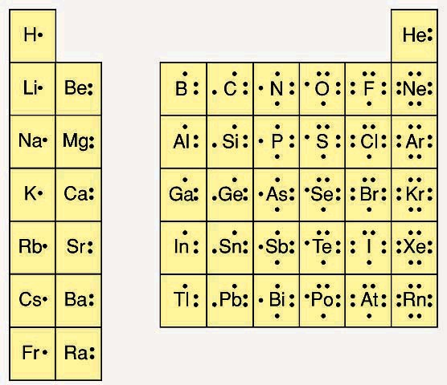

Notice that for the main group elements, the number of valence electrons is equal to the group number.
Making Compounds
To form stable compounds, atoms will combine according to the octet rule.

Octet rule: Atoms in a compound will lose, gain or share electrons in order to achieve a stable, noble gas configuration.

This rule leads to the formation of two kinds of compounds, ionic and covalent.

When a metal combines with a non-metal, the resulting bond is an ionic bond. This is the lose/gain part of the octet rule. The metal loses electrons and becomes positively charged and the non-metal gains electrons and becomes negatively charged. The ionic bond is the force between the oppositely charged particles.

When a non-metal combines with another non-metal they share electrons. These shared electrons keep the atoms together and are a covalent bond.

These rules of thumb are not perfect and there are many exceptions to these rules. For the purposes of this class, these rules will be inviolate.

Covalent bonding

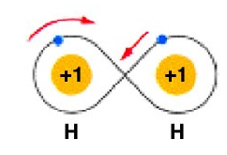
An individual hydrogen atom has 1 electron. The closest noble gas, helium, has 2 electrons. Two hydrogens come together to share their electrons with each other. Each hydrogen now feels like it has two total electrons. Hydrogen exists in its elemental state as H₂, a molecule made of two hydrogens. The Lewis structure for hydrogen can be represented as shown in figure B but often a shared pair of electrons is shown as a dash, as shown in figure C.
Water is another covalent molecule. Notice that both oxygen and hydrogen are non-metals. The formula for water is H₂O, it contains 2 hydrogens and 1 oxygen. The oxygen has 6 electrons in it’s valence shell and the hydrogen each has 1. When the hydrogen and oxygen each share 1 electron with each other, then all the atoms feel like they have a complete set. Elements in the first period, like hydrogen, try to get 2 electrons in their outer shell. Elements in the second period and above, like oxygen, try to get 8 electrons in their outer shell.
The Lewis structure describes what is bonded to what but does not really describe what the molecule looks like. Two descriptions are shown below. The one on the left is a space-filling model and the one on the right is a ball and stick description. 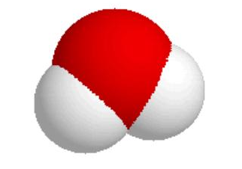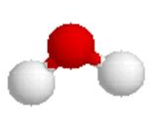

Like hydrogen, oxygen exists in its elemental state as a diatomic molecule. Each oxygen has 6 electrons and so need to share to more and so makes two bonds with the other oxygen. This is called a double bond.
Nitrogen forms a triple bond. The nitrogens are sharing 6 electrons, 2 in each bond.

For an interesting discussion on covalent bonding, please go to the following web site. In particular, the discuss bond polarity.

http://edie.cprost.sfu.ca/~rhlogan/covalent.html

Ionic Compounds
Please watch the animation 9.3 on your CD.
When a metal combines with a non-metal, the resulting bond is an ionic bond. The metal loses electrons and becomes positively charged and the non-metal gains electrons and becomes negatively charged. Positively charged ions are called cations, negatively charges ion are called anions.

Ionic bonds are formed between anions cations. It is the electrostatic attraction between opposite charges.

In sodium chloride, the sodium (symbol Na) loses an electron and becomes positively charged in its ionic state. All the metals in group I are +1 in their ionic state. All the metals in group II are +2 in their ionic state. You can find the charges of various metals in the chart below.

The chlorine (Cl) will gain an electron and becomes negaitvely charged in its ionic state. All the elements in group VII are -1 in their ionic state. All the metals in group VI are -2 in their ionic state. You can find the charges of various non-metals in the chart below.

Charges of some Common Monatomic ions
H
1+
1-
Li  1+ | Be  2+ |  |  |  |  |  |  |  |  |  |  |  |  | N  3- | O  2- | F  1-
Na  1+ | Mg  2+ |  |  |  |  |  |  |  |  |  |  | Al  3+ |  | P  3- | S  2- | Cl  1-
K  1+ | Ca  2+ | Sc  3+ | Ti  3+  4+ | V  3+  4+ | Cr  2+  3+ | Mn  2+  3+ | Fe  2+  3+ | Co  2+  3+ | Ni  2+  4+ | Cu  1+  2+ | Zn  2+ |  |  |  |  | Br  1-
Rb  1+ | Sr  2+ |  |  |  |  |  |  |  | Pd  2+  4+ | Ag  1+ | Cd  2+ |  | Sn  2+  4+ |  |  | I  1-
Cs  1+ | Ba  2+ |  |  |  |  |  |  |  | Pt  2+  4+ | Au  1+  3+ | Hg  2+  * |  | Pb  2+  4+
Fr  1+ | Ra  2+

Please note that many of the metals shown here can have more possibilities that I can show here. Vanadium, for example, can be 2+, 3+, 4+ or 5+. I have only shown the more common charges.

*Mercury can be 1+ in the polyatomic ion Hg₂²⁺.

Polyatomic ions
There are groups of covalently bound atoms that act like a single ion. An OH has a negative charge and will combine with one sodium ion like a chloride ion. A list of these polyatomic ions is shown below.

Polyatomic ions and their names:

Formula | Name
NH₄⁺ | Ammonium
OH⁻ | Hydroxide
NO₃⁻ | Nitrate
NO₂⁻ | Nitrite
CH₃CO₂⁻ | Acetate
CN⁻ | Cyanide
MnO₄⁻ | Permanganate
CO₃²⁻ | Carbonate
HCO₃⁻⁻ | Bicarbonate
SO₃²⁻ | Sulfite
HSO₃⁻ | Bisulfite
SO₄²⁻ | Sulfate
PO₄³⁻ | Phosphate
HPO₄²⁻ | Hydrogen phosphate
H₂PO₄⁻ | Dihydrogen phosphate
SiO₃²⁻ | Silicate
CrO₄²⁻ | Chromate

Formulas of Ionic Compounds
For an ionic compound to be stable, the positive charges have to equal the negative charges. In NaCl, sodium (Na) is +1 and the chloride is –1. In MgO the magnesium is +2 and the oxygen (O) is –2 and so again the charges cancel each other out. Remember the charges come from the chart above.

Can we combine sodium (Na⁺) with oxygen (O²⁻)? Yes! To make a stable compound we need 2 sodiums for every one oxygen.
There is rule for finding the correct formula. In every ionic formula the cation is written first and the anion written second. In the formula, the charge on one becomes the subscripts of the other.
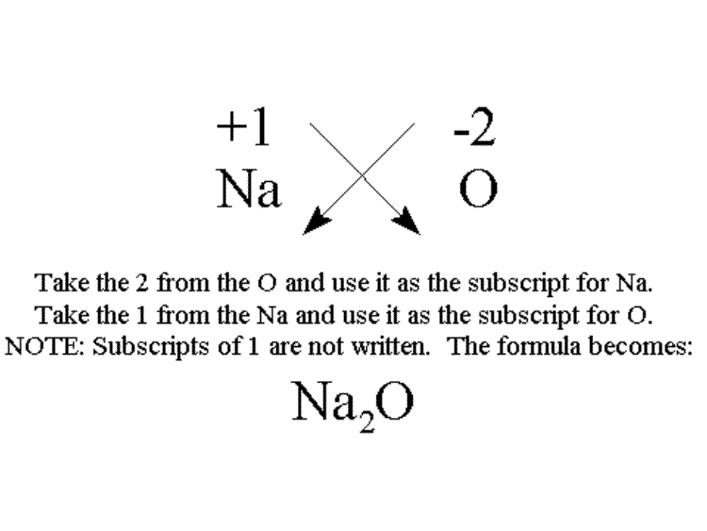
The only corollary to this is that if you can divide both subscripts by an integer greater than one, you must do so. For example, Mg²⁺ and O²⁻ do not form Mg₂O₂ but MgO.
This works for many compounds.

Ba⁺² Cl⁻ | becomes | BaCl₂  _{barium chloride}
Al⁺³ O⁻² | becomes | Al₂O₃  _{aluminum oxide}
Ca⁺² N⁻³ | becomes | Ca₃N₂  _{calsium nitride}
K⁺¹ P⁻³ | becomes | K₃P  potassium phosphide

Please go to this site for more information on writing formulas. http://www.scidiv.bcc.ctc.edu/wv/4/0004-0010-formula-ionic.html

Naming Binary Ionic Compounds
Rules for naming simple ionic compounds.

- Name the metal by its elemental name.
- Name the nonmetal by its elemental name and an -ide ending.
- Name metals that can have different oxidation states using roman numerals to indicate positive charge.
Example Fe²⁺ is Iron(II)
(See table “Charges of some Common Monatomic ions” to determine which metals can have more than one positive charge.)
- Name polyatomic ions by their names.

Examples
Cation | Anion | Formula | Name
Al³⁺ | Cl⁻ | AlCl₃ | Aluminum chloride
Ca²⁺ | OH⁻ | Ca(OH)₂ | Calcium hydroxide
Fe³⁺ | O²⁻ | Fe₂O₃ | Iron(III) oxide

Please check your understanding by playing a quick naming game at the following site:
http://www.quia.com/jg/65800.html

Naming Binary Covalent Compounds
There are many other naming schemes. There are naming schemes for acids, organic compounds and simple covalent compounds. You book covers simple covalent compounds in this chapter probably because it is so similar to the naming scheme for ionic compounds. Remember, ionic compounds are metal combined with a non-metal. A covalent compound is the combination of non-metals.

Rules for naming simple covalent compounds:

- Name the non-metal furthest to the left on the periodic table by its elemental name.
- Name the other non-metal by its elemental name and an -ide ending.
- Use the prefixes mono-, di-, tri-.... to indicate the number of that element in the molecule.
- If mono is the first prefix, it is understood and not written

Examples:
N₂O₄ is called dinitrogen monoxide
CO₂ is called carbon dioxide
CO is called carbon monoxide
N₂O is called dinitrogen monoxide. (It is also called nitrous oxide but that is another naming scheme.)
CCl₄ is called carbon tetrachloride

Here is a chart of those prefixes:
1 - mono | 2 - di | 3 - tri | 4 - tetra | 5 - penta
6 - hexa | 7 - hepta | 8 - octa | 9 - nona | 10 - deca

Chemical Reactions
Substances react to form other substances in chemical reactions. We often identify a chemical reaction because we observe a temperature change, a color change (not just a dilution but a change from say blue to red,) a solid forming or a gas forming. Sometimes chemical reactions occur and we are unable to see it with ours eyes.

When we describe chemical reactions, we show the reactants on the left and the products on the right separated by an arrow.

Chemical reactions do not create enough energy cause a measurable amount of change in mass through the equation E=mc² so mass must remain constant. We are not changing the nucleus so the number of each of elements must remain constant.

In the reaction of hydrogen and oxygen to make water, 2 hydrogens are required to react with one oxygen so that the equation is balanced.

The equation for this reaction is

2H₂ + O₂ -> 2 H₂O

Please go to the following site to work on balancing equations:

http://www.wfu.edu/~ylwong/balanceeq/balanceq.html

Please also do methane, ethane and propane on the Interactive exercises on balancing equations.

