Chapter 2 Notes
Motion

Reading Assignment: Read Chapter the entire chapter.
Homework: see the web site for homework.
http://web.fccj.org/~smilczan/psc/homewkmid.html

From the study guide:
Starting on page 19 All the Multiple Choice and matching.
2.1 Speed and constant velocity.

Speed is the amount of distance something moves versus time. An equation that describes this is $\text{speed}=\frac{\text{distance}}{\text{time}}$ or $v=\frac{d}{t}$ where v is velocity or speed, d is distance and t is time.

We can imagine this equation works well when the speed of something is constant or the speed described is the average speed. When I drive from Jacksonville to Tallahassee my instantaneous speed (that is my speed at any given time) varies from 0 mph to 70 mph. My average speed however is 60 mph.

Notice that we can rearrange the equation to solve for distance (d) or time (t) by using simple algebra.
$d=v×t$ and $t=\frac{d}{v}$

Please notice that the units are consistent and provide a check of your work. For this reason, please include them when doing these and all science problems. Here is a problem:

How long does it take to go the 180 miles from Jacksonville to Tallahassee traveling at an average speed of 60 miles per hour (60miles/hour)?

notice hour the units of hours cancel out and the unit 1/1/hours is the same as hours.
t=180 miles /60 miles/hour

Section 2.2 UNITS

A unit is standard quantity used for measuring. In our everyday life we measure in English units. In science, most measurements are taken in metric units. The metric system uses base units such as the meter (m), liter (l) and the gram (g) for each type of measurement, distance, volume and mass. There are times when the size of the unit is not practical for a purpose. It is impractical to measure my weight in grams. The metric system uses prefixes to create new units. The prefixes are based on powers of ten. Three
common prefixes are
prefix | value | example | example in words
centi- or ‘c’ | 10⁻² or 1/100 | $$\text{1 cm }=\frac{1}{\text{100}}\text{m or 100 cm }=\text{ 1 m}$$
milli or ‘m’ | 10⁻³ or 1/1000 | $$\text{1 ml }=\frac{1}{\text{1000}}\text{m or 1000 ml }=\text{ 1 l}$$
kilo or ‘k’ | 1000 | 1 kg = 1000g | 1 kilogram equals 1000 grams.

2.3 Vectors.

Some measurements require both a value (4.0 miles) and a direction (east). A value that does not have a direction associated with it is called a scalar quantity. A Vector has magnitude (a number representing how big it is) and direction . This book described speed as a scalar quantity (25 mph) and velocity as a vector quantity (25 mph to the east.)

Adding vectors is interesting and can be accomplished graphically or with trigonometric equations. Lets say you had to make a trip from your house to the store but you could not get there directly. You had to travel 4.0 miles east and then 3.0 miles north. You have traveled 7.0 miles but how far is the store by the way the crow flies? Take a ruler. Draw a line 4 inches over. Then draw a line 3 inches perpendicular to that. Measure the line from the starting point (house) to the final point (store) . It should be 5 inches.

Please try the following Vector Addition Demo.
How would you add 12 miles east and 6 miles north?

2.4 Acceleration.
Acceleration is defined as the rate of change of velocity. . When an object is moving faster there is a positive acceleration and when it is moving slower there is a negative acceleration. Because velocity is a vector quantity, acceleration is also a vector quantity. Acceleration occurs when an object changes direction. The SI unit for acceleration is m/s/s or m/s². Acceleration can be described by the following :
$$a=\frac{v_{f}−v_{i}}{t}$$
where v_{f} is the final velocity and v_{i} is the initial velocity. The change in time is usually expressed as simply t because you assume that the initial time was zero. Some definitions follow:

Uniform acceleration
constant, unchanging acceleration; when an object is uniformly accelerated, the speed of the entire time interval that the acceleration occurred over can be represented by the average velocity of that time interval.
Variable acceleration
Non-uniform acceleration. For our purposes, we assume that acceleration is uniform.
Positive acceleration
velocity of object increases
Negative acceleration (or deceleration)
velocity of object decreases
Average acceleration
the change in velocity divided by the time taken to make this change
Acceleration due to gravity (or g)
equal to –9.80 m/s².

In the cow applet, set the initial velocity to 3 and the initial acceleration to 0. Draws the graphs of distance vs time and velocity vs time below.

Now try the v=3 and acceleration = 2.

The Big Six: Six equations to describe motion.

$$d=v_{\text{ave}}⋅t$$
v_{f} = v_{i} + a t
d = v_{i}t + ½ a t²
v_{f}²= v_{i}² + 2 a d
$$a=\frac{v_{f}−v_{i}}{t}$$
$$v_{\text{ave}}={\left(v_{i}+v_{f}\right)}/2$$

2.5 Free Fall
Objects will fall to the earth with an acceleration of 9.8 m/s². It doesn’t really matter what size the object is or how much it weighs as long as we ignore air resistance. It does not matter how fast the object is moving along the earth’s surface. That is to say any motion in the x direction has no effect on the motion in the y direction.
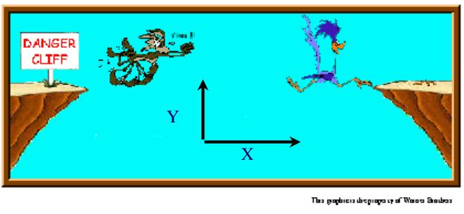

Cannonballs show a parabolic motion because they have a speed in the x direction that propels them forward. Their speed in the y direction is counteracted by the pull of gravity. Eventually they stop moving up and move toward earth accelerating toward earth at 9.8 m/s². Please play with the following demo and note that there is a optimum angle to get the maximum distance.

2.6 Air Resistance

A cannonball has another force slowing it down. It is the result of air resistance. The molecules in the air act with a frictional force slowing the object down in both the x and y direction. The faster the object is moving the more the frictional force.

For a person jumping out of an airplane, it might seem like they will continue to accelerate toward earth at 9.8 m/s² until the splatter their brains on the surface. At some point, the skydiver’s air resistance (frictional force) equals that of the gravitational force and the speed at which they are moving is called the terminal velocity. Of course, they further slow themselves down with a parachute.

2.7 and 2.9 and 2.11 Force and Newton’s laws.

A Force is a push or a pullon an object. The symbol for force is F; SI unit is the Newton, N. One Newton is defined as the force necessary to cause a one-kilogram mass to accelerate at the rate of 1 m/s². 1 N = 1 kg m/s²

Newton’s first Law: Unless an outside force is acting on in, an object at rest remains at rest, and an object in motion remains in motion. The at rest part is kind of obvious, my pencil does not suddenly fly across my desk unless I push it. If I push my coffee cup across the table it comes to a stop, why? The force acting on it is the force of friction.

Newton’s Second Law: An unbalanced force (or net force) causes an object to accelerate; this acceleration is directly proportional to the unbalanced force and inversely proportional to the object’s mass; called the law of acceleration
a = F / m or F = m a

Inertia: a measure of how an object resists changes in motion; it is a measure of an object’s mass.

Newton’s Third Law – When one object exerts a force on another object, the second object exerts a force on the first object that is equal in magnitude, but opposite in direction; for every action, there is an equal, but opposite reaction; called the law of action-reaction. In the following case, if you push a table, what keeps you from moving? It is the friction force acting against the table pushing back on you. The friction comes from the rubber on your shoes. If you wear socks or are standing on ice, you lose a lot of friction and it may be that you are what moves!

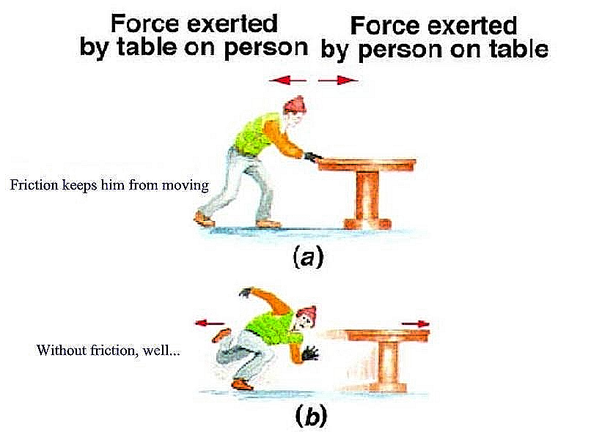
2.12 Circular motion.
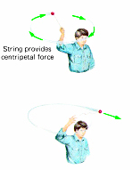
Imagine you are twirling a ball on a string around your head. If the string suddenly broke the ball would go flying off in a straight line. The string then, is acting as some kind of force that we will call the centripetal force. The centripetal force on an object moving in a curved path is the inward force that must be exerted to produce this motion. It always acts toward the center of curvature of the object's path.

The earth revolves around the sun. What keeps the earth from flying away? The force of gravity of the earth and the sun provide that centripetal force.

The equation for centripetal force is;
$$F_{c}=\frac{{\text{mv}}^{2}}{r}$$

Examining this equation we note that increasing the mass or velocity increases the centripetal force required to maintain the circular motion. Decreasing the radius will also increase the centripetal force required to maintain the circular motion. This can have some important consequences for driving a car.

2.13 Newton’s Law of Gravity:
Gravitational force -an attractive force that exists between all objects with mass; an object with mass attracts another object with mass; the magnitude of the force is directly proportional to the masses of the two objects and inversely proportional to the square of the distance between the two objects.
Stated mathematically:
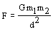
Where G is the universal gravitational constant (meaning it has the same value throughout the universe), m₁ and m₂ are the masses of the objects in kilograms, and d is the distance between them in meters
G = 6.67 x 10⁻¹¹ N m² / kg²
Cavendish found the universal gravitation constant, allowing the earth to be "weighed." As we examine this equation we can note that the larger the masses, the larger the gravitational force. The farther apart the masses are the smaller the force. Because the force is proportional to 1/d², If we double the distance between two masses, the gravitation force is not halve but 1/4 of the original value. The other thingto note is the distances are based on the center of the mass (center of gravity) and so even though I am standing on the earth, I an quite a distance from the earth’s center. (R=6400 km or 3980 mi.)

2.10 Mass and Weight
Mass is the property of matter that manifests itself as inertia and may be thought of as the quantity of matter in the body. The unit of mass is the kilogram (kg). The corresponding English unit is the pound.
Weight is the force of gravity upon the mass. When asked for our weight, we typically respond with our mass (73 kg) because the force of gravity is pretty much the same everywhere on earth. The real units for weight are the Newton N. ( My real weight would be 73 kg *9.8m/s²). Remember F=ma.

