The Scientific Method.

Why do Scientists do what they do?
Over the years, I think that the answers seem to fall into two categories:

It is my personal opinion that the structure of science is better suited for the latter but as I discuss the scientific method, you be the judge.

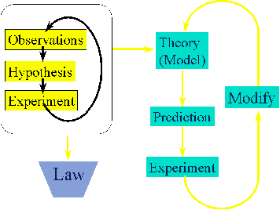
Figure 1: A graphical view of the Scientific method.

The scientific method involves a cyclic process of observation, hypothesis and experimentation. Lets begin with these three.

- Observation:

- Hypothesis:

- Experiment

- Theory

- Law:

If an experiment is consistent with the hypothesis then the explanation becomes a theory. A behavior that has been observed innumerable times is called a natural law. A theory may be tested many times and involve modification or it may have to discarded entirely if experiments show it to be inconsistent with observed behavior. Theories are useful to us because they have predictive power and so therefore allow us to make something useful. The philosophical question is, “If these theories are consistent with what we see, is that a truth about the world?”

One of the interesting aspects of science is that one theory often builds on another. The more a theory has been tested, the more faith we put in to it. After a while we pretend it is the “truth”, but how do we know for sure? In this class we will say that the shape of water is bent. We are using many theories in this discussion. We are presupposing that atoms exist. The existence of molecules uses theories and laws of physics such as the laws of electrostatic attraction and the laws of motion and the theories of the existence of subatomic particles such as electrons and protons.
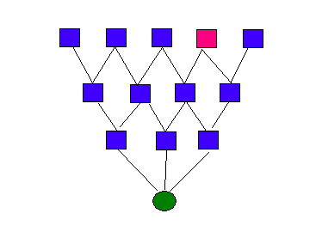
Figure 2: A pictorial description of a theory (green) and its relationship to the other theories that it builds on (blue). What if one of them was wrong (red)?

What if one of the underlying theories is wrong? What if atoms do not exist does the fact that we expect allow us to find them? What if we are just a giant computer simulation?

