Chapter 10
This chapter begins to answer the questions: So now that I now what atoms and molecules look like, how do these structures translate into what I see in the world around me.

Reading Assignment: Read the entire chapter.
Homework: see the web site for homework.
http://web.fccj.org/~smilczan/psc/Homework7_11.htm

Solids, Liquids and Gases
We have already covered these phases of matter. See online section 5.2

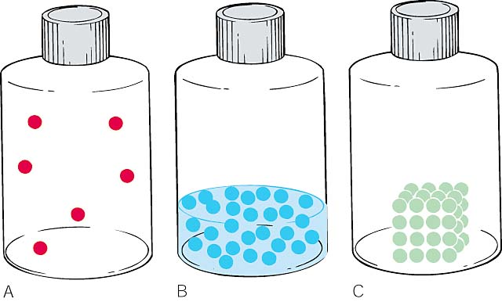
(A) In a gas, the molecules are not held together art all so a gas dispenses throughout a container, taking the shape and volume of the container.
(B) In a liquid, the molecules are attracted to each other enough to maintain a volume. The molecules can move past each other so the liquid takes the shape of the container.
(C) In a solid, the molecules are so strongly attracted to each other the molecules cannot move past each other. In a solid, a molecule’s neighbors do not change. A solid retains its own shape and volume.

We will begin by looking at various types of solids. Please read about amorphous solids at http://www.britannica.com/eb/article?eu=119054

Ionic solids

Ionic compounds are the combination of cations and anions. In table salt, sodium chloride, sodium is the cation (Na⁺) and chloride is the anion (Cl⁻). In the crystal structure, the anion (Cl⁻) and the cation (Na⁺) form a regular pattern alternating back and forth. In the 2 dimensional picture below we can see that each sodium ( Na⁺ ) is surrounded by chlorides(Cl⁻). The crystal is held together by electrostatic attraction.
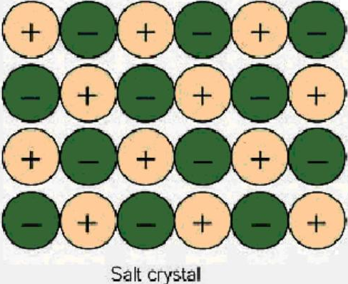

This pattern holds true for three dimensions as well. Because of this, each sodium ion, is surrounded by six chlorine ions, and each chlorine ion is surrounded by six sodium ions.

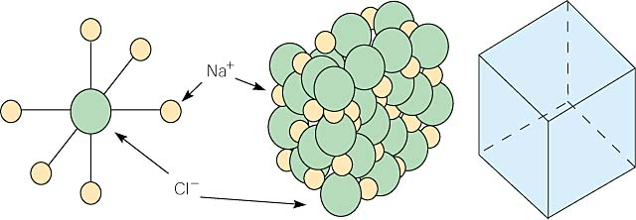

A crystal builds up like this, giving the sodium chloride crystal a cubic structure. This cubic structure is reflected in the cubic shape of salt crystals. This is why the salt crystals form angles of 90°.

You can clearly see the cubic structure in the ordinary table salt crystals.

Not all crystal structures have a cubic repeating unit. Some are hexagonal such as gold, quartz (SiO₂) or water. The shapes of the unit cells will affect the shapes of the crystals. Many of you may have quartz crystals at home. Look at your crystals. The crystal probably shows angles of 120°. This is a reflection of the 120° angles in the crystal.

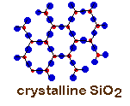

Metallic Crystals
In pure gold, the atoms bond to each other forming a repeating unit similar to the ionic crystals.
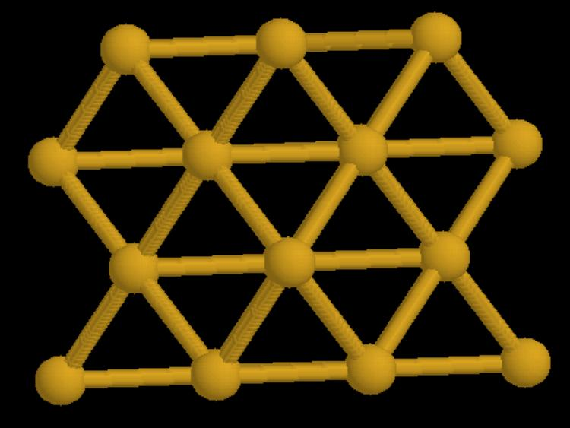
(from http://www.tulane.edu/~inorg/Solid%20State%20Structures.html)

Because all the atoms in this crystal are the same, metallic crystals pack efficiently and tend to be fairly dense. The outer shell electrons in a metallic crystal tend to be delocalized, that is they are loosely bound to their nuclei. Metal atoms can be thought of as an array of positive ions immersed in a sea of delocalized valence electrons. The ability of the electrons to move in the crystal accounts for the ability of the metal to conduct electricity.

Covalent crystals

In the diamond, each of the carbons is bonded to four other carbons by covalent bonds. This creates a huge structure. You can look at the whole structure at http://www.recipnet.indiana.edu/common/Minerals/diamond/diamond.htm.
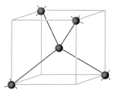 This unit cell builds to a more intricate structure seen below. The exceptional strength is due to the strength of the covalent bonds.

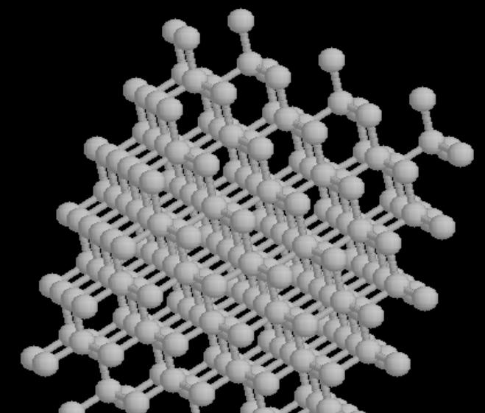

Molecular crystals.

Water can form crystals. How? The H₂O molecule is stable. The answer lies in the polarity of the bonds. Oxygen and hydrogen do not share the electrons equally. The oxygen has a greater pull on the shared electrons than the hydrogen. The extra electron density creates a partial negative charge on the oxygen and a this leaves a partial positive charge on the hydrogen. In the picture below, please notice that the solid bonds are the covalent bonds and the dashed bond is the bond between molecules. This particular intermolecular bond is called a hydrogen bond. A hydrogen bond is much weaker than a covalent or ionic bond but it is the strongest of the intermolecular bonds.

When water is a solid, hydrogen bonds form to make a regular pattern of water molecules. We can see, however it is much easier to break these hydrogen bonds than the covalent bonds in the diamond crystal. Even the heat above 0°C can break enough of the the hydrogen bond to break down ice into water.

Please watch animation 10.1 (Polarity of water) on your CD!

There are other intermolecular bonds such as dipole-dipole and induced dipole-induced dipole. These intermolecular bonds (Hydrogen bonding, dipole-dipole and induced dipole-induced dipole) are called van der Waals forces.

Please go to the following web site to review the special properties of water.
http://www.biology.arizona.edu/biochemistry/tutorials/chemistry/page3.html

Solutions.

A solution is a mixture in which one substance, called the solute is uniformly distributed in another substance called the solvent. The most common solvent in our everyday life is water. Some examples of solutions are Kool-Aid, cranberry juice, vodka and saline solution. Solutions are typically clear (although they may be colored) and homogeneous (all the same). My cherry Kool Aid is a clear red solution. In this solution the solvent is water and the solutes are sugar, artificial flavor and the artificial color. Another interesting property of solutions is that different concentrations can be made. As all of you are aware, you can make very sweet Kool Aid and less sweet Kool Aid.

When the solute particles get big enough so that they refract light, the solution is called a colloid. Milk is an example of a colloid. When the particles get big enough to be removed with ordinary filter paper (coffee filters) then the mixture is a suspension. Suspensions tend to settle on standing. Liquid “Kaopectate” and “Milk of Magnesia” are suspensions.

The solubility of a substance is the maximum amount of solute that dissolves in a given amount of solvent at a given temperature. A solution that is below the maximum is described as unsaturated and a solution at the maximum is described as saturated. A unstable condition can exist where there is more than the maximum amount of solute in the solvent, this is called supersaturated.

Increasing the temperature tends to increase the solubility of a solid in water and tends to decrease the solubility of a gas in water.

Please read about making rock candy at http://www.beakman.com/rock-candy/rock-candy.html . When making the candy, you increase to temperature to increase the solubility of the sugar in the water. The sugar is saturated at the high temperature. When the solution cools the solution is supersaturated in sugar and slowly the excess sugar crystallizes into rock candy leaving a saturated solution at the lower temperature.

The concentration of a solution is the amount of solute divided by the amount of solution. The units for these amounts vary depending on the units of concentration. It is a measure of the amount of solute per volume of solution. A weight by weight percent is grams of solute per 100 grams of solution. A 2 % sugar solution has 2 grams of sugar per 100 grams of solution. (This might be considered parts per hundred.)

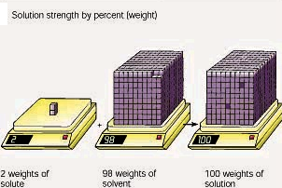

Scientists often use parts per million. This is grams of solute per million grams of solution. Concentration is also measured in molarity, which is moles of solute divided by liters of solution. You may remember that moles are proportional to number of molecules. You may calculate these concentrations using the equations below.
$$w/w\text{\%}=\frac{\text{grams}\text{of}\text{solute}}{\text{grams}\text{of}\text{solution}}×\text{100}$$

$$\text{ppm}=\frac{\text{grams of solute}}{\text{grams of solution}}×1,\text{000},\text{000}$$

$$\text{molarity}=\frac{\text{moles of solute}}{\text{liters of solution}}$$

How does water dissolve salts?
When table salt, sodium chloride, dissolves in water, it dissociates into its respective cations and anions, Na⁺ and Cl⁻. How does water stabilize the Na⁺? It uses the partially negatively charged oxygen side. One oxygen from the water cannot stabilize the Na⁺ alone, but several oxygens from different waters can surround the Na ⁺ and their combined partial negative charges can stabilize the Na⁺. The chloride is stabilized in the same way by the partially charges hydrogen side of the waters. Please examine the picture below.

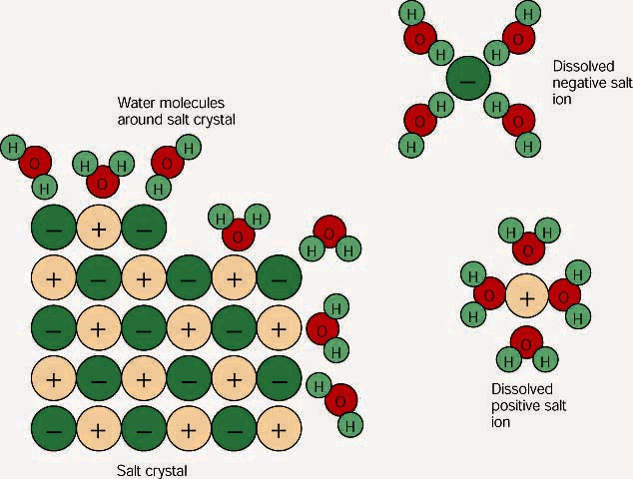

These free ions in a salt-water solution allow electricity to flow through water. Ionic compounds such as sodium chloride, that dissolve in water and dissociate to form ions, are called electrolytes.

Please Watch animation 10.3 on ionic solutions.

Why oil and water do not mix.

Liquid water is held together by hydrogen bonds. (Liquid water has fewer hydrogen bonds than ice.) Oils and fats not have any polar part and so for them to dissolve in water they would have to break some of water’s hydrogen bonds. Water will not do this so the oil is forced to stay separate from the water.
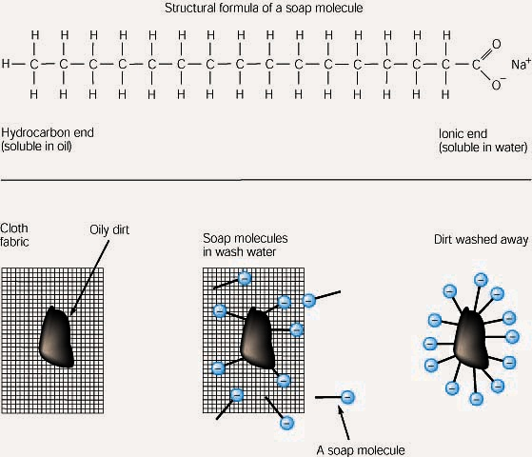
Soap cleans oil and grease because one end of the soap molecule is polar and so is soluble in water, and the other end is non-polar and so similar to oil and grease. The soap molecules surround the grease leaving the water-soluble parts on the outside so the water can help wash the grease away. Thus, the soap molecule provides a link between two substances that would otherwise be immiscible.
Please Watch animation 10.2 on polar and non-polar solutions..
Acids and Bases
There are more than one set of definitions for acids and bases. The most common definitions involve a H⁺ or a proton. A proton cannot exist by itself in water and so it reacts with water to form H₃O⁺ (H⁺ and H₂O). Since the solvent is almost always water, every time you see H⁺, realize it is really H₃O⁺. The Arrhenius definitions of acids and bases are as follows:

An acid is a substance that makes H⁺ (or H₃O⁺) when dissolved in water. An example of an acid is HCl that splits up in water to form H⁺ and Cl⁻. HCl is a strong acid because it completely dissociates. Acetic acid is a weak acid. Only a fraction of acetic acid dissociates into H⁺ and the acetate ion.

A base is a substance that makes OH⁻ when dissolved in water. An example of a base is NaOH that splits up in water to form Na⁺ and OH⁻. NaOH is a strong base because it completely dissociates. Ammonia (NH₃) is a weak base. Avery small amount of the ammonia reacts with water to form ammonium hydroxide.

For more information on acids and bases please look at the following web site:
http://www.science.ubc.ca/~chem/tutorials/pH/index.html

Acids and bases react to form water. The H⁺ from the acid reacts with the OH⁻ from the base to form water. HCl reacts with NaOH to form salt and water.

Acids and bases can react with other things including metals such as aluminum.

The pH scale

Water auto-ionizes to form a small amount of H⁺ and OH⁻. In pure water the H⁺ concentration equals the OH⁻ concentration. In water the concentrations of H⁺ and OH⁻ are in a delicate balance, if we increase H⁺ concentration the OH⁻ will decrease. If we increase OH⁻ concentration the H⁺ will decrease. Look at the chart below.
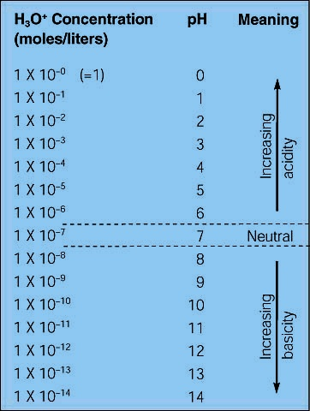

In pure water, the H⁺ concentration is 1x 10⁻⁷. As we add an acid the H⁺ concentration will increase and the pH will decrease. The pH is defined as the negative log of the H⁺ concentration. As we add base the H⁺ concentration will decrease and the pH will increase.
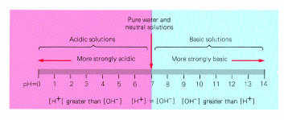
In an acidic solution the H⁺ concentration is greater than the OH⁻ concentration. In a basic solution the OH⁻ concentration is greater than the H⁺ concentration.

