Work and Energy

Reading Assignment: Read the entire chapter.
Homework: see the web site for homework.
http://web.fccj.org/~smilczan/psc/homewkmid.html

3.1 Work
The word “work” has a variety of meanings in everyday language: effort, labor, employment, or task. In physics, work has a specific meaning; work done by a constant force on an object is defined to be the product of the magnitude of the applied force times the distance through which the force acts. In an equation:
$$W=\text{force}×\text{distance or }W=F×d$$
In situations where the force is not parallel to the distance traveled, we use only that part of the force that is parallel. The equation then becomes:
$$W=F_{\text{par}}×d$$
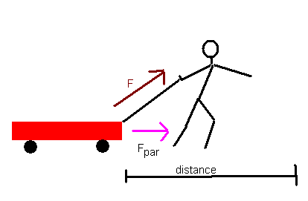We can see the difference if we think about a boy pulling a little red wagon. We exert a force across the ground and up. It is only the force across the ground that counts in the determining the work.
The unit for work is the Joule or J. Since the unit for force is the newton (N) and the unit for distance is the meter (m) it is not surprising that 1 J is equal to 1 a newton-meter (N•m).
$$W=F×d\text{ so 1 Joule}=\text{1 newton }×\text{meter}$$

3.2 Power
Power is the rate at which work is being done or the rate at which energy is transformed.
$$\text{power }=\frac{\text{work}}{\text{time}}\text{ or }P=\frac{W}{t}$$
Its unit for power is the watt (W), which is a joule/sec. The power of a horse is how much work it can do per unit time and one of the British units for power a horsepower. One horsepower is equal to _______.

3.3 & 3.4 Energy, Kinetic and Potential

Energy is the ability to do work. The unit of energy is the joule the same unit as work. There are two major categories of energy in classical mechanics, kinetic and potential energy.

Kinetic energy is the energy of motion. An object in motion is capable of doing work. Kinetic energy is ½ mass times velocity squared or:
$$\text{KE}=\frac{1}{2}{\text{mv}}^{2}$$
Certainly you can imagine that Tony Boselli (lineman for the Jaguars) running has energy. Tony weighs twice what I weigh. If Tony and I were running along at the same speed, he would have twice the energy of me. For us to have the same energy, I would only need to need to run not twice as fast but 1.4 times as fast (the square root of 2.)

How much energy does Tony Bosselli (320lbs, 145 kg) have running at 4.00 m/s (9 miles per hour)?

Potential energy is the energy due to an object's position or configuration. Energy can be stored for later use in the form of potential energy. The mathematical formula for the potential energy depends upon the type of force involved. A common example of potential energy is the force of gravity that can give a mass potential energy by virtue of its ability to fall.
The potential energy of a mass due to gravity can be calculated by the work equation. It can be described as the work it can do or the work required to lift the object.

$\text{W }=\text{ F}×\text{d but the equation for gravitational force is F}=\text{ma where a}=g=9\text{.}{\text{8 m/s}}^{2}$ so..
$$W=\text{ mgh where m is mass in kg, g is 9}\text{.}{\text{8 m/s}}^{2}\text{ and h is the height of the object}\text{.}$$
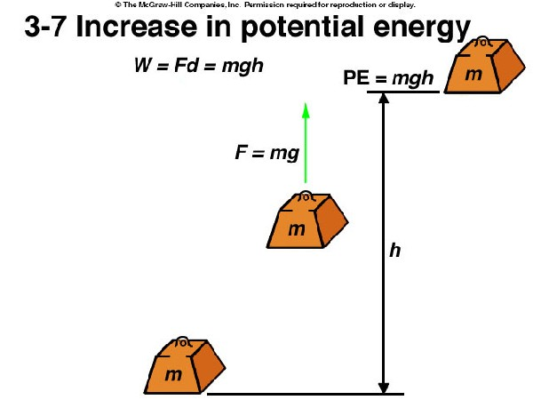

3.6 & 3.7 The Law of Conservation of Energy.
According to the law of conservation of energy, energy cannot be created or destroyed, although it can be changed from one form to another. KE + PE = constant. A simple example involves a stationary car at the top of a hill. As the car coasts down the hill, it moves faster and so it’s kinetic energy increases and it’s potential energy decreases. On the way back up the hill, the car converts kinetic energy to potential energy. In the absence of friction, the car should end up at the same height as it started.
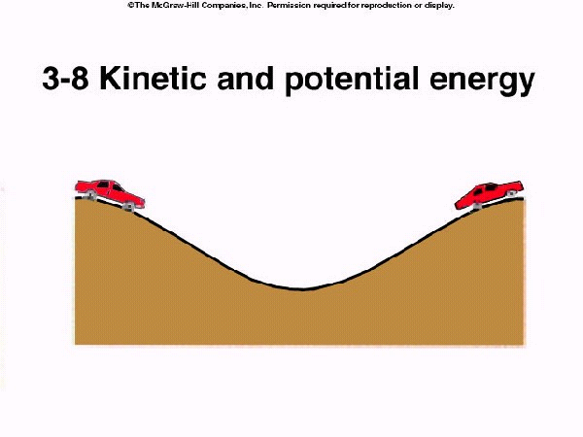
This law had to be combined with the law of conservation of mass when it was determined that mass can be inter-converted with energy.

One can also imagine the energy transformation in a pendulum. When the ball is at the top of its swing, all of the pendulum’s energy is potential energy. When the ball is at the bottom of its swing, all of the pendulum’s energy is kinetic energy. The total energy of the ball stays the same but is continuously exchanged between kinetic and potential forms. The CD from the book has a great animation for this.
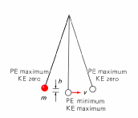
Forms of Energy
There are 7 forms of energy that I am aware of:
- Mechanical

- (light)
- (heat)

- Nuclear

We see transformations between these forms in our everyday life. In our car we use the stored chemical energy in the gasoline and convert that to the kinetic-mechanical eneegy of moving us to our school or job. We may also convert some of that chemical energy to radiant energy (lights) and thermal energy (heat).

3.8 Linear Momentum.
Momentum is a measure of how hard it is to stop a moving object; it is the product of the object's mass and its velocity; since velocity is a vector, momentum is a vector
Quantity. The symbol for momentum is p and SI units are either N sec or kg m/sec. The direction of the momentum is the same as that of the velocity.

p= m v

where p is momentum, m is mass in kg, and v is velocity in m/s

High mass objects can have low momentum when they have low velocities; low mass objects can have high momentum when they have high velocities. The more momentum an object has, the harder it is to stop.

How can we relate momentum and force? The rate of momentum of a body is proportional to the net force applied to it. $F=\frac{Δp}{Δt}$
Conservation of Momentum.
In the absence of outside forces, the total momentum of a set of objects remains the same no matter how the objects interact with one another.
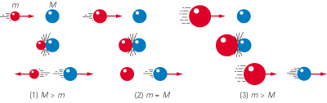
Lets examine the three possibilities shown in the picture above. In the first case, a small mass hits a large mass. Think about me hitting Tony Boselli. The second case is familiar to those who play pool. In the second case, the masses are the same. The third case shows a large mass hitting a small mass.

Try the applet at this web site for experimentation. Note they use an air track so friction can be ignored.
http://www.msu.edu/user/brechtjo/physics/airTrack/airTrack.html

3.10 Angular momentum.
For a single particle, the angular momentum vector is defined by
$$F≡r×p$$
where r is the radius vector and p is the momentum. If the velocity is perpendicular to the radius vector, then
$$L=\text{mvr}$$
One can see that for momentum to be conserved that , keeping the mass the same, if the radius were decreased then the velocity will increase.
Enjoy one of the two following applets to show that when the radius is increased then velocity _______.

http://liftoff.msfc.nasa.gov/academy/rocket_sci/orbmech/angular_momentum.html
http://webphysics.ph.msstate.edu/jc/library/9-7/index.html

3.11-3.13 Einstein and Stuff

Special Relativity: Einstein’s special theory was based on two postulates
- The physical laws are the same in all inertial frames of reference.
- The speed of light in a vacuum is constant for all observers, regardless of the motion of the source or the observer.
This second law contradicts what we are used to observing. If you and another car are moving toward each other and you are both going 50 miles an hour, from your frame of reference, the car coming at you is moving at 100 mph. On the other hand if you are both going down Beach Blvd in the same direction, from your frame of reference, the other car is standing still.

What Einstein said was that no matter how fast you are moving, light always moves at the same speed relative to you (3x10⁸ m/s). The result of this is that the speed of light becomes the upper limit to speed.

If that is true, what would happen to a rocket as it approached the speed of light. We are still applying a force, what happens to counteract this force. The answer is that the mass increases. The equation for mass is $m=\frac{m_{0}}{\sqrt{1−v^{2}c^{2}}}$. The result of this equation is that as you approach the speed of light, the mass becomes infinitely heavy.
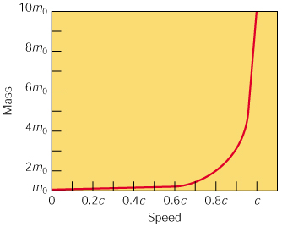
FIG. 3-19 The relativity of mass. The greater the speed of an object relative to an observer, the greater the object's mass appears to the observer. This effect is conspicuous only at speeds near the speed of light c, which is 3 x 10⁸ m/s, about 186,000 mi/s.

Notes from http://www.ncsa.uiuc.edu/Cyberia/NumRel/GenRelativity.html

In 1916 Einstein expanded his Special Theory to include the effect of gravitation on the shape of space and the flow of time. This theory, referred to as the General Theory of Relativity, proposed that matter causes space to curve.
One way of thinking of the curvature of space-time was elegantly described by Hans von Baeyer. In a prize-winning essay he conceives of space-time as an invisible stream flowing ever onward, bending in response to objects in it s path, carrying everything in the universe along its twists and turns.

This is a basic postulate of the Theory of General Relativity. It states that a uniform gravitational field (like that near the Earth) is equivalent to a uniform acceleration.
What this means, in effect, is that a person cannot tell the difference between (a) standing on the Earth, feeling the effects of gravity as a downward pull and (b) standing in a very smooth elevator that is accelerating upwards at just the right rate of exactly 32 feet per second squared.
In both cases, a person would feel the same downward pull of gravity. Einstein asserted that these effects were actually the same. A far cry from Newton's view of gravity as a force acting at a distance!
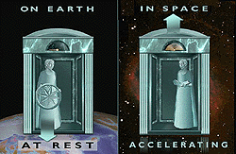

Please remember that you are responsible for what is in the book not covered in the lecture. The CD has an excellent animation for rockets and you can read about energy reserves on your own.

