Notes Chapter 4

Reading Assignment: Read the entire chapter.
Homework: see the web site for homework.
http://web.fccj.org/~smilczan/psc/homewkmid.html

Liquids Solids and Gases:
This chapter begins the first where we will look at matter on a microscopic scale. Matter is made of small particles of atoms or molecules. There are three common states of matter, solid, liquid and gas. A gas and a liquid will change shape to fit the shape of their container. A gas will change volume to fit the volume of the container.

 | Definite shape | definite volume
solid | yes | yes
liquid | no | yes
gas | no | no

In general, solids are denser than liquids, which are denser than gases. . The particles in the solid are touching with very little space between them. The particles in a liquid usually are still touching but there are some spaces between them. The gas particles have big distances between them.

Solid – In a solid, the attractive forces keep the particles together tightly enough so that the particles do not move past each other. Their vibration is related to their kinetic energy. In the solid the particles vibrate in place.

Liquid – In a liquid, particles will flow or glide over one another, but stay toward the bottom of the container. The attractive forces between particles are strong enough to hold a specific volume but not strong enough to keep the molecules sliding over each other.

Gas – In a gas, particles are in continual straight-line motion. The kinetic energy of the molecule is greater than the attractive force between them, thus they are much farther apart and move freely of each other. In most cases, there are essentially no attractive forces between particles. This means that a gas has nothing to hold a specific shape or volume.
(A fourth state of matter, called plasma, exists when a gas becomes ionized. Plasma exists inside stars and in interstellar gases.)

Temperature is a measure of the average kinetic energy of a molecule or atom. It is related to ½ mv² where m is the mass of the particle and v is the velocity. In gases it is easy to visualize the velocity of the particles. In solids, since the molecules do not change neighbors, it is hard to visualize the velocity of the particles. In solids, the velocity is related to how the particles are vibrating in place.
Molecules in motion applet (http://mc2.cchem.berkeley.edu/Java/molecules/index.html)
When you increase the size of the molecules the velocities ___________. That is because at the same temperature gases have the same average kinetic energy. Think about me (160 pounds) and Tony Boselli (320 pounds). I will have to be moving much faster to have the same energy as Tony.
Decrease the temperature of the red particles. When you decrease temperature you __________ kinetic energy and you ___________ velocity.

Temperature Scales. We are familiar with two temperature scales, Fahrenheit and Celsius (formerly called Centigrade). The boiling point of water is 212°F and 100°C and the freezing point of water is 32 °F and 0°C. These are both scales arbitrarily designed by people. We can see that the temperature value of a degree Fahrenheit is less than a degree Celsius because the difference between the boiling and freezing point of water is divided up into 180 °F and only 100 °C. We also see that they have different relative starting points. The relationship between these scales is defined by the following equations:
$$F=\frac{9}{5}C+\text{32}\text{ and }C=\frac{5}{9}(F−\text{32})$$
Sample Problem: What is the Celsius temperature for 98.6 °F?

Answer:

The Kelvin Scale.
In his work on gasses, Lord Kelvin found it convenient to define a new temperature scale. In this scale, zero corresponds to zero kinetic energy. He based the scale on the Celsius scale and temperatures in this scale are designated K. We can imagine that this is the lowest temperature possible because after molecular motion stops, molecules cannot move any slower.
This point then is called absolute zero and is 0 K, which is equal to -273°C. At this point, we have been unable to cool matter to 0 K, although we have come very close.

 | Fahrenheit | Celsius | Kelvin
Boiling point of water | 212 | 100 | 373
A warm day | 86 | 30 | 303
Freezing point of water | 32 | 0 | 273

Heat.
If temperature is the kinetic energy per molecule, then heat can be thought of as the sum of the kinetic energy of the molecules. This can also be thought of as the thermal energy of the substance. Boiling water is 100° C. I would rather spill one drop of water on my skin then 1 gallon. Why? The gallon of water has more molecules of water and therefore more thermal energy.

Heat is more often associated with thermal energy transfer. Since heat is a form of energy, the correct SI unit is the Joule. A calorie is a more common unit. A calorie is defined as the energy required to raise 1 gram of water 1 °C. One calorie is the equivalent of 4.184 Joules (1 cal = 4.184 J). The calories you see on your cereal packages are the equivalent of kilocalories and are sometimes given the unit Cal. It seems a little silly but you can’t expect Cheerios to give a lesson on units. (1 kilocalorie = 1000 calories = 1 Cal)

Changing temperatures.
How much energy is required to raise a substance a certain number of degrees?
The answer is, “It depends on the substance.” Some things, like water, can absorb a lot of heat and only change temperature a few degrees. That is why we use it in the radiators of our cars. Other substances show a large increase in temperature for the same amount of heat. The amount of heat a substance requires to raise it one degree is called the specific heat or heat capacity. Here are the heat capacities of some common substances.
Substance | Specific heat or Heat capacity
Water (liquid) | 4.184 J/g °C ( 1.00 cal/ g °C)
Aluminum (solid) | 0.90 J/g °C ( 0.215 cal/ g °C)
Copper (solid) | 0.385 J/g °C ( 0.092 cal/ g °C)
Iron (solid) | 0.442 J/g °C ( 0.106 cal/ g °C)
Water (solid) also called ice | 2.089 J/g °C ( 0.499 cal/ g °C)

How much energy is required to raise a cup of water (250 grams) 50 °C?

Use the equation
$$E=m×\text{SH}×ΔT$$
Where m is mass in grams, SH is the specific heat and ΔT is the change in temperature.

4-4 Density
Density is the amount of matter in a given unit of volume. It can be measured in grams per cubic centimeter (g/cm³). It is a measure of how tightly packed the atoms of a substance are. When we say that ice is less dense than water, we mean that the water molecules are more tightly packed when they are in the liquid state. The formula for determining density is
$\text{Density}=\frac{\text{Mass}}{\text{Volume}}$ or $D=\frac{M}{V}$

One always hears that muscle is denser that fat. This means that I can work out, not lose weight and still lose inches off my waist. This is because 1 pound of muscle will take up less space than 1 pound of fat.

Mass is typically measured in grams. Volume is typically measured in ml which is the same thing as cm³ (or cubic centimeters of cc. 1 ml = 1 cm³ = 1 cc)

The density of water is 1.00 g/ml. The density of some common elements are shown below:

Densities of selected elements
element | density (g/cm³) | appearance
aluminum | 2.70 | silvery white, metallic
antimony | 6.68 | silvery white, metallic
cadmium | 8.64 | silvery white, metallic
carbon (graphite) | 2.25 | black, dull
chromium | 7.2 | steel gray, hard
cobalt | 8.9 | silvery gray, metallic
Copper  Gold | 8.92  19.3 | reddish, metallic  yellow, metallic
iron | 7.86 | silver, metallic
lead | 11.3 | silvery-bluish white, soft, metallic
manganese | 7.2 | gray pink, metallic
Nickel  Platinum | 8.9  21.4 | silver, metallic  silver, metallic
silicon | 2.32 | steel gray, crystalline
silver | 10.5 | silver, metallic
tin (gray) | 5.75 | gray
tin (white) | 7.28 | white metallic
Zinc | 7.14 | bluish white, metallic

Sample problem: A solid has a mass of 128 g. It is a rectangular solid 1.0 cm by 2.0 cm by 3.0 cm. What is the density of the solid and what metal is it?

Pressure
Pressure (P) is the force (F) which acts on a given area (A).
$$P=\frac{F}{A}$$
The pressure on a surface is the perpendicular force per unit area acting on the surface. The unit of pressure is the Pascal, which is equal to the newton/meter².

Buoyancy
Archimedes Principle

Some objects, when placed in water, float, while others sink, and still others neither float nor sink. This is a function of buoyancy. The idea of buoyancy was summed up by Archimedes, a Greek mathematician, in what is known as Archimedes Principle: Any object, wholly or partly immersed in a fluid, is buoyed up by a force equal to the weight of the fluid displaced by the object.

The equation for this force is:
$$\text{Buoyancy Force }=d×V×g$$
where d is the density of the liquid, V is volume of liquid displaced and g is the gravitational acceleration (9.8 m/s²).

From this principle, we can see that whether an object floats or sinks, is based on not only its weight, but also the amount of water it displaces. That is why a very heavy ocean liner can float. It displaces a large amount of water.

Gases and the kinetic molecular theory.
The kinetic-molecular theory of gases can be stated as four postulates:

1.A gas consists of molecules in constant random motion.
2.Gas molecules influence each other only by collision; they exert no other forces on each other. They do not stick to each other.
3.All collisions between gas molecules are perfectly elastic; all kinetic energy is conserved. When cars collide, energy is lost to bending bumpers and metal. Molecules do not act like this. Instead they act like billiard balls. Billiard balls do not lose energy when they collide.
4.The volume actually occupied by the molecules of a gas is negligibly small; the vast majority of the volume of the gas is empty space through which the gas molecules are moving.

Variables used for describing gases.

Temperature(T): Temperature is related to the kinetic energy of the gas and is measured in Kelvin (K). Since the kinetic energy is ½ mv², the same molecule will increase in velocity as temperature increases.

Amount of gas (n): Typically measured in moles.

Volume: In a closed system, the volume of the gas is the same as the volume of the container. Typically measured in liters.

Pressure in a closed system: Typically measured in pascals (Pa) or atmospheres (atm). 133 Pa = 1 atm. Pressure is force/area. The force of the gas comes from the molecules hitting the sidewall of the container. The area is the areas of the wall of the container.
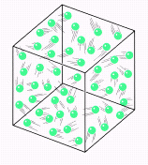
Pressure in an open system (outdoors): Also measured in pascals (Pa) or atmospheres (atm). We feel the pressure of the air around us. What is the pressure of the atmosphere on your book sitting on your desk? Pressure is still force/area. The area is the areas of the top of the book. Imagine a column of gas extending from your book to the top of the statosphere. The force comes from the weight of that gas pushing down. (F=mg where g= 9.8m/s²).

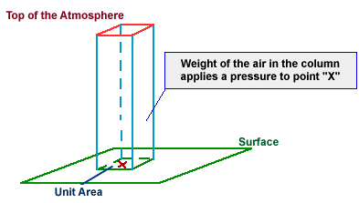

Pressure under water.
Water weighs considerably more than air does, so it can exert much more pressure. It takes only 33 feet of sea water to weigh the same as all the air from sea level to the top of the stratosphere. . This means that at a depth of 33 feet deep in the ocean, there is a total pressure of 2 ATMs of pressure. One ATM from the water, + one ATM from the water. Every additional 33 feet of sea water, will add another ATM. At 66 feet we have two ATMs of water pressure plus our 1 ATM of air pressure for an absolute pressure of 3 ATM.

Scuba divers use a regulator to breath air at those pressures. This concentration can sometimes cause problems with their blood chemistry.

Ideal Gas Equation

For the most part gasses all follow the equation:
PV = nRT which can also be written $\frac{\text{PV}}{\text{nT}}=R$ where P is pressure (in atm), V is volume (in liters), n is number of moles and T is temperature (in K). R is a constant and is equal to 0.08206 L atm/moleK.

Combined Gas Law
Since$\frac{\text{PV}}{\text{nT}}=R$, If we change one of the variables, (P, V, n, or T) then one or more of the other variables must also change. This leads to the equation $\frac{P_{1}V_{1}}{n_{1}T_{1}}=\frac{P_{2}V_{2}}{n_{2}T_{2}}$ or if the number of moles stays the same $\frac{P_{1}V_{1}}{T_{1}}=\frac{P_{2}V_{2}}{T_{2}}$.

Boyle’s Law:
Boyle’s Law examines the effect of changing volume on Pressure. To isolate these variables, temperature must remain constant. We can eliminate temperature from both sides of the equation and we are left with P₁V₁= P₂V₂
Sample Problem: A piston with a volume of gas of 1.0 m³ at 100 kPa is compressed to a final volume of 0.50 m³. What is the final pressure?

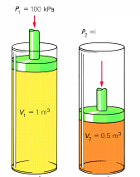

Charles’s Law
Charles’s Law examines the effect of changing temperature on volume. To isolate these variables, pressure must remain constant.
so Charles’s law is $\frac{V_{1}}{T_{1}}=\frac{V_{2}}{T_{2}}$

Sample problem: A piston with a volume of gas of 1.0 m³ at 273 K is cooled to a temperature of 136.5 K ? What is the final volume? (Assume pressure is kept constant.)

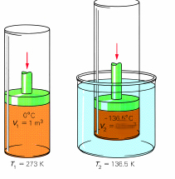

Phase Changes
Please watch animation 4.4 on your CD.

As heat is added to a solid material, the particles of the solid begin to vibrate faster. At a certain temperature, they begin to slide past each other and the material melts. At this point the energy added goes in to breaking the attractive forces so while melting is occurring, the temperature does not change. For water it remains 0 degrees C. If the material is heated further, some of the particles obtain enough kinetic energy to break their bonds to other particles and they enter the vapor phase. As more heat is added, particles enter the gas state at a faster rate. When the pressure of the surrounding air is equal to the pressure of the vapor, boiling begins and vapor bubbles can form inside the material instead of just at the surface. At the boiling point, heat energy added to the material is used to break the remaining intermolecular bonds and create gas vapor, so boiling occurs at a constant temperature.

More Phase Changes:
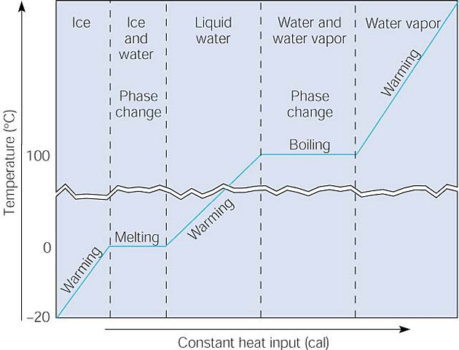
This graph shows three warming sequences and two phase changes with a constant input of heat. The ice warms to the melting point, and then absorbs heat during the phase change, as the temperature remains constant. When all the ice has melted, the now liquid water warms to the boiling point, where the temperature again remains constant as heat is absorbed during the second phase change from liquid to gas. After all the liquid has changed to gas, continued warming increases the temperature of the water vapor.

What Equations do we use for each of these situations?
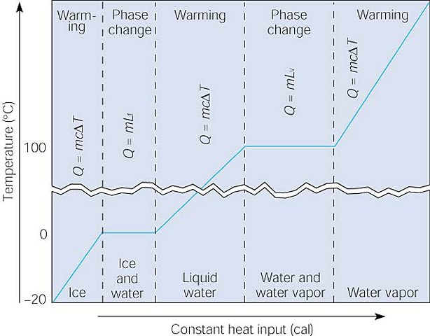

Compare this graph to the one in on the previous page. This graph shows the relationships between the quantity of heat absorbed during warming and phase changes as water is warmed from ice at -20ºC to water vapor at some temperature above 100 ºC. Note that the specific heat for ice, liquid water, and water vapor (steam) have different values. It takes a lot of energy to convert water (liquid) in to steam (gas). The heat of vaporization of water (Lv on the chart) is 2260 kJ/kg.

Sample problem:
How much energy is required to vaporize 700 g of water?

Heat Engines
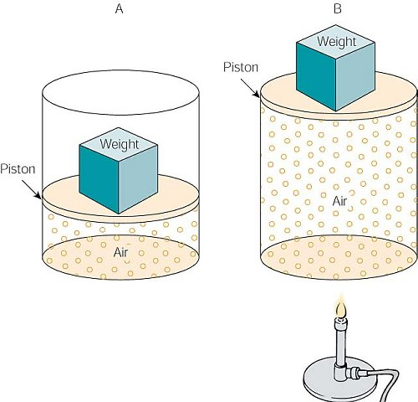

A heat engine is a device that converts heat into mechanical energy or work. This picture shows a very simple heat engine. The air in (B) has been heated, increasing the molecular motion and thus the pressure. Some of the heat is transferred to the increased gravitational potential energy of the weight as it is converted to mechanical energy.

Thermodynamics.

The first law of thermodynamics is the law of conservation of energy. The second law of thermodynamics states that some of the heat input to a heat engine must be wasted in order for the engine to operate.

Entropy is a measure of the disorder or randomness of the particles that make up a body of matter. In a system of any kind isolated from the rest of the universe, entropy cannot decrease.

Imagine making a salad. In a large bowl you put the lettuce, cucumbers, slices tomatoes and carrots and then you mix them up by tossing the salad. You have created a less ordered system. The lettuce, cucumbers, tomatoes and carrots will not suddenly jump back to their individual bowls. This is an example of entropy or randomness not being reversible. If you were to separate them out yourself you would decrease the entropy of the salad (make it more ordered) but in doing so your body would convert sugars to carbon dioxide and water and this process would more than counteract the entropy loss of the salad. The total entropy of the universe increases with every natural process.

Another example of entropy we can see when we drop a small amount of food coloring in to a glass of water. The color spreads out. The food coloring is less ordered when it is spread out throughout the water. What drives this dilution? The answer is the drive for greater randomness or entropy.

Here is another implication of the second law of thermodynamics: Heat naturally flows form a region of higher temperature to a region of lower temperature. In terms of “order”, heat energy is more “ordered” when it is concentrated. When transferred to a region of lower temperature, it is “spread out “ or more “disordered”, and the entropy increases. Hence the universe eventually should cool down to a final common temperature when the entropy of the universe has reached a maximum. This possible fate is sometimes referred to as the “heat death” of the universe.

