Waves

Reading Assignment: Read the entire chapter.
Homework: see the web site for homework.
http://web.fccj.org/~smilczan/psc/homewkmid.html

A wave is a periodic disturbance that spreads out from a source and carries energy with it.
There are two types of waves mechanical and electromagnetic.
- Mechanical
  - Examples -- sound waves, water waves, etc.
  - Require medium for transfer; cannot be transferred through a vacuum
  - The speed of the wave depends upon the mechanical properties of the medium.
  - Some waves are periodic (particles undergo back and forth displacement as in a sound wave.)
  - Some waves are sinusoidal (paricles undergo up and down displacement as in a wave on a string.)
- Electromagnetic
  - Examples -- light waves, radio waves, microwaves, X-rays, etc.
  - Do not require a medium for transfer; can be transferred through a vacuum
Transverse and Longitudinal waves (6.2)
  - Transverse waves cause the medium to move perpendicular to the direction of the wave.
  - Longitudinal waves cause the medium to move parallel to the direction of the wave.
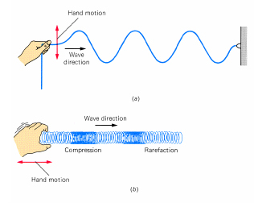
FIG. 6-2 Transverse and longitudinal waves. (a) Transverse waves travel along the rope in the direction of the black arrow. The individual particles of the rope move back and forth (color arrows) perpendicular to the direction of the waves. (b) In longitudinal waves, successive regions of compression and rarefaction move along the spring. The particles of the spring move back and forth parallel to the spring.
An analogy to these waves can be shown in waves of a crowd.
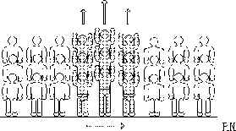
The standard wave we see at the baseball game could be considered a transverse wave because the people are moving perpendicular to the direction of the wave.
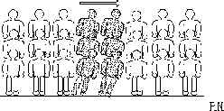
If the people bump shoulders instead of standing up, this would be a longitudinal wave.
Please go to the following applet and examine the transverse and longitudinal waves.
http://www.phy.ntnu.edu.tw/~hwang/waveType/waveType.html

Describing waves:
There are some terms required for discussing waves.
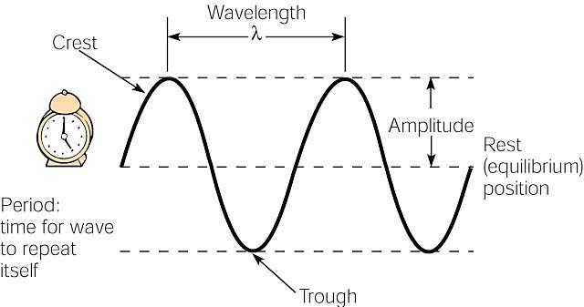
Here are some terms associated with periodic waves. The wavelength is the distance from a part of one wave to the same part in the next wave, such as from one crest to the next. The amplitude is the displacement from the rest position. The period is the time required for a wave to repeat itself, that is the time for one complete wavelength to move past a given location.
- Wavelength the distance between two successive in-phase points; symbol is λ and SI unit is meters
- Amplitude maximum displacement of wave; measure of wave's energy
- Frequency the number of waves passing a point per second; symbol is ν or f and SI unit is Hertz (Hz)
- Period time for one wave; symbol is T and SI unit is second
T = 1 / ν or T = 1/f
ν = 1 / T or f = 1/T
- Speed the speed with which the wave moves through the medium is the product of the wavelength and the frequency; SI unit is m/s
v = λ ν or v = λ f
Sample problem:
The speed of light is 3.0 x 10⁸ m/sec. The wavelength of red light is 700 nm or 7x 10 ^{–9}m What is the frequency of this wave? Frequency is f and wavelength is λ.
Answer
$$\begin{aligned}\text{speed of light}=v=\text{fλ} \\ f=\frac{v}{λ}=\frac{3×{\text{10}}^{8}\text{m/s}}{7×{\text{10}}^{−9}}=4\text{.}\text{29}×{\text{10}}^{\text{16}}\text{1/sec}=4\text{.}\text{29}×{\text{10}}^{\text{16}}\text{Hz}\end{aligned}$$
Wave behavior
- Refraction is the "bending of waves" .
  - A wave passing from one medium to another medium of different density changes its speed causing the wave to bend
  - The speed of the wave is greatest in the less dense medium

- Reflection
"bouncing back" of a wave
  - Laws of Reflection - The angle of incidence equals the angle of reflection (or it can be stated θ₁ = θ₂) ; the incident wave, the reflected wave, and the normal all lie in the same plane
  - Angle of incidence and angle of reflection are always drawn relative to the normal.
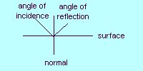
  - Example of reflection - echo
  - Go to this website to see waves reflected

- Interference - result of the superposition of two or more waves
  - Superposition Principle - when two waves are in the same place at the same time, the displacement caused by the waves is the algebraic sum of the two waves. Two situations can occur. There can be constructive or destructive interference. Lets examine adding the following two waves.
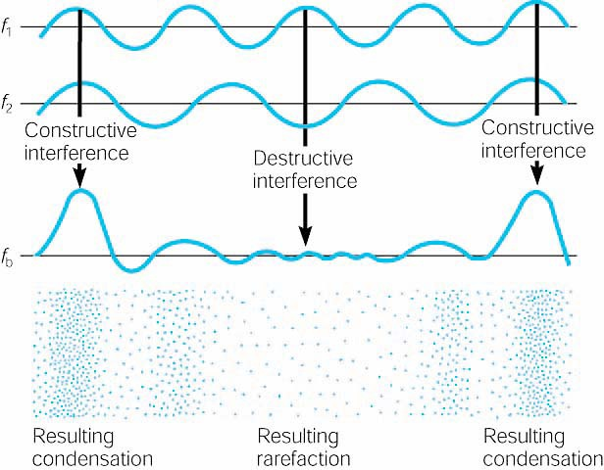
Two waves of equal amplitude but slightly different frequencies interfere destructively and constructively. The result is an alternation of loudness called a beat.
In Constructive interference, the signs of the waves are the same and the resulting wave is greater in amplitude than the individual waves. In destructive interference, the signs of the waves are the different and the resulting wave is smaller in amplitude than the individual waves.

Please use the following applets to watch constructive and destructive interference.
http://users.erols.com/renau/wave_interference.html

http://webphysics.ph.msstate.edu/jc/library/15-11/index.html

this applet is particularly great if your sound card is working:
http://library.thinkquest.org/19537/java/Beats.html

Diffraction The ability of waves to bend around the edge of an obstacle in their path is called diffraction.
Please go to this web site to read about diffraction.
http://open.dtcc.cc.nc.us/opticianry/oph141/diffract.htm
 Please draw in the diffraction pattern.
When a pebble is dropped into a pool of still water, a circular wave is generated that travels away from the point where the pebble entered. The farther the wave goes from the point where the pebble entered the water, the straighter the wave becomes.
But if a barrier with a small opening stops the wave, the small part of the wave that passes through the barrier becomes circular again -- as if the pebble had been dropped into the water at that point.
We say that the wave has bent around the barrier, or that it has changed directions: Where the wave was traveling in a straight line before passing the barrier, it has now 'bent' or changed directions after passing the barrier.
DIFFRACTION of a wave is the bending or redirection of the travel of the wave when it passes a barrier without changing the medium in which the wave is traveling.
Sound (6.3)
Please go to this web site to read about sound.
http://library.thinkquest.org/19537/Physics2.html

Very simply, sound is the vibration of any substance. The substance can be air, water, wood, or any other material, and in fact the only place in which sound cannot travel is a vacuum. When these substances vibrate, or rapidly move back and forth, they produce sound. As described in the How We Perceive Sound: The Ear section, our ears gather these vibrations and allow us to interpret them.
To be a little more accurate in our definition of sound, however, we must realize that the vibrations that produce sound are not the result of an entire volume moving back and forth at once. If that were the case, the entire atmosphere would need to shift for any sound to be made at all! Instead, the vibrations occur among the individual molecules of the substance, and the vibrations move through the substance in sound waves. As sound waves travel through the material, each molecule hits another and returns to its original position. The result is that regions of the medium become alternately more dense, when they are called condensations, and less dense, when they are called rarefactions.

Sound waves are often depicted in graphs like the one below, where the x-axis is time and the y-axis is pressure or the density of the medium through which the sound is traveling.
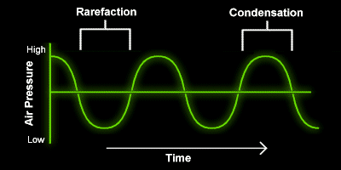

The Doppler effect
As an ambulance speeds towards you, sirens blazing, the sound you hear is rather high in pitch. This is because the sound waves in front of the vehicle are being squashed together by the moving ambulance. This causes more vibrations to reach your ear per second. As you know, more vibrations per second results in a higher pitched sound. When the ambulance passes you, the sound becomes lower in pitch. Behind the ambulance there are fewer vibrations per second, and a lower sound is heard. This change in pitch is known as the Doppler Effect.
When a vehicle travels faster than the speed of sound, about 330 meters per second, a sonic boom can be heard. As the vehicle overtakes its own sound, the sound waves spread out behind in a shockwave, or sonic boom.

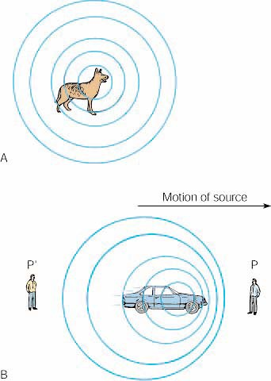
(A) Spherical sound waves from a stationary source spread out evenly in all directions. (B) If the source is moving, an observer at position P will experience more wave crests per second than an observer at position P'. The observer at P interprets this as a higher pitch, and the phenomenon is called the Doppler effect.
Please go to this web site to visualize the Doppler effect.
http://wigner.byu.edu/masong/doppler.html
Please go to the web site
http://library.thinkquest.org/19537/Physics7.html
At that web site please press the “I” button for more on the Doppler effect

For more information on Sonic booms try
http://www.af.mil/news/factsheets/Sonic_Boom.html.

Electromagnetic radiation
While visible light, radio waves, microwaves and X-rays seem very different to our senses, they are all part of the electromagnetic spectrum. All of these waves, electromagnetic radiation, move through a vacuum at the speed of light (3 x 10⁸ m/s) and do not require a media to propagate. The only differences between these types of radiation are the amount of energy these waves contain. Radio waves have a wavelength of about two or three meters. Remember that two meters is about the size of a human being. An FM station broadcasting at 90 MHz is broadcasting at a wavelength of 3.3 meters. Visible light is at about 0.0000006 meters or 600 nm. (That is for yellow.)
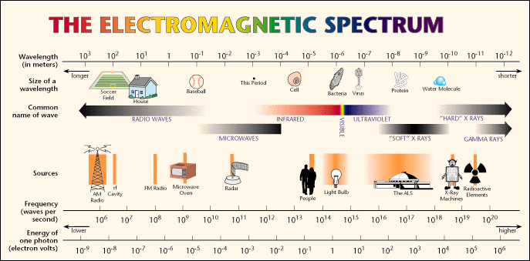

For more on the electromagnetic spectrum, visit this NASA website.
http://imagine.gsfc.nasa.gov/docs/science/know_l2/emspectrum.html

Behavior of light

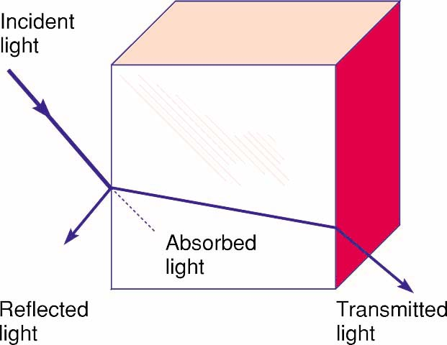

Light that interacts with matter can be reflected, absorbed or transmitted through transparent materials. Any combination of these interactions can take place, but a particular substance is usually characterized by what it mostly does to light.
Light travels in a straight line, and the color of an object depends in which wavelengths of light the object reflects. Each of these flowers absorbs the colors of white light and reflects the color that you see.

Color
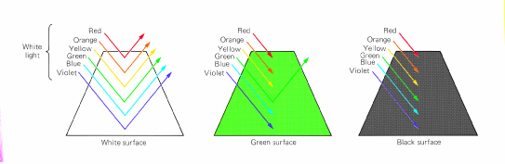
FIG. 6-40 A white surface reflects all light that falls on it. A green surface reflects only green light and absorbs the rest. A black surface absorbs all light that falls on it.

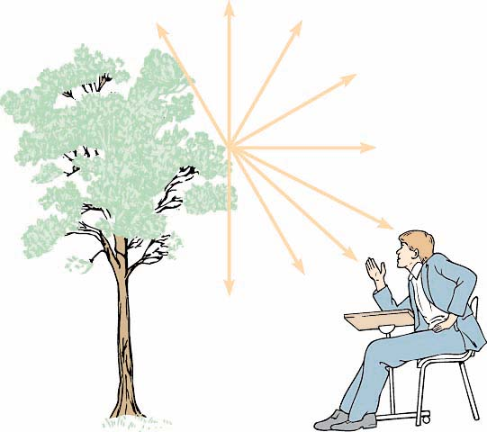
Bundles of light rays are reflected diffusely in all directions from every point on an object. Only a few light rays are shown from only one point on a tree in this illustration. The lights that move to your eyes enable you to see a particular point from which they were reflected.

Interference and thin films

In a thin film, light can be reflected at the top of the film or from the bottom of the film. Depending on the thickness of the film, the waves of light can show constructive or destructive interference. If the phases of the waves are off by 180° then destructive interference will occur and that wavelength will be cancelled out.

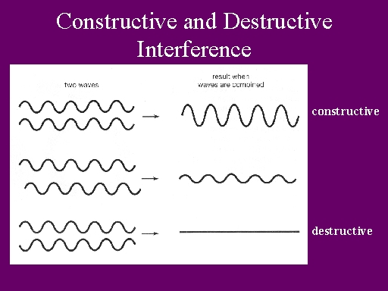

This removal of some frequencies or colors and the strengthening of other colors leads to the myriad of colors you see in the oil as it floats on water in a rainstorm.

For more on thin film interference, go to
http://physics.bu.edu/py106/notes/Thinfilm.html.

