The Atom
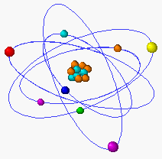

Reading Assignment: Read the entire chapter.
Homework: see the web site for homework.
http://web.fccj.org/~smilczan/psc/Homework7_11.htm

The Atom
All matter in the universe if made of atoms. The air we breathe and the ground we stand on. The differences in matter are remarkable. Matter can be a solid, liquid or gas.
An atom is the smallest particle that displays the individual characteristics of an element. What are these atoms made of and how do they combine to form atoms? These are the questions we will begin with in this chapter.

The atom is made of subatomic particles, the proton neutron and electron. A summary of these particles is shown below.

 | mass (amu) | mass (kg) | relative charge | charge in coulombs
proton | 1 | 1.67 x 10⁻²⁷ | +1 | 1.67 x 10⁻¹⁹
neutron | 1 | 1.67 x 10⁻²⁷ | 0 | 0
electron | 0.00054 | 9.11 x 10⁻³¹ | -1 | -1.67 x 10⁻¹⁹

Electrons, protons and neutrons were discovered separately in 1897, 1907 and 1932 respectively.

What defines an atom?

What is the arrangement of particles inside the atom? One would assume that the protons in an atom would move away from each other because positive charges repel each other. Certainly no one would expect them to congregate together. That is exactly what was discovered! Please watch the following movie to see the experiment that showed this to be true.
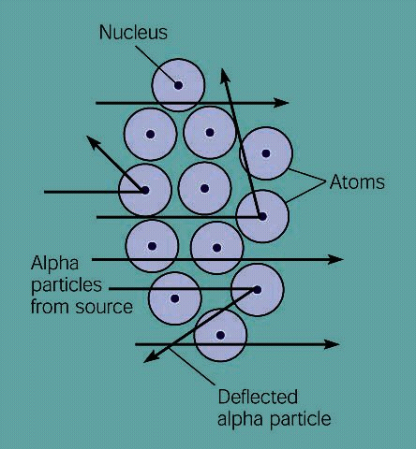
(That is if you can stand the download time.) http://web.fccj.org/~ksanchez/1025/movies/ruth.mov
This one is better: http://micro.magnet.fsu.edu/electromag/java/rutherford/ (Open the slit)

When Rutherford shot the alpha particle at the gold foil, the last thing he expected was for the particle to bounce back. There should be nothing massive enough to stop the particle. The alpha particle weighs 4 times what a proton weighs. That would be like Tony Bosselli (320 pounds) running at a 10 year old girl (80 pounds) and getting knocked on his butt.

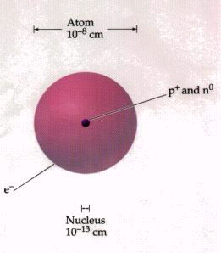
From the observations that most of the alpha particles went straight through and only sometimes were deflected or reflected, Rutherford concluded that all the massive particles were centered in a small area which is called the nucleus. How small is the nucleus compared to the size of the atom?
The nucleus is 5 orders of magnitude smaller then the atom. How big is this difference? If the atom were the size of a baseball stadium, the nucleus would be smaller than the baseball.
What holds the protons together in this small area? Whatever the answer, it must be a VERY strong force. In must be stronger than the repulsive forces that drive positive charges apart. The protons are packed very closely together. The density of the nucleus is very large. If a paper clip had the density of a nucleus, it would weigh ten million tons!

You can read about the fundamental forces of nature at the following web page.
http://library.thinkquest.org/3471/nuclear_forces.html

The Forces of Nature
Gravitational Force: The attractive force that binds the progressively growing galaxy together is the gravitational force. It's the force that not only holds you to the Earth but also reaches out across the vastness of intergalactic space.

Electromagnetic Force: Two electrons exert repellent electromagnetic forces on each other. At a deeper level, this interaction is described by a highly successful theory called quantum electrodynamics. From this point of view we say that each electron detects the presence of the other by exchanging virtual photons with it, the photon being the quantum of the electromagnetic field.

Weak Force: The weak force is a short-range force which is responsible for accounting for beta decay within the nucleus. The role of the weak interaction seems to be confined to causing beta decays in nuclei whose neutron/proton ratios are not appropriate for stability.

Strong Force: The theory of the strong force, that is, the force that acts between quarks, has also been developed. They are nuclear forces which are repulsive at very short range as well as being attractive at greater nucleon-nucleon distances. This keeps the nucleons in the nucleus packed together but not meshed together. There's no easy way to describe the theory behind this theory also known as the Meson theory of nuclear forces.

How do we define elements?
When we examine an individual atom, it is the number of protons that define the element of the atom. The number of protons is the atomic number (Z). All carbons have 6 protons in the nucleus; all chlorines have 17 protons in the nucleus. Most chemists use the periodic table to look up this kind of information. There are many places to find periodic tables on the web. Look at the one at the following site. Use the table to determine the atomic number of tin (Sn). Notice that each element can be represented by a two-letter symbol, the first letter of which is always capitalized, the second letter, if there is one, is not capitalized.

What else is in the nucleus?
Neutrons also reside in the nucleus. In most stable nuclei, the number of neutrons approximately equals the number of protons. As the number of protons in the nucleus increases, so does the number of neutrons. The neutrons seem to play some kind of role in stabilizing the nucleus.

While a chlorine atom always has 17 protons, it can have any number of neutrons. Two atoms with the same number of protons and different number of neutrons are called isotopes. Two naturally occurring stable isotopes exist for chloride. One has 18 neutrons and the other has 20 neutrons. Because protons and neutrons are the only massive particles in the atom, the mass number of the atom (A) is the protons plus the neutrons.

An ion exists when the protons do not equal the electrons. If there are more electrons than protons than the atom is negatively charged. If there are more protons than electrons than the atom is positively charged. We can describe an individual atom with the symbol in the center, the atomic number in the lower left, mass number in the upper left, and the charge in the upper right.

atomic number = number of protons
mass number = protons + neutrons
charge = protons – electrons

$${}_{\text{Atomic number}}^{\text{Mass Number}}{}{\text{Symbol}}^{\text{Charge}}$$
or

$${}_{\text{protons}}^{\text{protons }+\text{ neutrons}}{}{\text{Symbol}}^{\text{protons- electrons}}$$
Example:
${}_{\text{50}}^{\text{119}}{}{\text{Sn}}^{2+}$ This tin atom has 50 protons, 69 neutrons and 48 electrons.
This is one of six stable isotopes of tin. This isotope can also be written tin-119. When elements are not combined with anything else, they are typically neutral ( not charged.)

You may want to bookmark this on-line periodic table.
http://periodic.lanl.gov/

Isotopes
When people hear the word “isotopes”, fear of radiation usually comes to mind. Many elements have more than one stable isotope. Chlorine for example has two naturally occurring isotopes: Chlorine-35 and chlorine-37. Naturally occurring chlorine is 75 % Chlorine-35 and 25% chlorine-37. It has an average atomic weight of 35.5 amu. Is that what is recorded for chlorine on the periodic table?

Some isotopes are not stable. Chlorine has 8 unstable isotopes with half-lives that vary from 300,000 years to 286 milliseconds.

Stable isotopes tend to fall in a band. You can see the band of stability in an applet below.
http://lectureonline.cl.msu.edu/~mmp/kap30/Nuclear/nuc.htm

In this picture, we have plotted protons on the x axis and neutrons on the y-axis. The white dots indicate stable isotopes and the yellow, red and blue dots indicate radioactive isotopes.
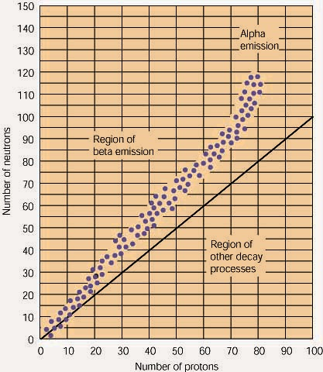

Isotopes on the top side of the band tend to decompose by emitting a beta (β) particle. (This lowers the neutron to proton ratio.) Isotopes on the lower side of the band tend to undergo positron emission, electron capture or alpha emission. Each of these raises the neutron to proton ratio. Here is a summary of the decay processes. When an isotope decays, it does not necessarily decay to a stable isotope. Uranium-235 decays 14 times before becoming the stable isotope Lead-206.

Types of decay

A stable nucleus must have the right combination of protons and neutrons.

- Too big: Alpha decay

- Too many protons: positron emission or electron capture

- Too many neutrons: Beta decay
- Nucleus has excess energy: Gamma decay

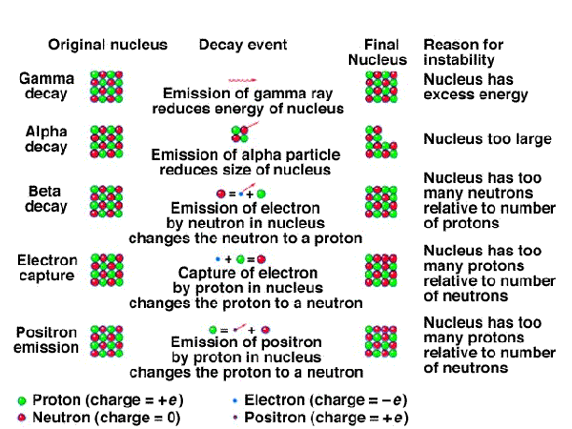

Balancing Nuclear Equations
- Sum of top numbers on the left must equal sum of top numbers on right.
- Same thing for bottom numbers.

Alpha Decay (${}_{2}^{4}{}\text{He}$)
•Large isotopes that need to decrease their size tend to decay by alpha emission.
•An alpha particle can be described as a helium nucleus.
2 protons and 2 neutrons.

${}_{\text{88}}^{\text{226}}{}\text{Ra }→{}_{\text{86}}^{\text{222}}{}\text{Rn }+ {}_{2}^{4}{}\text{He}$
See discussion at http://web.fccj.org/~smilczan/psc/nukeq.html

If we know that Radium 226 is an alpha emitter, we can figure out the other product:.
Top: 14=14+0 Bottom: 6= 7-1
The element radon is the only element with atomic number 86.

Beta Decay (${}_{\text{-1}}^{0}{}e$)
•Occurs if there are too many neutrons.
•A neutron to proton conversion occurs. This releases an electron or beta particle.
•Carbon-14 undergoes beta decay to the stable nitrogen-14 isotope.
${}_{6}^{\text{14}}{}C$→ ${}_{7}^{\text{14}}{}N$ + ${}_{\text{-1}}^{0}{}e$

See discussion at http://web.fccj.org/~smilczan/psc/nukbeta.html

If we know that carbon 14 is a beta emitter, we can figure out what the other product will be.
Top: 14=14+0 Bottom: 6= 7-1
The element nitrogen is the only element with atomic number 7.

For a more complete discussion of nuclear reactions
http://www.dallassd.com/our%20schools/high%20School/Chemsite/nucleareqns/index.html

Ionizing radiation
Each of the decay processes can produce radiation which can destroy chemical bonds. We are often worried about this radiation because it can damage the bonds in our DNA, among other things. Positrons do not exists for very long because they react with an electron in a process called annihilation. This leaves three kinds of radiation:

 | What is it? | Stopped by:
Alpha | 2 protons and 2 neutrons (high energy) | almost anything. example:paper
Beta | A high energy electron | wood, heavy clothing, plastic
Gamma | Electromagnetic radiation (High energy) | lead, concrete

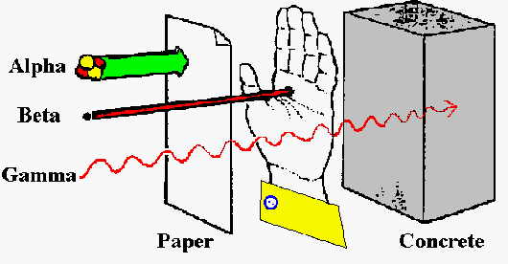
Alpha radiation actually does the most damage to cells. We do not usually worry about it because it is easy to shield against it. Gamma radiation is the scariest of these types because it is so difficult to shield against it.

See the effects of radiation on a lung at http://www.ccnr.org/alpha_in_lung.html

Half Life
The half-life of a radioisotope is the time it takes for one half of a sample to decay. The decay of an isotope is not linear. Lets look at the decay of radioactive iodine (iodine-131) . Iodine-131 has a half-life of 8 days. Every eight days the amount of iodine is cut in half.

days | amount of I-131
8 | 20
16 | 10
24 | 5
32 | 2.5
40 | 1.25

Please enjoy this applet
http://lectureonline.cl.msu.edu/~mmp/applist/decay/decay.htm

Measuring radiation

There are a number of units for measuring radioactivity.
Curie is a unit of radioactivity. One curie refers to the amount of any radionuclide that undergoes 37 billion atomic transformations a second. A nanocurie is one one-billionth of a curie ( 37 Becquerel, = 1 nanocurie). The curie just measure the amount of activity. It is proportional to the number of disintegrations per second.
Roentgen is a measure of exposure; it describes the amount of radiation energy, in the form of gamma or x-rays, in the air.
Rad (radiation absorbed dose) measures the amount of energy actually absorbed by a material, such as human tissue (Gray=100 rads). The rad takes into account both the amount of radiation and the matter that is absorbing it. Some compounds such as lead or barium absorb more radioactivity than others, such as water.
Rem (roentgen equivalent man) measures the biological damage of radiation. It takes into account both the amount of radiation and the biological effect of the type of radiation in question. As was stated earlier, an alpha particle does more damage than a beta particle which does more damage then a gamma ray. A millirem is one one-thousandth of a rem (Sievert=100 rems).

For more information on radiation, read this statement from the EPA
http://www.epa.gov/radiation/rert/radfacts.html

As you read in your book, radon is the largest source of radiation exposure for an average person. The EPA publishes a wealth of information on radon. You may visit their site if you wish:
http://www.epa.gov/iaq/radon/

Binding Energy
Please go to this web site
http://library.thinkquest.org/3471/binding_curve.html

The total energy required to break up a nucleus into its constituent protons and neutrons can be calculated from, called nuclear binding energy.

Nuclear Masses
Where does the binding energy come from? The answer is a loss of mass. Mass can be converted to energy using Einstein’s equation: E = mc²

Nuclear masses can change due to reactions because this "lost" mass is converted into energy. For example, combining a proton (p) and a neutron (n) will produce a deuteron (d). Deuterium is an isotope of hydrogen.

If we add up the masses of the proton and the neutron, we get
m_{p} + m_{n} = 1.00728u + 1.00867u = 2.01595u
The mass of the deuteron is m_{d} = 2.01355u

Therefore change in mass = (m_{p} + m_{n}) - m_{d} = (1.00728u + 1.00867u) - (2.01355u) = 0.00240u

An atomic mass unit (u) is equal to one-twelfth of the mass of a C-12 atom which is about 1.66 X 10⁻²⁷ kg. So, using E=mc² gives us energy/u = (1.66 X 10⁻²⁷ kg)(3.00 X 10⁸ m/s)²(1eV/1.6 X 10⁻¹⁹ J) which is about 931 MeV/u. So, our final energy is
The quantity 2.24MeV is the binding energy of the deuteron.

Fusion and Fission

Fission
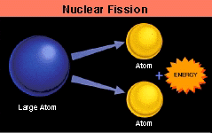
Nuclear Fission involves the breaking up of large nuclei to smaller nuclei. The most famous fission reaction is the chain reaction involving the destruction of uranium-235. Your CD has an interesting animation on this topic.
The interesting thing about this reaction is that when a Uranium 235 is hit by a neutron, it decomposes to a barium-139, a krypton-94 and three more neutrons and a lot of energy. These three neutrons can then go hit three more uranium atoms and a chain reaction has begun.

You can see this reaction at:
http://lectureonline.cl.msu.edu/~mmp/applist/chain/chain.htm

Fusion

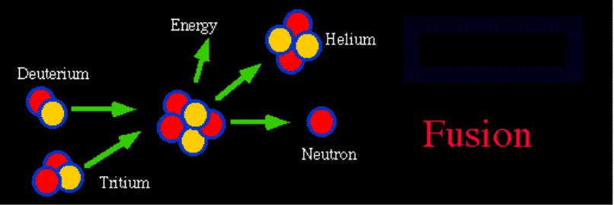

Please go to http://www.jet.efda.org/pages/content/fusion1.html to read about fusion.

Nuclear Fusion is the energy-producing process which takes place continuously in the sun and stars. In the core of the sun at temperatures of 10-15 million degrees Celsius, Hydrogen is converted to Helium providing enough energy to sustain life on earth.
For energy production on earth different fusion reactions are involved. The most suitable reaction occurs between the nuclei of the two heavy forms (isotopes) of Hydrogen - Deuterium (D) and Tritium (T); eventually reactions involving just Deuterium or Deuterium and Helium (³He) may be used.

Quarks, Hadrons and other stuff
Please go to the following site and go through “What is fundamental” and “What is the world made out of”. The complete discussion of the standard model is beyond the scope of the course. We knew that there had to be something else because we learned that during beta decay, a neutron was converted to a proton and an electron. This indicated to us that our protons neutrons and electrons were made of sub-sub atomic particles, in this case quarks and leptons.
http://www-spires.dur.ac.uk/HEPDATA/PART/particleadventure/frameless/startstandard.html


Physicists have developed a theory called The Standard Model that explains what the world is and what holds it together. It is a simple and comprehensive theory that explains all the hundreds of particles and complex interactions with only:
6 quarks.
6 leptons. The best-known lepton is the electron. We will talk about leptons in just a few pages.
Force carrier particles, like the photon. We will talk about these particles later.
All the known matter particles are composites of quarks and leptons, and they interact by exchanging force carrier particles.

Matter and Antimatter
For every type of matter particle we've found, there also exists a corresponding antimatter particle, or antiparticle.
Antiparticles look and behave just like their corresponding matter particles, except they have opposite charges. For instance, a proton is electrically positive whereas an antiproton is electrically negative. Gravity affects matter and antimatter the same way because gravity is not a charged property and a matter particle has the same mass as its antiparticle.
When a matter particle and antimatter particle meet, they annihilate into pure energy!

