The Atom
The Electrons in the Atom
Reading Assignment: Read the entire chapter.
Homework: see the web site for homework.
http://web.fccj.org/~smilczan/psc/Homework7_11.htm

Electrons are the ‘glue’ that hold molecules and compounds together. We just finished a chapter where we looked at a few nuclear reactions. In these nuclear reactions we rearranged the nucleus. Chemical reactions typically involve some rearrangement of the electrons. In this chapter we will look at the nature of the electron with an eye toward the future where we will use this information to begin to understand chemical bonding.

Outline
- The Bohr Model of the atom
  - Light spectra
  - spectra of the elements
  - Quantization
  - laser
- The photoelectric effect
- The electron as a wave
  - deBrolie
  - Scroedenger
  - Heisenberg uncertainty principle
  - The physical significance of the 4 quantum numbers
  - The outcome

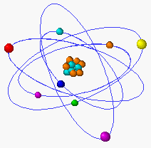

When we last left our atom we had the nucleus in the center surrounded by electrons. An interesting experiment was about to require us to examine our view of the electrons. This experiment involved the spectra of elements.

We have already discussed what color is.
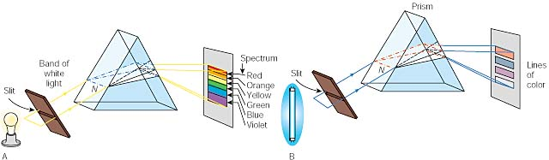Light from incandescent solids, liquids, or dense gases, produces a continuous spectrum. If we pass this light through a thin slit and then through a prism, the prism will separate the colors into a spectrum from red (lowest energy) to violet (highest energy). This does not surprise us as we remember that white light is a combination of many wavelengths. (Black is the absence of light.)

An interesting thing happens when we use light just from one element, such as hydrogen. Light from this gas produces a line spectrum that contains only certain frequencies. Neon lamps are similar to these lamps. The lamps get there energy from the electrical potential energy of the wall socket and convert that to radiant or light energy.

Bohr came up with an interesting explanation of this phenomenon. He stated that the electrons orbit the nucleus the way the earth orbits the sun. An electron in an atom can only exist in certain orbits around the nucleus. I have drawn 4 orbits but there are more.

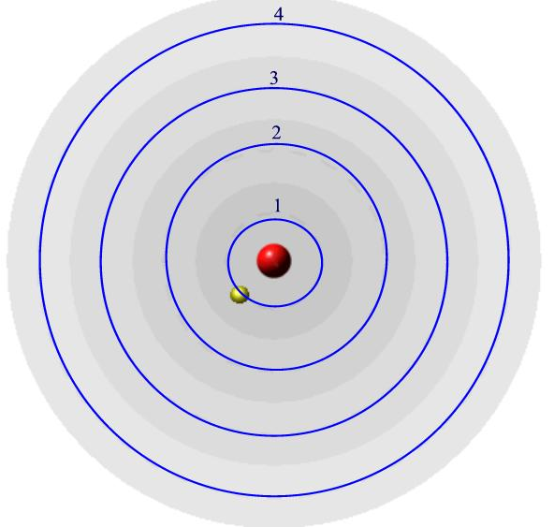
What Bohr said was that the electron could only exist in these blue orbits, not in between. Each orbit has a definite energy with the inner orbit being the lowest in energy. The energy of the orbits increases as you get further from the nucleus. By saying that the electron can only have specific energies, we can say that the energies of the electrons are quantized. (The beginning of quantum mechanics.)

The electron is normally in the lowest orbit (orbit number 1) called the ground state. In this experiment it is excited into a higher orbit by the electrical energy (say to orbit number 4.) As is comes back to a more stable orbit it can release the energy as light of a specific wavelength.

The transitions to 1 (2 to 1, 3 to 1, 4 to 1 etc) are all in the UV region and we cannot see them. The transitions to 2 (3 to 2, 4 to 2, 5 to 2 etc) are in the visible region. This explains why hydrogen absorbs only specific wavelengths of light and emits only certain wavelengths. It is because the electrons can only be in these distinct orbitals.

Look at the following applet and start with hydrogen. When a broad visible spectrum of light shines on hydrogen, notice it only removes 4 wavelengths of light. The red absorption line comes from an electron absorbing that wavelength and going from orbit 2 to orbit 3.

While you are there, notice that each of the elements has a different pattern of absorption. Do you think that we can use this to analyze what some matter is made of? YES!

http://javalab.uoregon.edu/dcaley/elements/Elements.html

Now look at emission. Each time an electron males a "quantum leap," moving from a higher energy orbit to a lower energy orbit, it emits a photon of a specific frequency and energy value. Hydrogen emits only 4 wavelengths. The red line comes an electron going from 3 to 2. Here is a chart that shows the various energies and the corresponding transitions.

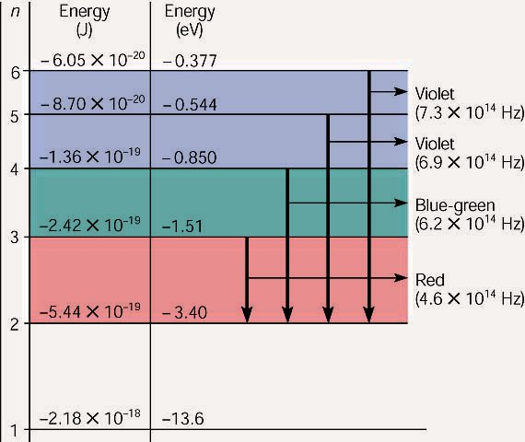
An energy level diagram for a hydrogen atom, not drawn to scale. The energy levels (n) are listed on the left side, followed by the energies of each level in J and eV. The color and frequency of the visible light photons emitted are listed on the right side, with the arrow showing the orbit moved from and to.

Please look on your CD for animations regarding absorbsion and emission or go to the following two web sites. (They are the same movies as on your CD, animations 8.2 and 8.3)
Absorption movie: http://webphysics.ph.msstate.edu/jc/library/27-1/index.html
Emission movie: http://webphysics.ph.msstate.edu/jc/library/27-6/index.html

Laser

Please watch Animation 8.5, “The Laser” on your CD.
(Following paragraph is an excerpt from that animation.)
The key to the laser is that many atoms have one or more excited energy levels whose lifetimes are much longer (10-3 s) than those of most excited levels (10-8 s). Such relatively long-lived levels are called “metastable”. The first step in laser operation is to bring as many atoms as possible in an appropriate material to such metastable levels. (There are various ways to do this, depending on the material.) When one of the atoms in a metastable state spontaneously drops to a lower state, the photon that is emitted has just the right frequency to cause other atoms in metastable states to drop to the same lover state by emitting radiation of this frequency. The process is called induced emission and was predicted by Einstein in 1917. The result is an avalanche of photons, all of the same frequency and all coherent, which means that their electromagnetic waves are exactly in phase (in step) with one another.

Please go to this web site and go through how a laser works.
http://www.howstuffworks.com/laser.htm
You should go through at least :
- Introduction to How Lasers Work
- The Basics of an Atom
- The Laser/Atom Connection
- Three-Level Laser
- Types of Lasers
(Following paragraph is an excerpt from that site.)

Although there are many types of lasers, all have certain essential features. In a laser, the lasing medium is “pumped” to get the atoms into an excited state. Typically, very intense flashes of light or electrical discharges pump the lasing medium and create a large collection of excited-state atoms (atoms with higher energy electrons). It is necessary to have a large collection of atoms in the excited state for the laser to work efficiently. In general, the atoms are excited to a level that is two or three levels above the ground state. This increases the degree of population inversion. The population inversion is the number of atoms in the excited state versus the ground state.
Once the lasing medium is pumped, it contains a collection of atoms with some electrons sitting in excited levels. The excited electrons have energies greater than the more relaxed electrons. Just as the electron absorbed some amount of energy to reach this excited level, it can also release this energy. As Figure 3 illustrates, the electron can simply relax, and in turn rid itself of some energy. This emitted energy comes in the form of photons (light energy). The photon emitted has a very specific wavelength (color) that depends on the state of the electon's energy when the photon is released. Two identical atoms with electrons in identical states will release photons with identical wavelengths.
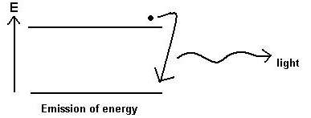
Figure 3
Laser light is very different from normal light. Laser light has the following properties:
- The light released is monochromatic. It contains one specific wavelength of light (one specific color). The wavelength of light is determined by the amount of energy released when the electron drops to a lower orbit.
- The light released is coherent. The light is “organized” and each photon moves in step with the others. This means that all of the photons have wave fronts that launch in unison.
- The light is very directional. A laser light has a very tight beam and is very strong and concentrated. A flashlight, on the other hand, releases light in many directions and the light is very weak and diffuse.
To make these three properties occur takes something called stimulated emission. This does not occur in your ordinary flashlight -- in a flashlight, all of the atoms release their photons randomly. In stimulated emission, photon emission is organized.
The photon that any atom releases (Figure 3) has a certain wavelength that is dependent on the energy difference between the excited state and the ground state. If this photon (possessing a certain energy and phase) should encounter another atom that has an electron in the same excited state, a phenomena called stimulated emission can occur. The first photon can stimulate or induce atomic emission such that the subsequent emitted photon (from the second atom) vibrates with the same frequency and direction as the incoming photon.
The other key to a laser is a pair of mirrors, one at each end of the lasing medium. Photons, with a very specific wavelength and phase, reflect off the mirrors to travel back and forth through the lasing medium. In the process, they stimulate other electrons to make the downward energy jump and can cause the emission of more photons of the same wavelength and phase. A cascade effect occurs, and soon we may have propagated many, many photons of the same wavelength and phase. The mirror at one end of the laser is "half-silvered", meaning it reflects some light and lets some light through. The light that makes it through is the laser light.
You can see all of these components in the following figures, which illustrate how a simple ruby laser works. The laser consists of a flash tube (like you would have on a camera), a ruby rod and two mirrors (one half-silvered). The ruby rod is the lasing medium and the flash tube pumps it.
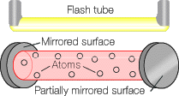 1
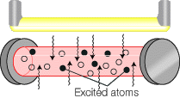 2
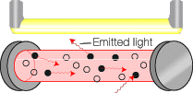 3
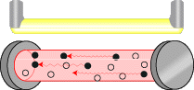 4
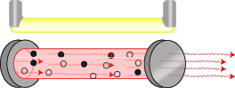 5
Figure 5
In scene one you have the laser in its non-lasing state. In scene two the flash tube fires and injects light into the ruby rod. The light excites atoms in the ruby. In scene three, some of these atoms emit photons. In scene four, some of these photons run in a direction parallel to the ruby's axis, so they bounce back and forth off the mirrors. As they pass through the crystal, they stimulate emission in other atoms. Monochromatic, single-phase, columnated light leaves the ruby through the half-silvered mirror -- laser light!

The photoelectric Effect
Please watch animation 8.1: The Photoelectric Effect

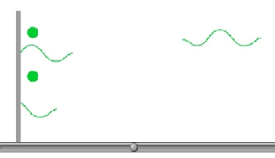

The photoelectric effect is the observation that under certain conditions, light striking a metal surface can cause electrons to be ejected. In the animation, the light increases in energy as it goes from red, to orange to yellow to green and then blue. Notice how only the higher energy green and blue can cause electrons to be ejected.
Einstein definition of photons comes from this photoelectric effect and the following experiment. A fairly high voltage difference is created between two pieces of metal.
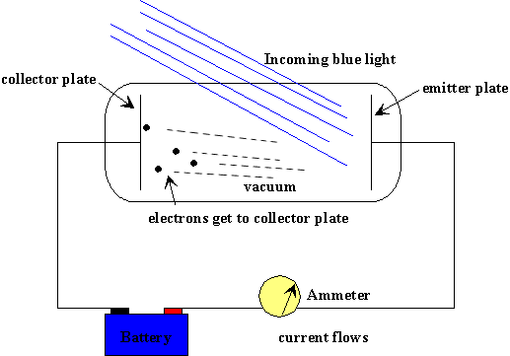

The observations are as follows: Initially with the plates in the dark, no electrons pass between the plates and no current flows. As we shine light on the plates, going from low energy red to high energy blue, suddenlt current begins to flow. How?

Einstein explained the result be describing the lightwaves as packets of energy. He called the packets of energy photons. Each photon has a specific energy, the shorter the wavelength, the higher the energy. When a high energy photon hits the plate (such as a green or blue), the photon has enough energy to knock out an electron and then the electron, being negative, will fly to the positive side. At this point, current flows.

The lower energy photons are unable to know out the electrons and no energy can flow.

The exciting thing to note is the treatment of energy as a particle or a packet, it is consistent with the fact energies are not additive. If we can bump electrons with light at 600 tera-hertz , we can’t just use 300 tera-hertz for twice the time and still expect to bump electrons.

What if the photon has greater than the threshold energy required to pop out an electron? The extra energy just goes into the kinetic energy of the electron. This relationship can be described by the following equation.
hf = w + KE

where hf is the energy of the photon.
w is the energy required to bump an electron.
KE is the kinetic energy of the electron.
If the photon has less energy than w, no electron is emitted.
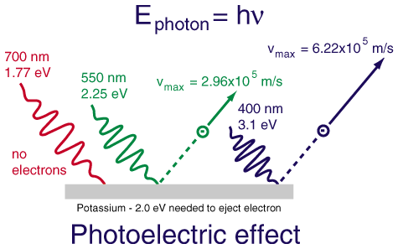

Louis de Broglie
(Biography at http://www-groups.dcs.st-and.ac.uk/~history/Mathematicians/Broglie.html or http://www.chembio.uoguelph.ca/educmat/chm386/rudiment/tourquan/broglie.htm )

De Broglie looked at the results of the Einstein’s work where Einstein stated that energy, a wave, has particle like properties. De Broglie suggested that if light can behave like a matter, perhaps matter could behave like light. That is both light and matter have wave and particle-like properties. From the equation E=mc² ,de Broglie derived the equation
$$λ=\frac{h}{\text{mv}}$$
where lambda is the wavelength, h is a constant (Plank’s constant), m is mass and v is the velocity of a moving particle. For most large objects, like me, my mass is large which makes my wavelength so small it is undetectable. For small particles such as electrons, the wavelength is important.

The proof for this hypothesis came in 1927 when Clinton Davisson and Lester Germer of Bell Labs saw an interference pattern when electrons were scattered by a nickel crystal. Notice the similarity of their particle experiment with the interference experiment with light described on page 206 of your textbook. (Figure 6-42.)
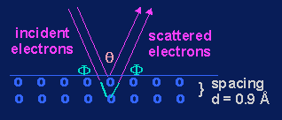Davisson-Germer Experiment (1927)
The upshot of this idea is that if electrons have wave-like properties, then only certain waves will “fit” for a given atom. The picture below shows a wave that firs and one that does not.

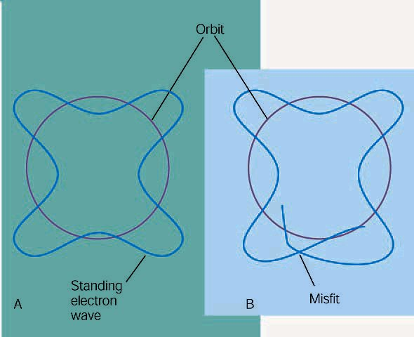
(A) A schematic of de Broglie wave, where the standing wave pattern will just fit in the circumference of an orbit. This is an allowed orbit. (B) This orbit does not have a circumference that will match a whole number of wavelengths; it is not an allowed orbit.

Your book does a nice job reconciling the Bohr model with the de Broglie theory. Notice in the picture below that each “orbit” of the Bohr model has a corresponding de Broglie wave.

Heisenberg uncertainty principle:

The Heisenberg uncertainty principle is a mathematical consequence of the treatment of the electron as a wave. It states the uncertainty of the electron’s position times the uncertainty of the momentum is equal to or greater than the quantity h/4π. This means that you cannot exactly know both a particle’s position and velocity at the same time. The physical significance can be described any number of ways. This is a result of the wave-like nature of the electron. To see the frequency or wavelength of a wave, you need to look at it over a certain time or space. It is not surprising that the Heisenberg uncertainty principle states that a wave will look a little blurry.

Erwin Schrödinger
(Biography at http://www.chembio.uoguelph.ca/educmat/chm386/rudiment/tourquan/schrod.htm )
The Schrodenger equation examines the behavior of the electron strictly as a wave. I have never examined the intricate complexities of the exact solution, and I probably never will. I have examined the results of this “solution” and it does explain some of the behavior of atoms that the Bohr model is unable to explain.

Because of the Heisenberg uncertainty principle, one cannot determine the exact position of an electron. One can determine areas where there is a high probability of finding an electron. These areas of high probability are called orbitals. These orbitals are analogous to hotel rooms where people may be analogous to electrons. You may not know where a person is in the room but you know that they are in the room. The position of the electron in an atom is described by 4 quantum numbers. The first three quantum numbers describe the orbital.

The PhysicalSignificance of the 4 Quantum Numbers.

The first quantum number is the principle quantum number, n. This quantum number can be 1, 2, 3... It is most closely related to the shell or orbits of the Bohr model.

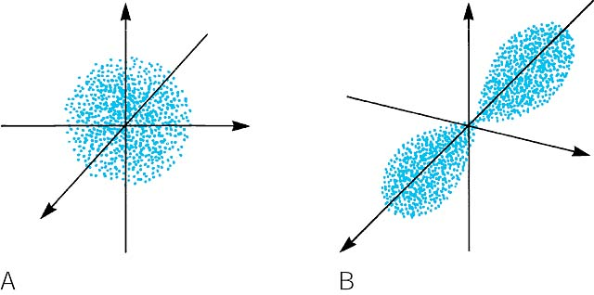
(A) A contour representation of an s orbital. (B) A contour representation of a p orbital.

The second quantum number is the orbital quantum number or the angular momentum quantum number, l. This represents the type of orbital. If l = 1 then the electron is in a s type orbital. If l = 1 then the electron is in a p type orbital. “s” orbitals are sphere shapes while “p” orbitals are dumbbell shaped. “p”-type orbitals come in groups of three, one is aligned along the x axis, one along the y axis and one along the z axis. We call these p_{x}, p_{y} and p_{z}.

There are also d and f orbitals. To look at pictures of these orbitals, go to this web site.
http://www.albany.net/~cprimus/self/orbtable.htm

There are three possible orientations of the p orbital, and these are called px, p_{y} and p_{z}. The third quantum number, the magnetic quantum number, m_{l}, describes which of the p orbitals, x y or z, the electron is in.

The final quantum number is spin, m_{s}. Electrons behave in some respects as if they were tiny charges spheres spinning around an axis. This spin (blue arrow) gives rise to a tiny magnetic field (green arrow). The values for spin are +1/2 or –1/2.

The Pauli exclusion principle states that an electron in a atom cam be described by a unique set of quantum numbers. This means that in an atom with more than one electron, no two electrons can have the same set of 4 quantum numbers.

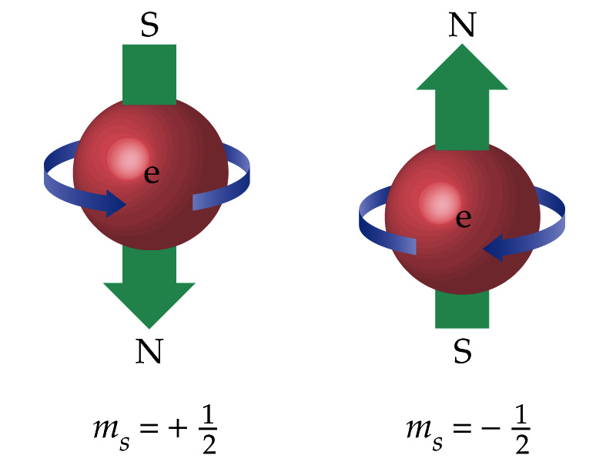

The outcome.
In an atom with more than one electron, s and p orbitals of the same shell do not have the same energy. The 2s and 2p orbitals are all part of the second shell of the Bohr atom. Using the Schrödinger equation increases the complexity of our model of the electron. Hopefully we will be able to use mostly the Bohr model as we examine the complexities of chemical compounds.

