Ionic Compounds
Chapter 9

Chapter 9: Ionic Compounds
- Octet Rule
- Ionic Bonding
- Formulas
- Naming Ionic compounds

Octet rule
- Octet rule: Atoms in a compound will lose, gain or share electrons in order to achieve a stable noble gas configuration.
- It is the electrons in the outer shell that participate in these changes to create bonds
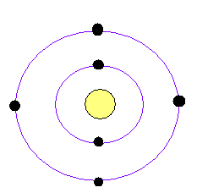
Valence electrons
- The valence electrons of an atom are defined as the electrons in the outermost shell of the uncharged atom.
- The number of valence electrons of an uncharged atom is equal to the group number for main group elements.

Dot structures
- In Lewis dot structures, the valence electrons are represented by dots.
- Lewis dot structures play a more important role in covalent bonding than ionic bonding.
- Sodium, in group I has 1 valence electron
- Carbon in group IV has 4 valence electrons.

Dots for common elements
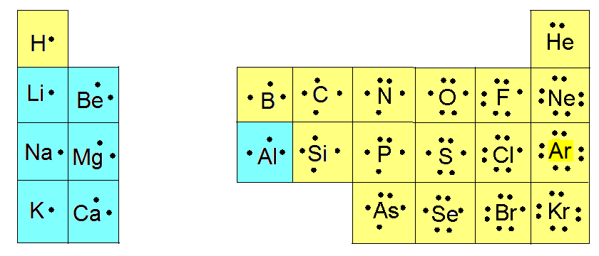

Types of bonding
- metal + non-metal leads to ionic bonding.
  - the metal will lose electrons to become positively charged.
  - the non-metal will gain electrons to become negatively charged.
  - the ionic compound is held together by the electrostatic attraction between the positive and negative charges.

Salt and Lewis Structures
- The sodium and chlorine combine in a 1:1 ratio.
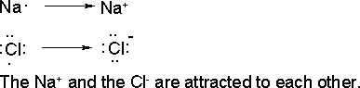

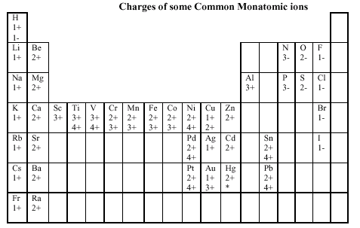

Does it have to be a 1:1 ratio? No!
- All ionic compounds must have no overall charge so positive charges must equal negative charges.
- Example sodium oxide: Na₂O
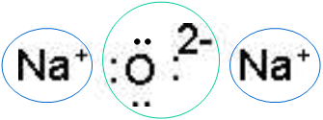
The Switcheroo Rule
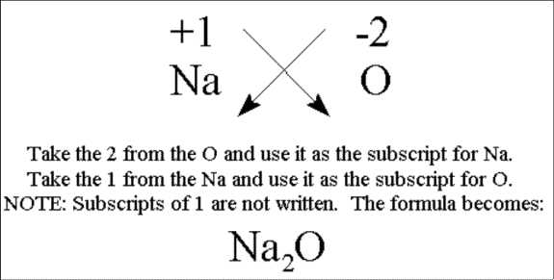
Note that the cation is written first and the anion second.

A Caveat to the Switcheroo rule
- If you can divide by an integer greater than one, you must do so.
- Mg²⁺ and O²- form MgO not Mg₂O₂

Polyatomic ions
- Polyatomic ions are groups of covalently bound atoms that act like a single ion.
- Example: nitrate NO₃⁻ combines with Mg²⁺ to form Mg(NO₃)₂.
- Note the use of ( ) to identify that it is 2 nitrates.
- Pb³⁺ and OH⁻ form: Pb(OH)₃

Ten polyatomic ions
Formula | Name
NH₄⁺ | Ammonium
OH⁻ | Hydroxide
NO₃⁻ | Nitrate
CH₃CO₂⁻ | Acetate
CN⁻ | Cyanide
ClO₃⁻ | Chlorate
CO₃²⁻ | Carbonate
HCO₃⁻ | Bicarbonate
SO₄²⁻ | Sulfate
PO₄³⁻ | Phosphate

Rules for naming simple ionic compounds.
1. Name the metal by its elemental name.
2. Name the nonmetal by its elemental name and an -ide ending.
3. Name metals that can have different oxidation states using roman numerals to indicate positive charge. Example Fe²⁺ is Iron(II)
(See table “Charges of some Common Monatomic ions” to determine which metals can have more than one positive charge.)
4. Name polyatomic ions by their names.

Ionic Nomenclature Practice
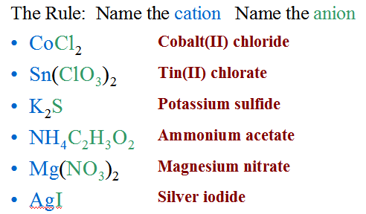

More Practice On the Web

- Nomenclature Activity
- game
- Worksheet
- More Worksheets

Homework
- An element that can form an ionic compound with oxygen is
  - hydrogen
  - carbon
  - sulfur
  - iron

- The formula for magnesium hydroxide is
  - MgOH
  - Mg₂OH
  - MgOH₂
  - Mg(OH)₂

- The name of the compound Ca₃N₂ is
  - calcium nitride
  - calcium nitrate
  - calcium nitrite
  - tricalcium nitrite

- The number of atoms in (NH₄)₃PO₄ is
  - 10
  - 14
  - 18
  - 20

- What is the name of the compound Ni(NO₃)₂?
- What is the formula for Iron(III)oxide?

Answers: 1) d 2) d 3) a 4) d 5) nickel(II)nitrate 6) Fe₂O₃ or Fe2O3 on the test

