The Periodic Table
Chapter 7

Chapter 7: The Periodic table and the atom
- Dalton’s Atomic Theory
- Periodic table
- Models of the Atom
- Subatomic Particles
- Describing Individual Atoms
- Isotopes
- Bohr Model of Atom (Year: 1913)
- The electron as a wave

Dalton’s Atomic Theory (1803)
- Elements are made up of atoms that are indivisible and indestructible.
- All atoms of an element have the same mass. No two different elements have the same mass.
- Compounds consist of small whole number ratios of elements.
- Elements are not changed during chemical reaction.

- Matter is composed of atoms. An atom is one of the 100+ elements.
- Each element has a name and a chemical symbol.
- The symbol is 1 to 2 letters. The first is capitalized, the second, is there is one, is lowercase. Example: F , Cl
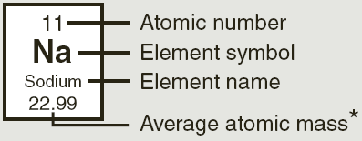

Periodic table
- Columns are called groups.
- Elements in the same group have similar properties.
- Rows are called periods.
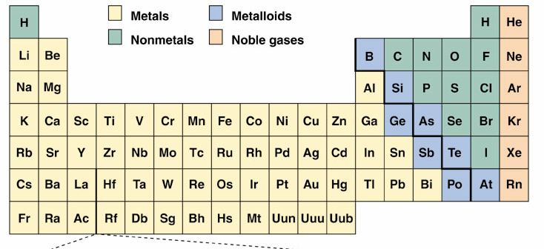
- Groups (vertical)
- 1A = alkali metals
- 2A = alkaline earth metals
- 7A = halogens
- 8A = noble gases

- Element: A substance made of atoms of one element.
- Compound: A substance made of atoms of 2 or more elements chemically bound together. Example: H2O
- Mixture: 2 or more elements and /or compounds not chemically bound together. Example: saline solution
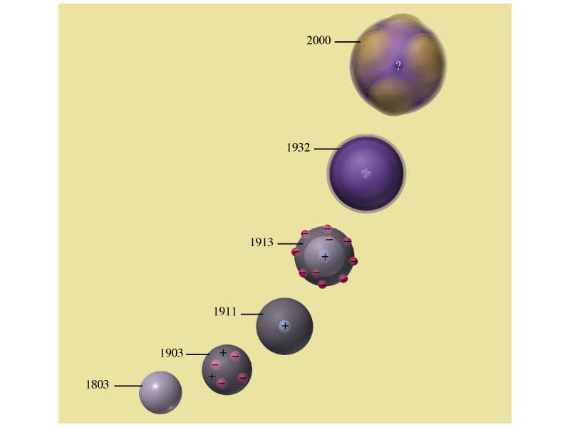
  - Homogeneous
  - Heterogeneous

Models of the Atom

1903 Thomson – The plum pudding model
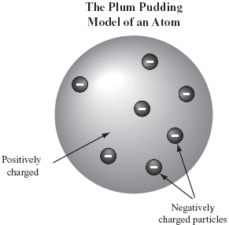

Steve’s Choc Chip Cookie model
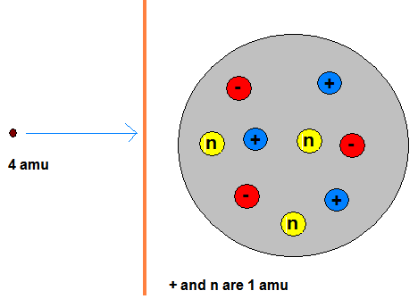

Rutherford’s Alpha Scattering Experiment
The Results!
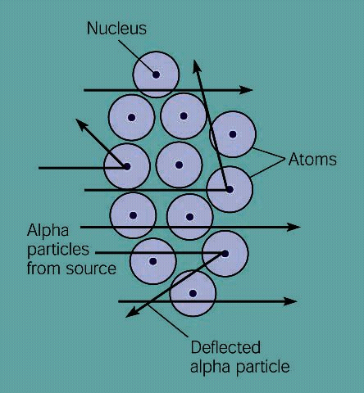

Subatomic Particles
Particle symbol l location charge mass
Electron e- orbital -1 1/1836
Proton p+ nucleus +1 1
Neutron n nucleus 0 1
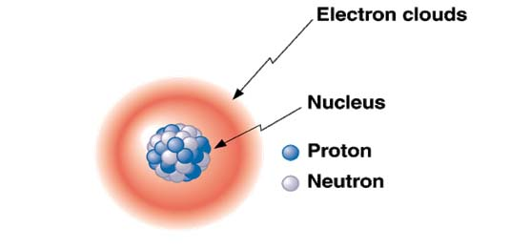

Describing Individual Atoms
${}_{\text{Atomic number}}^{\text{Mass Number}}{}{\text{Symbol}}^{\text{Charge}}$${}_{\text{protons}}^{\text{protons }+\text{ neutrons}}{}{\text{Symbol}}^{\text{protons- electrons}}$

Example
${}_{\text{50}}^{\text{119}}{}{\text{Sn}}^{2+}$

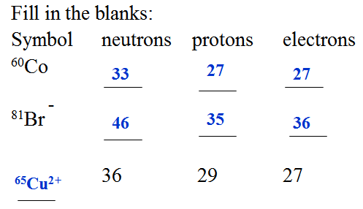
Isotopes
- Isotopes are atoms with the same number of protons but different numbers of neutrons.
- Same element, different mass.
- Some isotopes are stable, others are not.
- The masses on the periodic table are weighted averages.
- Isotopes of hydrogen and carbon.
Chlorine
- Chlorine is 75% chlorine-35 and 25% chlorine-37. What is the average mass?

Radiant Energy Spectrum
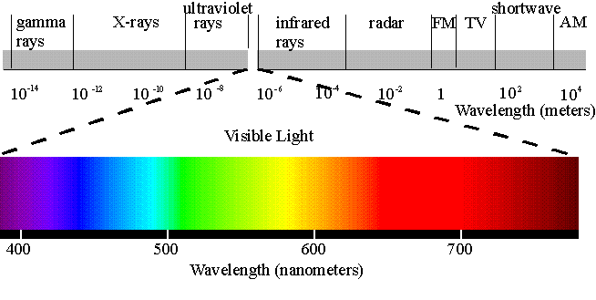
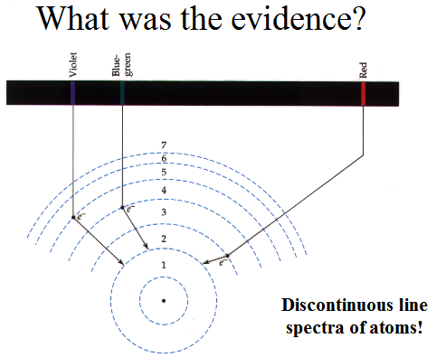
Bohr Model of Atom (Year: 1913)
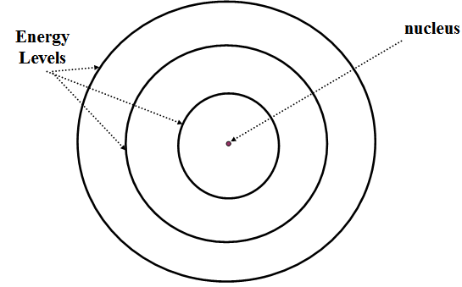

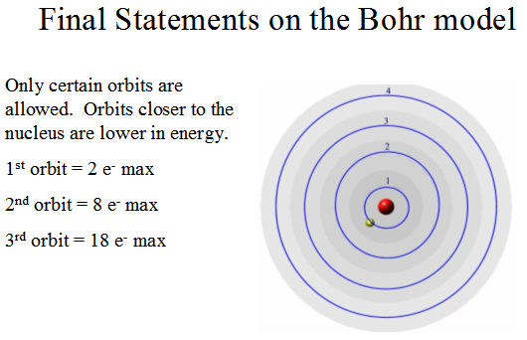

The electron as a wave
- Einstein, “Light, a wave, can have particle like properties”
- De Brolie, “particles, like electrons, can have wave-like properties”
- Scrödinger, “Came up with an equation that describes an electron”

The Players

The outcome
- n, principle quantum number. Correlates with shell of Bohr model
- l, subshell. Correlates with type of orbital, s p d or f.
- ml, orientation. p_{x}, p_{y} or p_{z}.
- s, spin. ↑or ↓

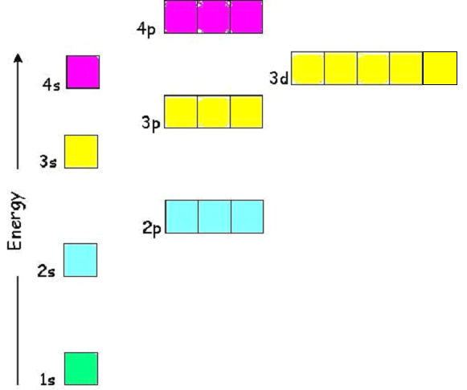
The first shell only has an s orbital
The second shell has s& p orbitals
The third shell has s, p d orbitals

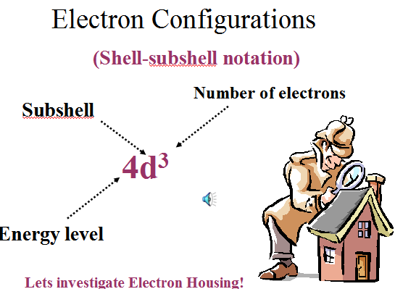

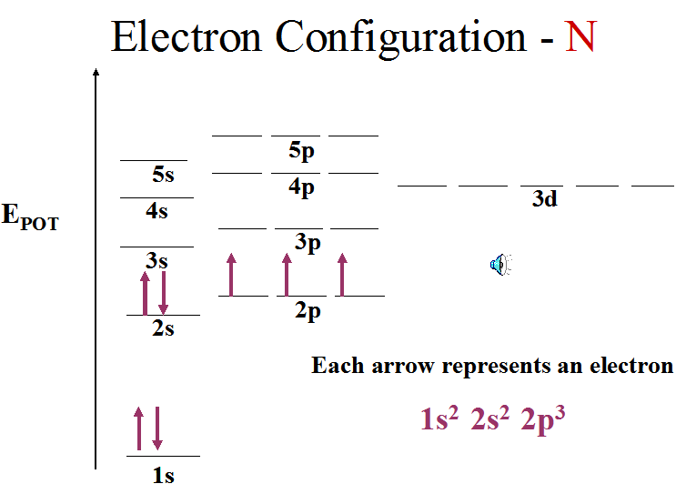

Homework
- Which elementary particle(s) are in the nucleus?
  - electron. (B) neutron. (C) proton. (D) protons and neutrons. (E) protons and electrons.

- Which elementary particle has a positive charge?
  - electron. (B) neutron. (C) proton.

- The nucleus of a certain nitrogen atom contains 7 protons and 8 neutrons.
The atomic number of the nucleus is ___

- The nucleus of a certain nitrogen atom contains 7 protons and 8 neutrons.
The mass number of the above nucleus is ____.

- The nucleus of an atom cannot be said to
  - contain most of the atom's mass.
  - be small in size.
  - be electrically neutral.
  - deflect alpha particles that come near it.

- How many protons are in the nucleus of a chlorine-37 atom?

- How many neutrons are in the nucleus of a chlorine-37 atom?

- Sulfur contains two naturally occuring isotopes, sulfur-32 and sulfur-34. If the weighted average is 32.1 amu, which is there more of?

Answers: 1) D 2) C 3) 7 4) 15 5) C 6) 17 7) 20 8) The sulfur-32. The average is closer to 32.

