PSC1341 Chapter 6
Thermal Energy & Gas Laws

Chapter 6: Thermal Energy & Gas Laws
- Temperature
- Phases: Solid, Liquid, Gas
- Phase Changes, the heating cooling curve
- Kinetic Molecular Theory
- Gas Behavior
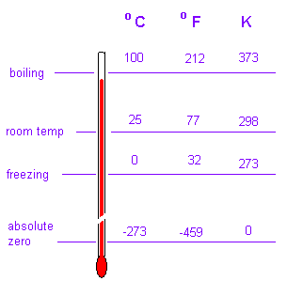
- Gas Laws

Temperature
- Temperature is a measure of the average kinetic energy of the molecules.
- Kinetic Energy is ½mv².
- As temperature increases, the velocity of the molecules increases.

Temperature Conversions
$F=\frac{9}{5}C+\text{32}$

K=C+273

Phases

Solid
- Attractive forces overcome the kinetic energy so neighbors do not change.
- Definite shape and definite volume
- Are generally the most dense of the three phases
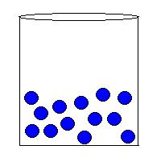
Liquid
- Attractive forces and kinetic energy both play a role
- The attractive forces keep a definite volume but the kinetic energy allows the molecules to move past each other.
- Takes the shape of the container.
Gas

- kinetic energy has overcome any attractive forces so the molecules do not stick together.
- Take the shape and volume of the container
- Generally are less dense than liquids

Attractive forces
- Water’s attractive forces are hydrogen bonds. Ice (mp = 0 ºC, bp 100 ºC) is a molecular solid.
- Salt (Ionic solid) and diamonds (covalent solid) have high melting points.
- Propane’s attractive forces are London forces. Propane has a very low mp and boiling point. It is a gas at room temperature.
Very Very Strong | Strong | Weak
Ionic and covalent | Hydrogen bonds | London forces

What is happening to water during a phase change?
- When there are temperature changes, the molecules move faster.
- During melting some of H-bonds break.
- During vaporization, all the rest of the H-bonds break.
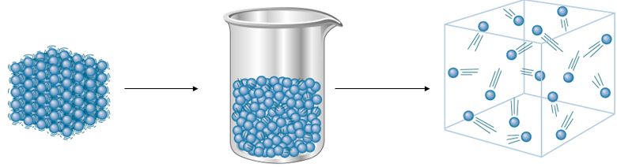
Heating & Cooling Curve
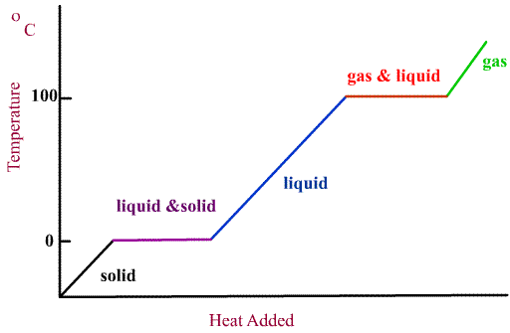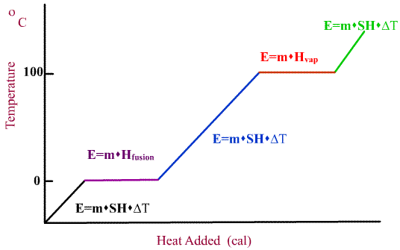

Sample: How much heat is required to vaporize 100. g of water from 37°C ?

Names of phase changes
(Increasing elevation lowers atmospheric pressure which lowers boiling point)
Kinetic Molecular Theory (Ideal Gas)
- Gas molecules moving in straight lines in constant random motion
- Temperature related to KE(1/2 mv²)
- Molecules act like billiard balls, collisions are elastic.
- Volume of molecules small compared to volume of the gas. An ideal gas molecule has no volume.
- Gas molecules do not stick to each other. Ideal gases have no attraction.
- Pressure is related to collisions with the side wall of the container.

Properties of Gases
- Volume, V: measured in liters (L)
- Amount, n: measured in moles
- Temperature, T: measures in Kelvin (K)
  - K = C+273.15
- Pressure, P: measured in atmospheres (atm)
  - 760 torr= 760 mm Hg = 1 atm
  - 14.70 lb/in² = 1 atm

Pressure in a closed system
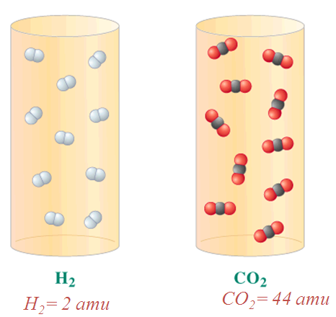
- P=force/area
- in a closed system, the force is the molecules hitting the sidewall of the container.
- The area is the area of the walls of the container.
Cool demo
A better demo

2 tanks, equal T, V, P and n
All gases tend to act the same. There are no attractive forces to differentiate a H₂ and a CO_{2.}

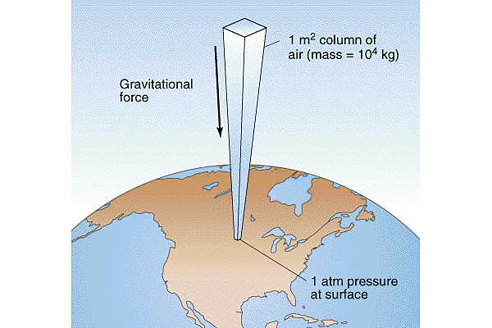
Pressure in an open system
What is the pressure of the atmosphere on your book sitting on your desk?
- Pressure=force/area.
- The area is the areas of the top of the book.
- Imagine a column of gas extending from your book to the top of the stratosphere. The force comes from the weight of that gas pushing down. (F=mg where g= 9.8m/s²).

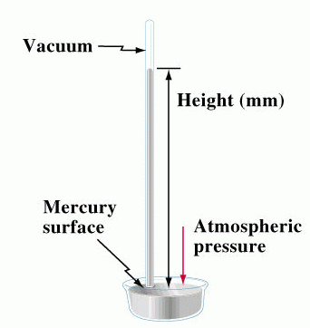
Barometer
- An instrument that measures atmospheric pressure
- Hg in tub feels weight of 1 atm
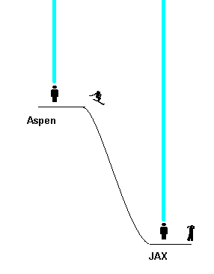
- Hg in bottom of tube feels weight of 760 mm Hg
- Which is denser air or Hg?
Pressure in Aspen vs. Jacksonville

Effects on Pressure
- Increasing temperature, increasing the number of moles and decreasing volume all increase pressure.
- These observations along with a mathematical model based on an ideal gas lead to the ideal gas equation:

Describing Gases
- Since all gases act mostly like ideal gases, they follow the same behavior, described by
PV=nRT
- R= 0.08206 L atm/mole K.

What is the volume of one mole of air at STP, 1.00 atm and 0 ºC?

Combined Gas Law
$\frac{\text{PV}}{\text{nT}}=R$$\frac{P_{1}V_{1}}{n_{1}T_{1}}=\frac{P_{2}V_{2}}{n_{2}T_{2}}$
so

At times 1 and 2.

Generally we worked with closed or sealed systems so n₁= n₂ .
The number of moles stays the same.
$\frac{P_{1}V_{1}}{T_{1}}=\frac{P_{2}V_{2}}{T_{2}}$

A sample of 23.0 L of NH₃ gas at 10 ºC is heated at a constant pressure until it fills a volume of 50.0 L. What is the new temperature in ºC?
Note that constant pressure means that P₁= P₂

How do I know which equation to use?
- If you see “changing”, “moved”, “compressed”, use the combined gas law equation.
$\frac{P_{1}V_{1}}{T_{1}}=\frac{P_{2}V_{2}}{T_{2}}$

- If you are asked about a single situation, use the ideal gas equation.
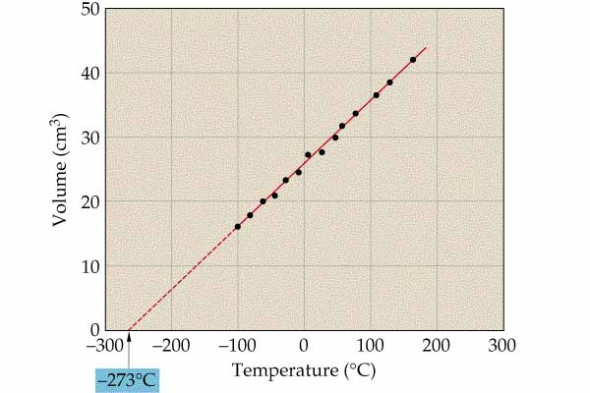
PV = nRT

Determining absolute zero

Partial Pressure Defined
- The partial pressure of a single gas in a mixture is defined as the pressure the gas would exert if it were alone in the container.
- PV=nRT holds for each individual gas in a mixture, as well as for the total mixture.

Air
Air | 100% | 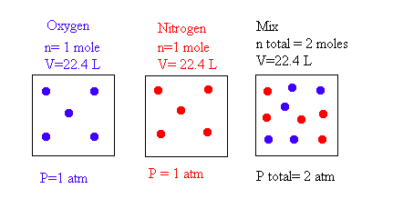1.00 atm
Nitrogen  (N₂) | 78% | 0.78 atm  (partial pressure of N₂)
Oxygen  (O₂) | 21% | 0.21 atm  (partial pressure of O₂)
Other stuff | 1% | 0.01 atm
Sample: A piston is squished from 20.0 mL to 5.0 mL. If the starting pressure is 1.00 atm, what is the final pressure? Assume temperature is constant.

Sample: How many moles of gas are in a balloon that has a pressure of 1.11 atm, a temperature of 25 °C and a volume of 4.00 L?

Sample: A rigid metal container contains a gas at temperature of 298K and a pressure of 2.34 atm. This gas is heated to a temperature of 398K. What is the final pressure?

Homework
- Molecules are, in general, farthest apart from one another in
(A) gases (B) liquids (C) solids

- The temperature of a gas sample in a rigid container is raised. The pressure the gas exerts on the container walls increases because
  - the molecules are in contact with the walls for briefer intervals
  - the molecular masses increase
  - the molecules have higher average speeds and so strike the walls more often and with greater momentum
  - the molecules lose more kinetic energy each time they strike the wall

- Molecular motion in a gas is the minimum possible at
  - 0°F
  - 0°C
  - 0 K
  - -273 K

- Which of the following statements about gases are true? Provide the best answer.
  - Gas molecules are small compared with the average distance between them.
  - Gas molecules collide without loss of kinetic energy.
  - Gas molecules exert almost no forces on one another, except when they collide.
  - All these statements are true.
  - All these statements are not true.

- The average human body temperature is 98.6°F. What is the equivalent temperature on the Celsius scale?
  - 22.8°C
  - 37.0°C
  - 51.2°C
  - 209.4°C

- A rigid container initially at 1 atm and 27°C is heated to 327°C. The volume of the container remains 1 liter. What is the final presure?
  - 0.0826 atm
  - 0.500 atm
  - 2.00 atm
  - 12.1 atm

- A piston with a volume of gas of 70.0 ml at 1.35 atm is compressed to a final volume of 22.5 ml. What is the final pressure?

Answer
1. A 2. C 3. C 4. D (They are all true, see kinetic molecular theory) 5. B 6. C( The trick here is to remember to convert temperatures to Kelvin) 7. (P₁V₁)/V₂= P₂ = (1.35 atm * 70 mL)/22.5mL= 4.2 atm

