Covalent compounds
Chapter 10
Covalent Compounds
- Some Simple Lewis Structures
- Possibilities for hydrogen and 2nd period elements.
- Carbonate, HCN, Acetate
- Shapes of molecules, VSEPR
- Naming covalent molecules

Covalent compounds
- Covalent bonds: between two non-metals.
- involves sharing electrons.
- electrons will exist in pairs.
- Atoms will share electrons to get 8 electrons in their outer shell. (Except hydrogen)
- Bonding electrons: shared pairs of electrons.
- Lone pairs: unshared pairs of electrons.

Hydrogen, H₂
- Each begins with one electron.
- Needs two to get the NG config of He (2 e-)
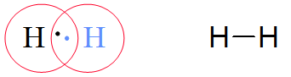

Fluorine, F₂
- Each F begins with 7 valence electrons.
- Needs to share one more with the other F.
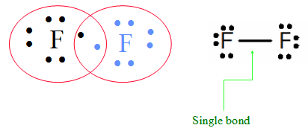
Oxygen, O₂
- Each oxygen begins with 6 electrons.
- Needs to share two more electrons.
- An example of a double bond.
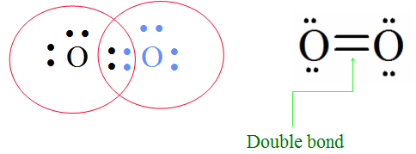
Nitrogen, N₂
- Each nitrogen begins with 5 electrons.
- Must share three more electrons.
- An example of a triple bond

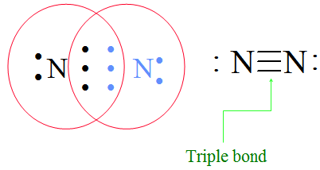
Water, H₂O
- Each H has I e- and needs to hare 1 more.
- O has 6 and needs to share 2 more
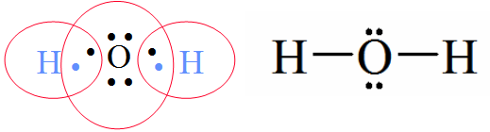
Carbon and hydrogen
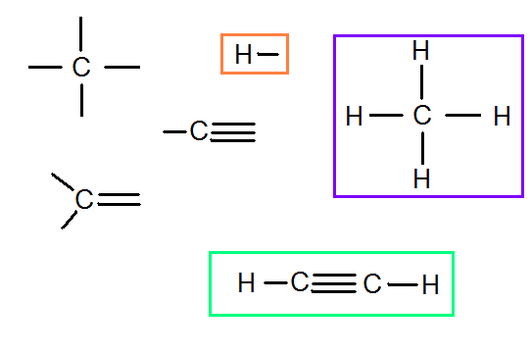
N, O, and F
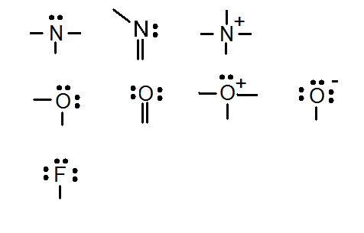
Carbonate
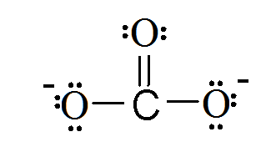
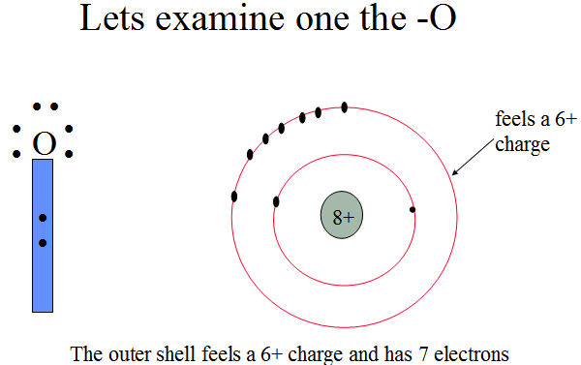
Formal Charge
- FC=Group# - # of bonds – e- in lone pairs
- For that oxygen FC=6-1-6 = –1
- Include the formal charge for every atom in a Lewis structure
- The sum of the individual formal charges equals the overall charge.
The central atom
- The first non-hydrogen atom is usually the central atom.
- Hydrogen is always terminal and so never can be the central atom.
- Carbon is always a central atom.
- There is often more than one central atom.
- If hydrogen is the first atom in the formula, it is usually acidic and attached to oxygen.

HCN
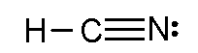

Acetate, CH₃CO₂⁻
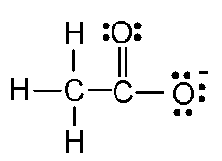

Shapes of molecules, VSEPR
- electrons repel
- areas of electron density repel equally
  - Areas of electron density
    - single bond
    - double bond
    - triple bond
    - lone pair
In this class we are only concerned with the geometry around the central atom.

Types of shapes
Areas of e⁻ density | shape | bond angles
2 | linear | 180º
3 | trigonal planar | 120º
4 | tetrahedral | 109.5º

table

Tetrahedral
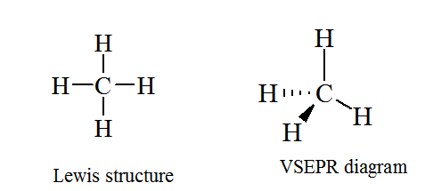

Water is also tetrahedral
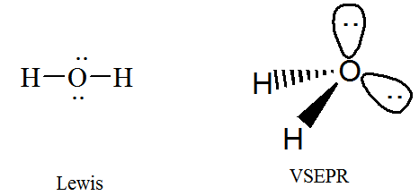

trigonal planar
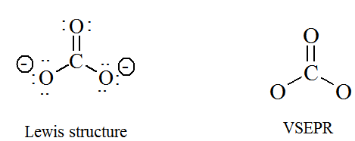

Linear
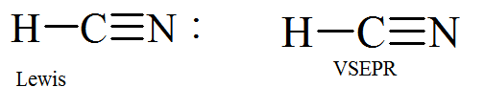

Naming simple covalent compounds
1. Name the first non-metal by it’s elemental name.
2. Name the second nonmetal by its elemental name and an -ide ending.
3. Use the prefixes mono, di, tri, tetra, penta and hexa to denote number of atoms of that element in the molecule.
4. If mono is the first prefix it is understood and not written.

When the addition of the Greek prefix places two vowels adjacent to one another, the "a" (or the "o") at the end of the Greek prefix is usually dropped; e.g., "pentaoxide" would be written as "pentoxide ", and "monooxide" would be written as "monoxide". The "i" at the end of the prefixes "di-" and "tri-" are never dropped.

Examples
- CO carbon monoxide
- CO₂ carbon dioxide
- P₂O₅ diphosphorous pentoxide
- NO nitrogen monoxide
- N₂O dinitrogen monoxide
- NO₂ nitrogen dioxide

Homework
- What is the name of N₂O₅?
- What is the name of NCl₃
- What is the formula of diphosphorous pentasulfide?
- What is the formula of boron trifluoride?
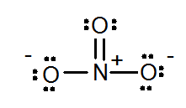
nitrate
- What is the shape of the nitrogen in nitrate?
- What are the bond angles of the nitrogen in nitrate?

1) dinitrogen pentoxide 2) nitrogen trichloride 3) P₂S₅ 4) BF₃ 5) trigonal planar 6) 120º

