PSC1341 Chapter 3
Work, Power and Momentum

Chapter 3: Work, Power and Momentum
- Work
- Power
- Simple Machines
- Energy
- Kinetic energy
- Potential energy
- Law of Conservation of Energy
- Momentum
- Law of Conservation of Momentum

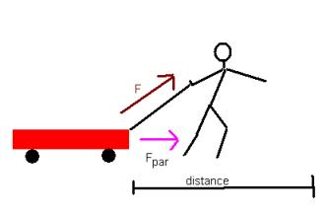
Work
- Work = Force times Distance W=Fxd
- Force is a vector quantity and only that part of the force that is parallel is the force of work so W=F_{par}d.

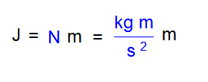
Units for Work
- W=Fd= mass * acceleration * distance
- The units for work are the Joule
- 4.184 J = cal
- 1000 cal = kcal=Cal

Power
- Power is the rate at which work is being done or the rate at which energy is transformed.
- $P=\frac{W}{t}$P=W/t
- Its unit for power is the watt (W), which is a joule/sec.
- One horsepower is equal to 750 watts.
- We usually think of kilowatts or Megawatts as in electricity generation or usage (check your utility bill).

Sample Problem: An Electronic lift can raise a 500.0 kg mass a distance of 10.0 m in 5.0 seconds. a) What was the work done by the lift? b) What is the power of the lift?

Simple Machines
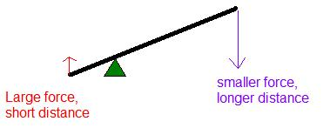
- Simple machines generally use a smaller force over a longer distance to get the same work done. A lever (like a crowbar) can apply a greater force over a small distance

http://www.edinformatics.com/math_science/simple_machines/

Energy
- Energy is the ability to do work.
- The unit of energy is the joule, the same unit as work.
- There are two major categories of energy, kinetic and potential energy

Kinetic Energy
- Kinetic energy is the energy of motion.
- $$\text{KE}=\frac{1}{2}{\text{mv}}^{2}$$

How much energy does Tony Boselli (320lbs, 145 kg) have running at 4.00 m/s (9 miles per hour)?
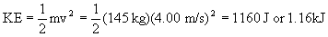

Potential energy
- Potential energy is stored energy often due to an object's position or configuration.
- The potential energy of a mass due to gravity can be calculated by the work required to reach that height.
- The potential energy= work =m*g*h
- M is mass in kg, g is the acceleration due to gravity (9.8 m/s²) and h is the height in meters,
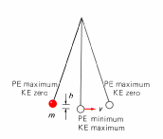
The Law of Conservation of Energy
- According to the law of conservation of energy, energy cannot be created or destroyed, although it can be changed from one form to another.
- KE + PE = constant

Energy Transformations
- Forms of Energy: Mechanical, Electrical, Chemical, Radiant (light), Thermal (heat), Sound, Nuclear
- Types of Energy: Kinetic, Potential
- Steve is converting chemical potential energy in pasta to mechanical kinetic energy.
- My car converts chemical potential energy in gasoline to mechanical kinetic energy.

Momentum
- $F=\frac{Δp}{Δt}$Momentum is a measure of how hard it is to stop a moving object
- It is the product of the object's mass and its velocity (p=m*v) where p is momentum,, M is mass in kg and v is velocity in m/s. The units for momentum are N*s or kg m/sec.
- The rate of momentum of a body is proportional to the net force applied to it.

Conservation of momentum
- In the absence of outside forces, the total momentum of a set of objects remains the same no matter how the objects interact with one another.

Sample Momentum Problem
A 100-kg astronaut ejects a 500 g camera at a speed of 6.0 m/s. The recoil speed of the astronaut will be what?

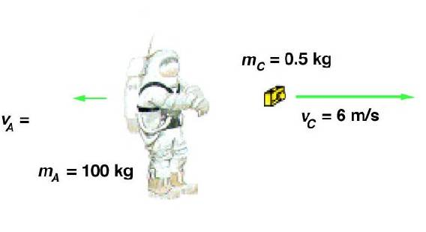
Solution:
The camera weight: 500g x 1 kg/1000g = 0.5 kg
Momentum is conserved.
Initially the momentum of the astronaut with the camera is 0.0.
At the end, the momentum of the astronaut plus the camera still equals zero.
The mass and the velocity of the astronaut are m_{a} and v_{a.}
The mass and the velocity of the camera are m_{c} and v_{c.} Note that I have to use the camera weight in kg so units cancel out.

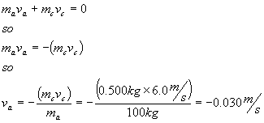

Homework
- A large (heavy) and a small (light) sphere are released at the same time from the same height above the ground. Which one of the following quantities associated with the spheres will be the same for both after 1 second, if frictional effects are ignored?
(A) speed (B) momentum (C) potential energy (D) kinetic energy

- A 1000.0 kg car stops on top of a 50.0 m hill. How much energy was used in climbing the hill?
(A) 50,000 J (B) 9,800 J (C) 20 J (D) 490 kJ or 490,000 J

- A rocket is fired in space. As it moves, the total momentum of the rocket and its exhaust gases
(A) decreases. (B) remains the same. (C) increases.

- A 100-kg astronaut ejects 1 g of gas from her propulsion pistol at a speed of 50 m/s. Her recoil speed is
(A) 0.5 mm/s (B) 5 mm/s (C) 5 cm/s (D) 50 cm/s

- A 40-kg boy runs up a staircase to a floor 5 m higher in 7 s. His power output is
(A) 29 W (B) 280 W (C) 1.4 kW (D) 13.7 kW

- The watt is a unit of
(A) energy (B) work (C) momentum (D) power

- Energy possessed by a body due to its motion is
(A) kinetic energy (B) nuclear energy (C) potential energy (D) thermal energy

- Energy possessed by a body due to its configuration is
(A) kinetic energy (B) nuclear energy (C) potential energy (D) thermal energy

- A body of mass 2 kg is dropped from a height of 1m. Its kinetic energy as it touches the ground is _______

(A) 19.6 N (B) 19.6 J (C) 19.6 kg (D) 19.6 m

- Why do the particles (molecules, atoms) in matter have KE?

- How is this molecular motion related to temperature?

- A 78.0 kg student decides to exercise by climbing a hill that rises vertically by 63.6 meters(m). What is the work done by the student?

- the information from question 11, if the student makes the climb in 200 seconds, what is the power output of the student (in Watts)?

Answers:
- speed, all the rest have mass in the equations
- D W = mgh
- B Law of Conservation of momentum
- A Icky problem. Convert 1 gram to .001 kg. Churn it through the conservation of momentum equation. The velocity of the astronaught is .0005 m/s which is 0.5 mm/s
- B First you have to find Work. W=mgh (40 kg*9.8m/s² * 5m) P=W/t
- D
- A
- C
- B Kinetic energy at the bottom equals potential energy at the top. PE=W=mgh
- The particles are always in motion. KE=1/2 mv²
- The higher the temperature, the faster the molecules move, the higher the kinetic energy.
- 48616 J
- 243 W

