PSC1341
Chapter 12
Chapter 12
- Acids and bases
- pH scale
- Buffer systems
- Organic compounds
- Writing organic structures
  - Condensed formulas
  - Stick figures
- Naming simple organic molecules
- Functional groups
- Functional groups in drugs

Acids and Bases
Part A
Arrhenius

•Acid: A substance that make H+ (H3O+) when dissolved in water.
•Base: A substance that makes OH- when dissolved in water.
•An acid/base reaction occurs when and H+ from an acid reacts with an OH- from a base.

Acids

•Strong acids: Dissociate completely when dissolved in water.
–HCl, HNO3

•Weak acids only dissociate a little bit.
–CH3CO2H, H₂CO₃

Base
•Strong base: dissociates completely when dissolved in water.
–NaOH, KOH
•Weak base: Makes only a little bit of OH-

- NH₃, HCO₃⁻

ACIDS AND BASES

Acids | Bases
HCl (hydrochloric acid or muriatic acid) | Cl⁻ (chloride ion)
H₂SO₄ (sulfuric acid) | SO₄²⁻ (sulfate ion)
H₃O⁺ ( hydronium ion) | H₂O (water)
CH₃CO₂H (acetic acid) | CH₃CO₂⁻ (acetate ion)
H₂CO₃ (carbonic acid) | HCO₃⁻ (bicarbonate)
NH₄⁺ (ammonium ion) | NH₃ (ammonia)
H₂O (water) | OH⁻ (hydroxide ion)

Water
•Water auto-ionizes
H2O + H2O  H3O+ + OH-
acid base [10-7M] [10-7M]
$K=\frac{\left[H_{3}O^{+}\right]\left[{\text{OH}}^{−}\right]}{{\left[H_{2}O\right]}^{2}}=\left[H_{3}O^{+}\right]\left[{\text{OH}}^{−}\right]=1×{\text{10}}^{−\text{14}}$

The big six

1. [H+] [OH-]= 10-14
2. pH = -log [H+]
3. pOH = -log [OH-]
4. [H+]=10-pH

5. [OH-]=10-pOH

6. pH + pOH = 14

pH scale
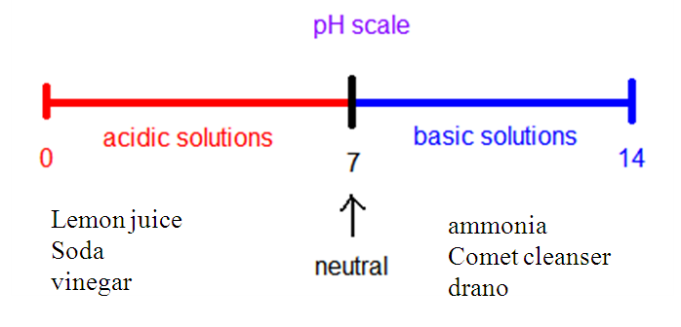
Quiz

- Is a blood solution with a pH of 7.26 acidic or basic? Answer: Basic
- Is “Clean Shower” with a pH of 5.00 acidic or basic? Answer: Acidic
- Would you expect an carbonic acid (H₂CO₃) solution to be acidic or basic? Acidic
- Would you expect an ammonia (NH₃) solution to be acidic or basic? basic

Buffer solution
A buffer solution keeps the pH approximately the same even upon the addition of a strong acid or strong base.
- Need a weak acid.
- Its conjugate base.
- Present in a large enough quantity to resist the pH changes.

CH₃CO₂H/CH₃CO₂⁻
- If you add an acid, H+, The base of the buffer reacts.
  - H⁺ + CH₃CO₂⁻ à CH₃CO₂H
  - H₃O⁺ + CH₃CO₂⁻ à H₂O + CH₃CO₂H
- Of you add a base, OH-, the acid of the buffer system reacts.
  - CH₃CO₂H + OH⁻ à H₂O + CH₃CO₂⁻

Organic Molecules
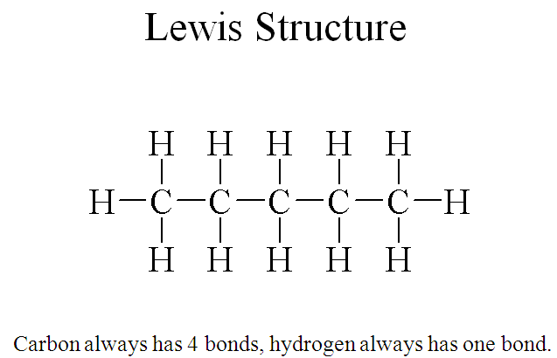
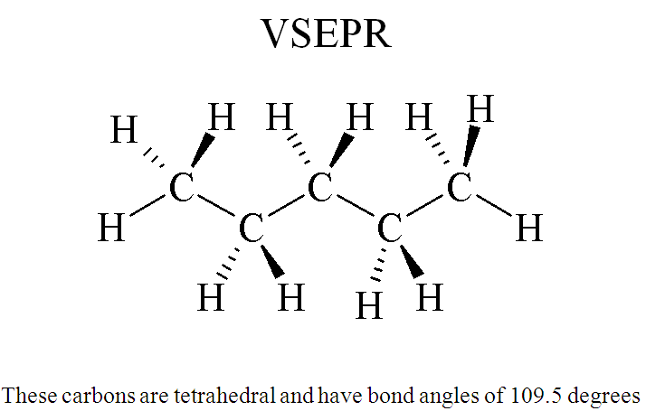
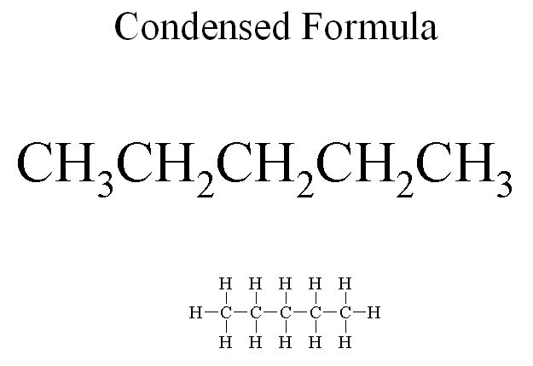
Stick figures
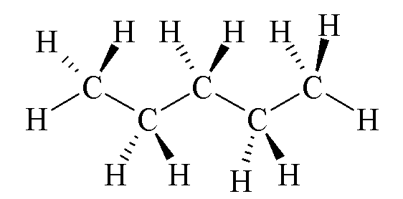

Stick Figures (Rules)
- Hydrogens attached to carbons are not shown. (Hydrogens attached to hetero-atoms are shown)
- Each vertex and terminus is a carbon.
- All hetero-atoms are shown explicitly.

Example

How many carbon atoms? 4
How many hydrogen atoms? 8
How many oxygen atoms? 2
Names of straight chain alkanes

Name | Formula |  | Condensed formula
methane |  | CH₄ | CH₄
ethane |  | C₂H₆ | CH₃CH₃
propane |  | C₃H₈ | CH₃CH₂CH₃
butane |  | C₄H₁₀ | CH₃CH₂CH₂CH₃
pentane |  | C₅H₁₂ | CH₃ CH₂CH₂CH₂CH₃
hexane |  | C₆H₁₄ | CH₃CH₂CH₂CH₂CH₂CH₃
heptane |  | C₇H₁₆ | CH₃CH₂CH₂CH₂CH₂CH₂CH₃

2-methyl pentane
Use -ane ending for the main chain and –yl ending for side chains

Table Prefixes used to show the presence of one to ten carbons in an unbranched chain.
Prefix | Number of Carbon atoms | Prefix | Number of Carbon atoms
meth- | 1 | hex- | 6
eth- | 2 | hept- | 7
prop- | 3 | oct- | 8
but- | 4 | non- | 9
pent- | 5 | dec- | 10

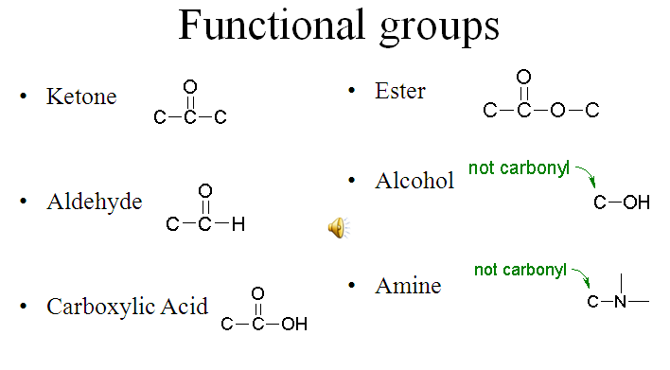
Functional groups in stick figures
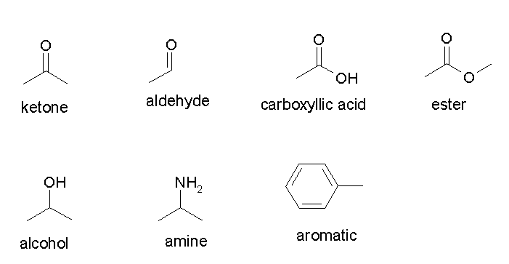
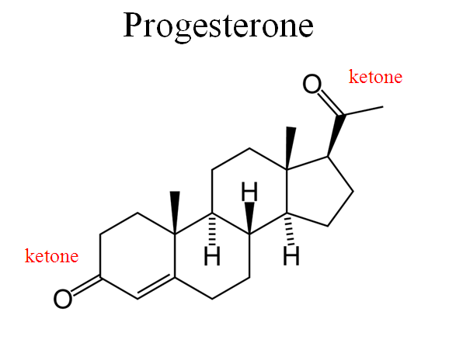
Niacin
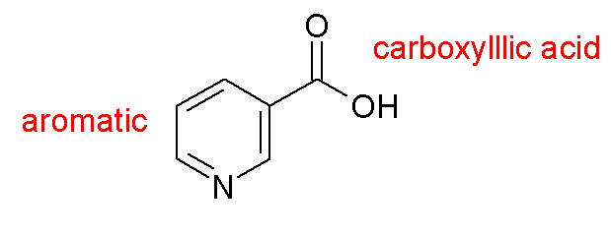
Asprin
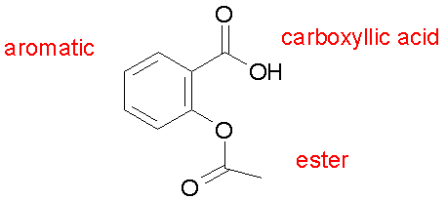
Homework
- Would you expect a solution of H₂CO₃ to be acidic or basic?
- Would you expect a solution of HCO₃⁻ to be acidic or basic?
- A solution has a pH of 11.0. Is the solution acidic or basic?
- A solution has a pH of 4.30. Is the solution acidic or basic?
- How many carbons in the above structure?
- How many hydrogens in the above structure?
- What is the name of this compound?

1. acidic 2. Basic, it is on the base side of the chart. 3. Basic, it is above seven. 4. Acidic, it is below seven. 5. Seven 6. Sixteen 7. heptane

