PSC1341 Chapter 2
Equations of Motion

Chapter 2: Equations of Motion
- Velocity & Speed
- Vector Quantities
- Acceleration
- Newton’s 3 Laws of Motion
- Gravitational Acceleration
- Equations of Motion
- Circular Motion

Speed and Velocity
- Speed is the distance traveled in a certain amount of time v = d/t
- Average speed is determined by total distance in total time
Avg v = d total/t total
- Instantaneous speed marks the speed of an object at a given moment in time.

- Speed = distance/time
- This equation can be rearranged to solve for distance or time.
- The speed (v) is the average speed.
- A scalar quantity is a value that does not have a direction associated with it.
- A vector quantity has an amount and a direction.
- Speed is a scalar quantity (25 mph) while velocity is a vector quantity (25 mph to the west).
- In this class we will measure speed in meters per second. (m/s)

$v=\frac{d}{t}$ $t=\frac{d}{v}$ $d=v×t$ or d=vt

Sample problem
Jonathon Papelbon pitches at 41.1 m/s. If the pitching mound is 18.4 meters from the plate, how many seconds does it take for the ball to reach the plate?
(Report your answer to three significant figures.)

Vector Quantities
- Direction is important.
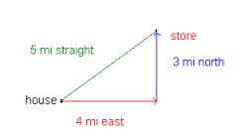

Acceleration
- Is the change in speed or velocity with time for motion in a straight line so that a = ∆v/t
- The units are usually m/sec² (meters per second squared)
$a=\frac{v_{f}−v_{i}}{t}$

Newton’s 3 Laws of Motion
- “An object at rest will remain at rest, and an object in motion will continue moving in a straight line unless it is acted upon by an outside force.”

- A force exerted on an object can change both its speed and direction; inertia is the resistance of an object to this change of speed and direction (greater mass means greater inertia).
2. “The net force exerted on an object is the product of its mass times its acceleration.”

- F = m a
  - Force in kg m/sec2 is the same as “1 Newton”
  - Mass in kg
  - Acceleration in m/sec2
- “Weight” is a force: w = m g
- Friction is a force.

Friction
- the force that resists relative motion between two bodies in contact
- Types of friction
  - Static (non-moving) friction
  - Kinetic or sliding friction
  - Rolling Friction
  - Lubricated friction

3. “For every action, there is an equal and opposite reaction.” If A exerts a force on B, then B exerts an equal and opposite force on A.
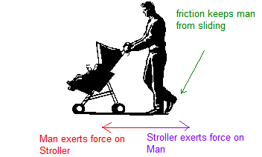

Gravitational Acceleration
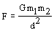
- the attractive force between objects with mass.
- the net force exerted by the Earth on objects.
- Acceleration due to gravity (on Earth) for free-falling objects is defined as g = 9.8 m/sec².

  - F = gravitational force (N)
  - G = gravitational constant
  - m1 = mass of object 1 (kg)
  - m2 = mass of object 2 (kg)
  - d = distance between the two objects (m)

Mass and Weight
- Mass is the property of matter that manifests itself as inertia and may be thought of as the quantity of matter in the body. The unit of mass is the kilogram (kg). The corresponding English unit is the pound.
- Weight is the force of gravity upon the mass. When asked for our weight, we typically respond with our mass (73 kg) because the force of gravity is pretty much the same everywhere on earth. The real units for weight are the Newton N. (My real weight would be 73 kg *9.8m/s2). Remember F=ma.

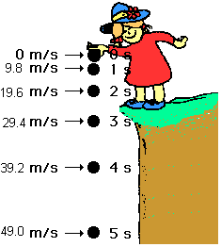
Falling objects
Note that the weight of the ball does not matter so a tennis ball will hit the bottom of the ditch at the same time as a bowling ball.

Actually this ignores the friction of the air, which does depend on weight and speed. Eventually, the friction of the air will limit the speed either can go. The limiting speed is called the terminal velocity

Equations of motion
$d=v_{\text{ave}}⋅t$ v_{f} = v_{i}+ a t
d = v_{i}t + ½ a t² v_{f}²= v_{i}² + 2 a d
$$v_{\text{ave}}={\left(v_{i}+v_{f}\right)}/2$$
$$a=\frac{v_{f}−v_{i}}{t}$$
Where v_{i} is the initial velocity, v_{f} is the final velocity, d is distance, t is time and a is acceleration.

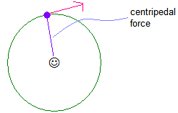
Circular Motion & Centripetal force
- Centripetal force is the inward pull exerted on an object that is moving in a circular path. It increases with greater mass, faster velocity or smaller radius (sharper curve).
- Fc = mv²/r

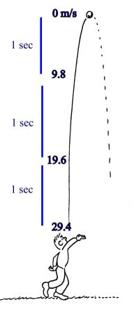
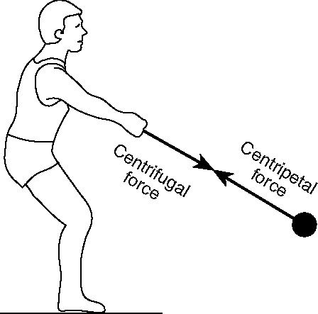

Sample Problem
A man throws a baseball straight up in the air at 29.4 m/s. How long does it take to reach the top? What is the speed at the top? What is the acceleration at the top? How long does it take to come down?

Sample Problem
A stone is dropped from the Empire State Building and strikes the ground 8.82 seconds later. How high is the building in meters? How high is the building in feet? (Ignore references to the book that we do not have.)

Homework:
- The cheetah is the world's fastest land mammal. It can run at speeds of up to 31.4 m/s (70 miles an hour or 113 kilometers an hour). How long would it take to travel the length of a football field, 91.4 m?
- An airplane travels at constant speed for a distance of 160 km in a time of ½ hour. Its speed is
- A stone is thrown upward from a roof at the same time as another identical stone is dropped from there. The two stones
  - reach the ground at the same time
  - have the same speed when they reach the ground
  - have the same acceleration when they reach the ground
  - none of the above

- Inertia is
  - An example of Newton’s first law of motion
  - defined as the tendency for an object to remain in uniform motion,
  - a term meaning resistant to change
  - altered by an unbalanced force
  - all of the above

- In which of the following cases is the net force on the object zero
  - A sports car accelerating from 0 to 60 in 3.4 seconds
  - The moon circling the earth
  - A high jumper at the peak of her jump
  - A motorcycle traveling at a constant velocity of 65 mph

- A car starts from rest with a constant acceleration of 2.0 m/s². In the first 4.0 s the car travels?
- A bicycle is traveling at 15.0 m/s. How many seconds does it take for the car to travel 129 meters?

Answer

- 2.91 seconds
- 320 km/hr
- C. The acceleration due to gravity is ALWAYS 9.8 m/s².
- E
- D (no change in speed means no acceleration so no force.)
- 16 m
- 8.60 seconds (see Papelbon problem)

m-w.com

