Chapter 16

Conjugation occurs whenever p orbitals are located on three or more adjacent atoms.

Butadiene

Butadiene described in hybridization theory:

Butadiene described in resonance theory:

Butadiene described in frontier molecular orbital theory:

Molecular orbital theory. A different way of looking at things

- In a molecule, atomic orbitals combine to form molecular orbitals.
- Atomic orbitals in equals molecular orbitals out.
- Atomic orbitals of similar energies combine most effectively.
- The effectiveness with which two atomic orbitals combine is proportioal to their overlap. As the overlap increases, the bonding orbital is lowered in energy and the anti bonding orbital is raised in energy.
- Both Hund’s rule and the Pauli exclusion principle still are true.

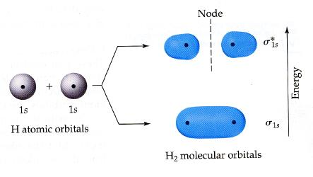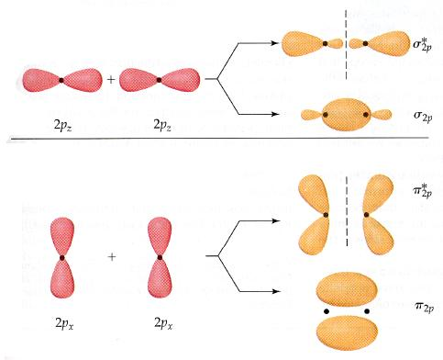

4 p orbitals in, 4 molecular orbitals out. http://www.chem.ucalgary.ca/SHMO/

Other examples of molecules with resonance & conjugation.

Reactions involving conjugated systems

Same w/ HBr

The Diels Alder Reaction: a 4+2

EDG on diene and EWG on dienophile usually help rxn.

note steriochemistry (endo rule)
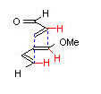
Claisen and Cope Rearrangements. A 1,5 diene relationship.

Cope

Claisen

