Benzene Structure
Hybridization Resonance

Molecular Orbital & Frost Circle

The Frost Circle: A method for describing the relative energies of molecular orbitals conjugated cyclic systems

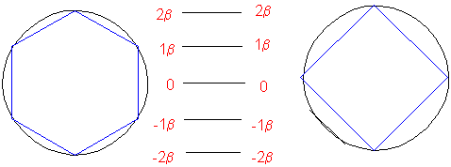

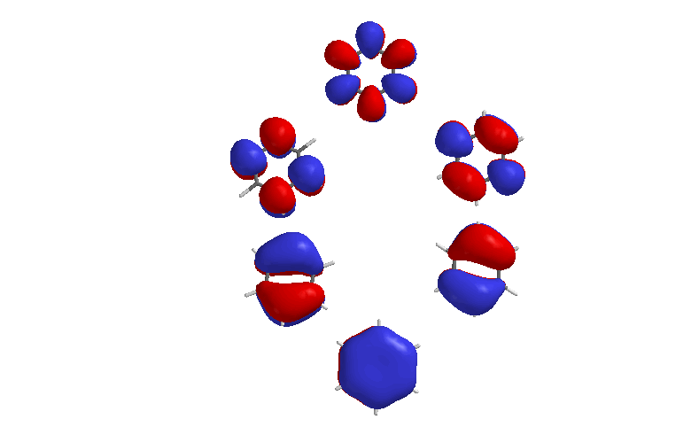

Huckel’s Rule
- Must be cyclic
- Must be planar (if not, non-aromatic)
- Must have 4n+2 electrons (If 4n, anti-aromatic)

Why anti?
Benzene all below the line.
Cyclobutadiene: 2 below, 2 at the line but unpaired. (Unpaired is less good.)

Nomenclature:
Mono-subtituted: The name of the substituent is listed first, followed by the word, "benzene”
Some have common names.
Ethyl Benzene Toluene Benzoic Acid Benzaldehyde Aniline Phenol Anisole
Di substituted : Use the common names when you can.
Example: 1,4-dichloro benzene or p-diclorobenzene
ortho-, or o- for the 1,2 isomer;
meta-, or m- for the 1,3 isomer;
para-, or p- for the 1,4 isomer;

1-chloro-3-nitrobenzene 2-methylbenzoic acid 3-aminophenol 2-methoxyphenol

