NMR of Aromatic Compounds
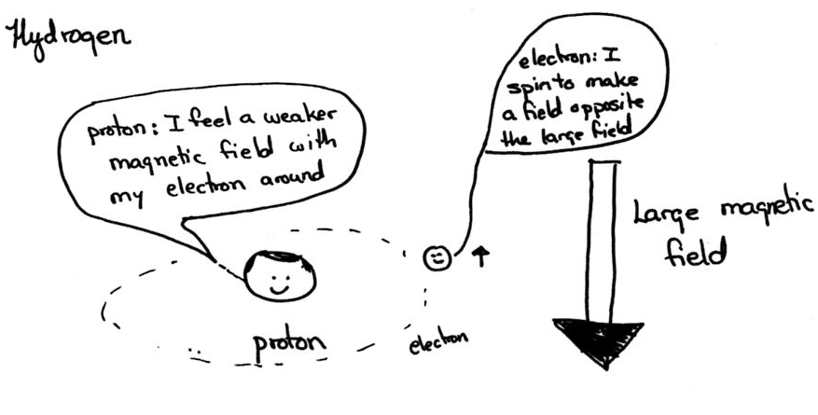
Electrons Shield

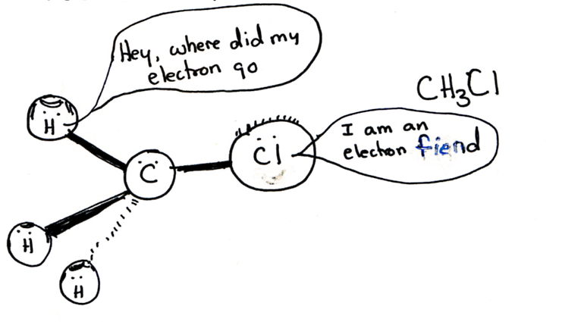Electron Withdrawing groups de-shield by removing electron density

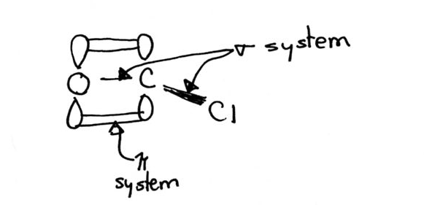
Electron density can be added or removed through the p or s systems

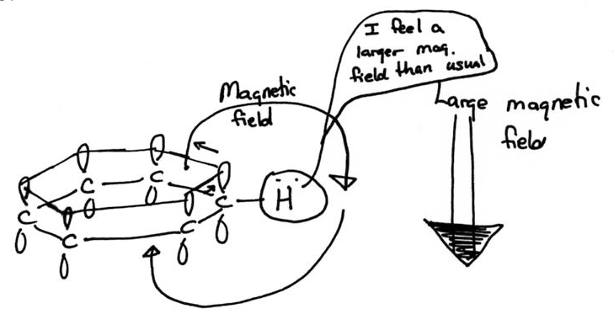
Ring currents usually deshield

Toluene: An alkyl group does not shift the signal very much. It is neither electron donating nor electron withdrawing.

Effects through the p system can be explained through resonance structures.
Electron withdrawing group: A lack of electrons will de-shield.
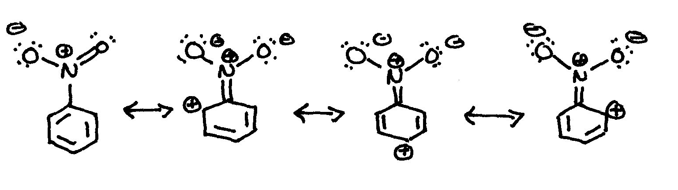

Electron donating group: Electrons will shield.
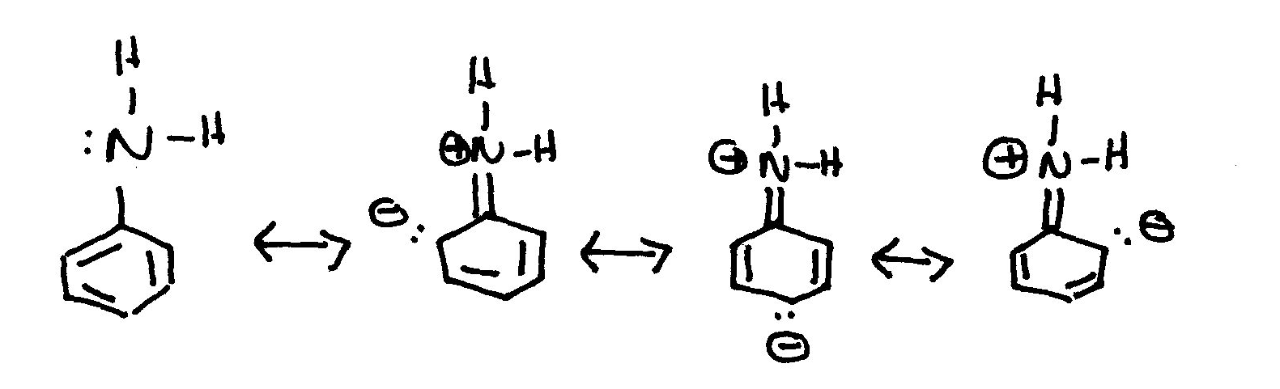

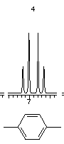
Di-substituted Aromatics
Para substitution gives a distinct splitting pattern.

