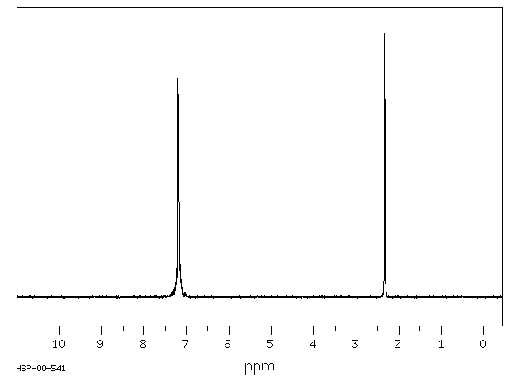

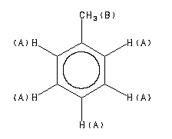
Assign. Shift(ppm)
A 7.38 to 7.00
B 2.34

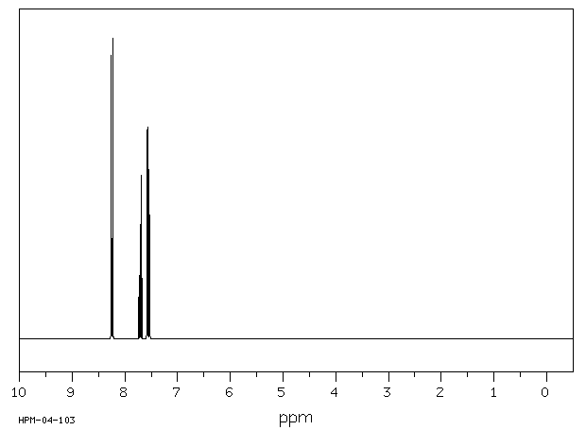
300 MHz
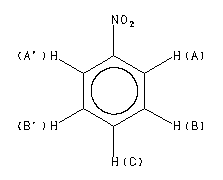

D(A) 8.245
D(B) 7.557
D(C) 7.705

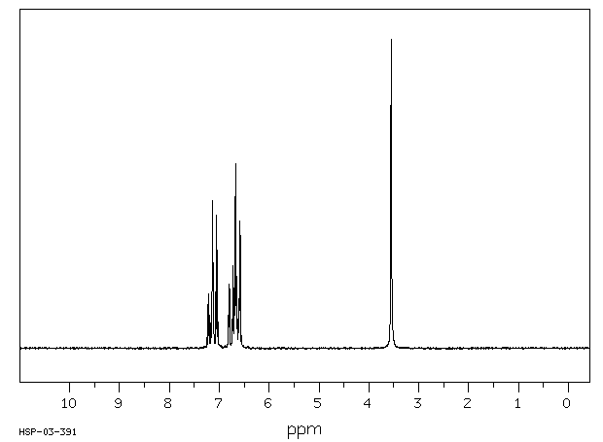

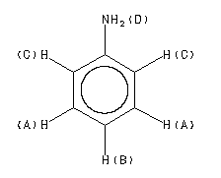

Assign. Shift(ppm)
A 7.12
B 6.73
C 6.64
D 3.55
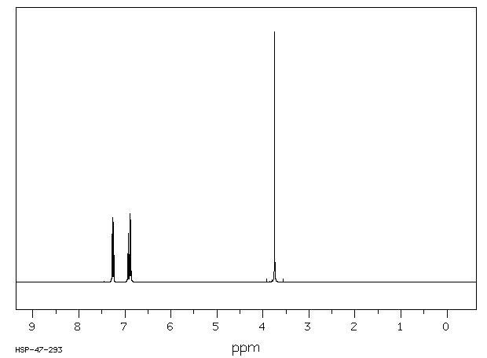

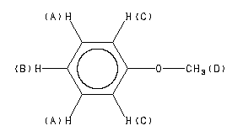
Assign. Shift(ppm)
A 7.259
B 6.919
C 6.880
D 3.745

